HW 4 – Challenge Questions

* **Explain why the values are not constant along the boundary (relate to the definition of a Type I boundary).**

A type 1 boundary means constant head, not flux. Flux can shift to accommodate different K values or head gradients. This is a normal part of the Darcy’s Law computation within MODFLOW.

* **Explain the shapes of the flow distributions and why they are not the same for the left (inflow) and right (outflow) boundaries.**

What I envision going on around our well is the cone of depression that you would see during a pumping test. The left boundary is slightly being influenced by pumping, drawing more flow in the center. The right boundary is being influenced by the well, but sees less flux because the well has now removed the incoming water; all that passes through this boundary is water not captured by the well, so there is less overall flux

* **You are still modeling stead state conditions? So, what is supplying water to the well?**

This should still be a steady state model, we just now have an additional factor of the well. We have a source of water loss now, which means each curve no longer has the same integral flux area underneath. I believe our constant head boundary is what supplies this extra water for our model. Our type 1 boundary means that there is essentially a limitless water source going into our model.

* **How do you interpret the flow along this transect? (see green line on plot below)**

This well seems to behave like an area with much lower conductivity, and acts a sink for the incoming water. The pumping is trapping flow into the area around the well, and we see the peak of this exactly on the well.

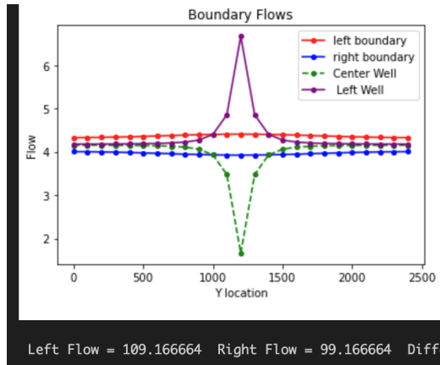

* **Then, look at the plot of equipotentials (i.e. the constant head lines, this is the last plot in the example) and flow vectors. Describe how water flows through the domain. To aid in your description, draw a line through all of the flow vectors that terminate in the well. This approximates the capture zone of the well.**

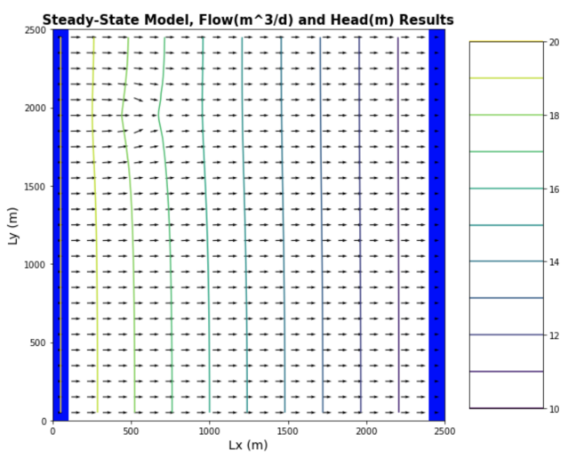



Water flows through our domain, for the most part, like we saw in our simple type 1 homogenous model we used in earlier models. However, we see a difference in the behavior of water around our pumping well. The flow lines immediately around our well are drawn into the well, and converge on the point. The water immediately after the well that just missed being captured is slowed down, but resumes a normal flow regime shortly afterwards.

* **Why aren't the drawdown contours circles? Either explain why this is correct, or fix the plot.**

This one kind of has me stumped…. I think it has to do with the difference between the left/right boundary and the top/bottom boundaries. There is only flow being provided from left to right, not the top or bottom domain, so perhaps this has something to do with the elliptical nature of the drawdown. It could also be due to the increased travel distance of the flowlines coming from the edges of our flow domain.

* **Why are the drawdown contours not equally spaced?**

This occurs because the well’s influence on the environment isn’t linear. The effects are felt less and less the further you get from a well. I think of it like the way gravity relates to distance, it gets exponentially stronger or weaker with distance. There is also a delay in the effects of the well at distance. Water right near the well feels a much more immediate impact, but it takes time for the effects to propagate toward the edge of the model.

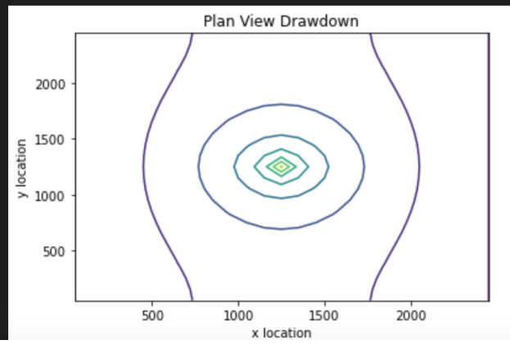

* **Move the well to [0,5,5]. Use all plots necessary to describe fully how water is flowing through the domain with the well in this location. Be sure to include the drawdown plot in your discussion - compare this plot to the equipotentials and flow vectors.**

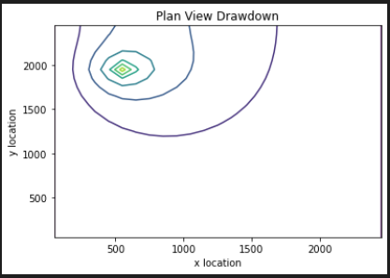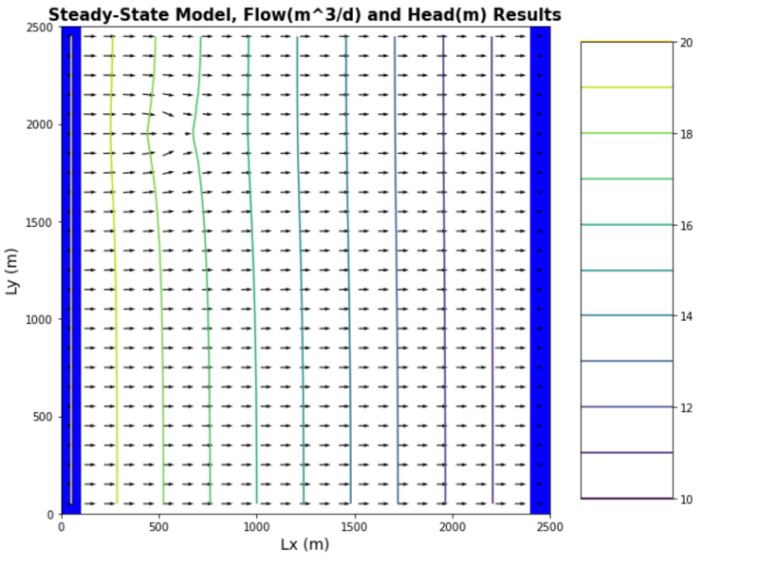

Water is flowing through this domain similarly to the other case, in that a few flowlines are being drawn into our well. Our flow net looks almost identical, just with the well in a different area. However, we can see a clear deviation in behavior in the drawdown plot. The drawdown is no longer symmetrical to the left and right of the well. Though, this isn’t clearly shown in the flow net plot, which I am unsure of how to explain. Flow seems like it’s getting accelerated more, since there is less room in between our well and the boundary now. This results in a higher head gradient before the well. But the water after the well behaves the same as the central well did, as there isn’t anything else to influence flow.

Glossary

1. **What are equipotentials? How do we create them from MODFLOW Models?**

Equipotentials are lines of equal head within our model. We use FloPy to analyze the head outputs of MODFLOW, and put it into a nice plot using the appropriate python library, like matplotlib.

1. **What are flowlines? (BONUS thought experiment: How can you impose a no flow boundary based on symmetry? Give it a shot to explain WHY this works in a couple of sentences.)**

Flowlines are akin to tracing the path of particles through our model space. If you were a water molecule at any given point, the flowline is the start to finish path you would take.

You can indeed impose a no flow boundary based on symmetry. If you mirror a pumping well against an injection well, you will get a no flow boundary between the two wells.

1. **What are flownets? And how does a flownet vary from a map of equipotentials with flow lines drawn on it?**

Flownets are simply a vector mapping of flowlines. As far as I’m aware, they are the same thing as a map of equipotentials with flowlines drawn onto them.

1. **Define the concept of 'capture' in a way that a non-expert might understand?**

I would compare it to the forces of gravity, and orbits. Water has to come close enough to the well to be influenced by the well, just like an object would get captured by a black hole. Once the water gets close enough, it’s path is now on course to enter the well.