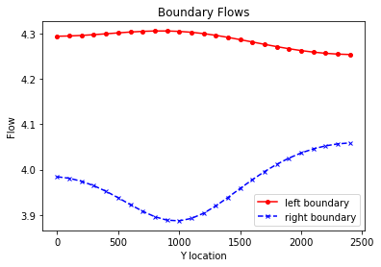

The base boundary flow line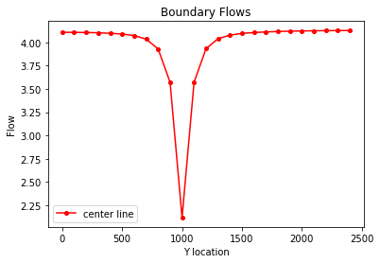middle flow line

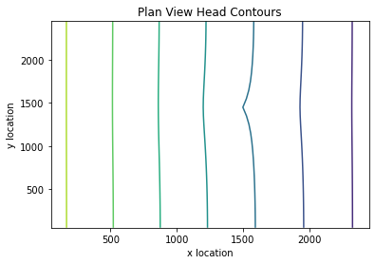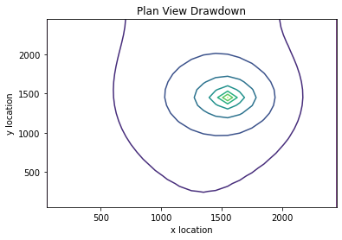 drawdown lines

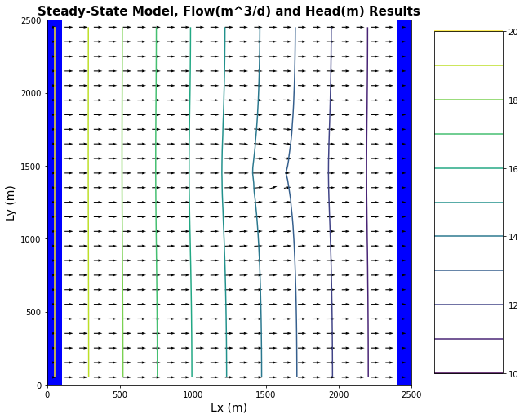equipotential and flow vector

Moved well draw down plot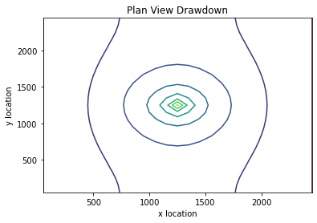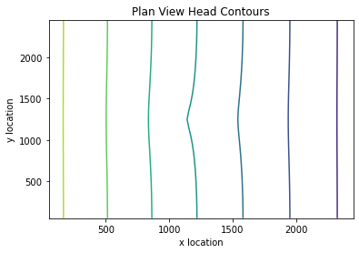

Equipotential flow vector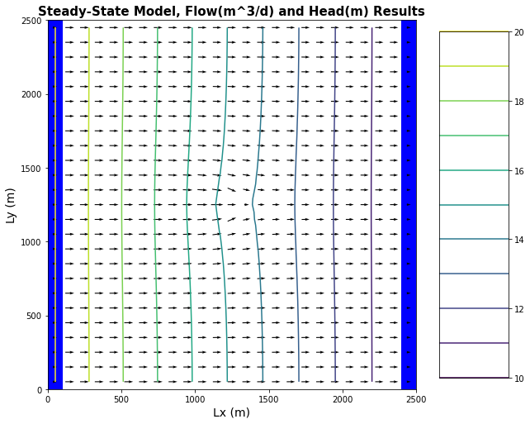

Discussion question 2: the values are not constant along the boundaries because the well is removing total volume from the system so while they all have a constant head boundary the flow is no longer constant throughout the system.

The flow shape is different because the well effects can be felt more on the downstream flow rather than the upstream so the right-hand side sees more effects from the well

Pressure is supplying water to the well due to the constant head so a head change is giving the well water.

Discussion question 3: the flow through the area of the well drops significantly as a lot of flow is removed from the system due to the well it also doesn’t do what an area of low k does as it doesn’t get more flow around the well.

Discussion question 4: the water generally flows through the domain in a straight path until it reaches the well then it flows towards the well and the flow after the well is less as the well drains flow from the system.

Discussion question 5: the contours are not circles as the flow is in the x direction and not omni directional so the biggest effects are seen in the x flow direction.

Some flow is lost as it passes through the well so the spacing there goes down but then normalizes after it so it returns to having the even spacing.

Discussion question 6: 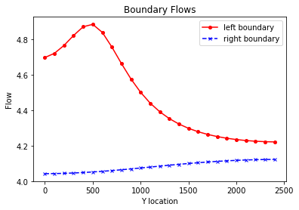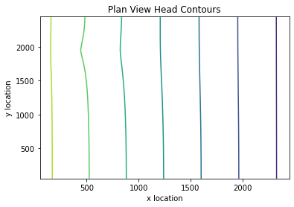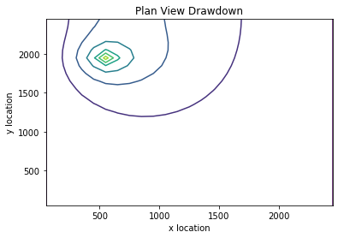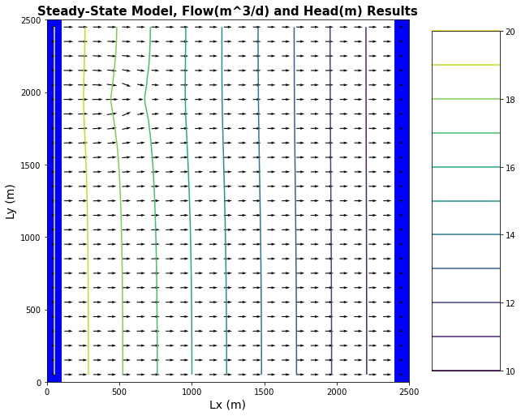

Glossary question 1: equipotentials are the flow potentials through a system and they are created through head difference.

Glossary question 2: flow lines are the draw depiction of the flow vector in a system.

Glossary question 3: flow nets are the depiction of how the flow lines appear to go through certain areas.

Glossary question 4: Capture is all the water that goes through the well that would gave gone down stream but was removed from the system.