The Challenge

1. Change the boundary condition heads to make this an unconfined model. You can pick whatever heads you would like but I recommend keeping both of them above zero (*Hint:these are the variables H_left and H_right in the starter code*). Run two simulations with the same head gradient across the model (i.e. H_lef-H_right being equal) but where one is confined and the other is unconfined.
   * Plot the equipotentials and flow lines for both simulations

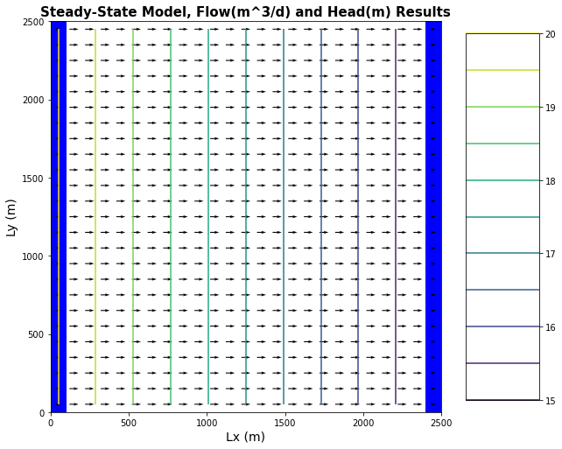 Flow lines and contour lines for confined

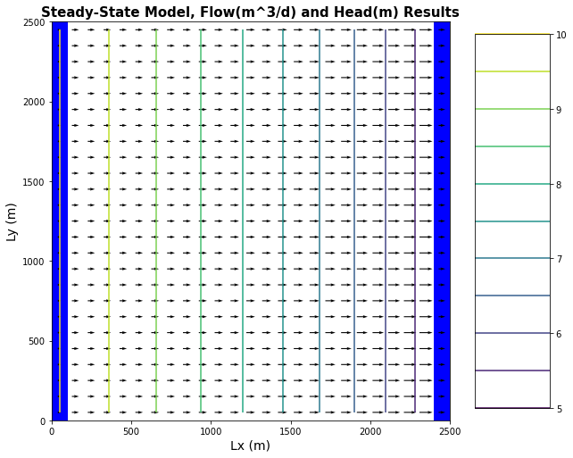 Flow lines and contour lines for unconfined

* + Plot the head difference between the two simulations

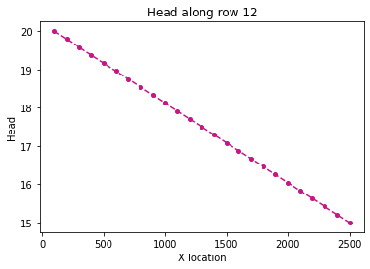 head gradient for confined

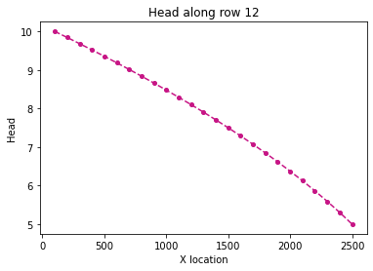

Head gradient for confined

* + Describe how the two head profiles differ and explain why this is the case. The two profiles are different as the profile that goes from 10 to 5 is exponentially decreasing as it goes to the right whereas from 20 to 15 it is a linear relationship.
  + Would your answer be different if you changed the overall head gradient (H_left-H_right), still keeping it the same between confined and unconfined cases though? The answer would not be different as unconfined heads give an exponential decrease to their head value over time as compared to confined.

1. For the two runs above (1) plot the flux across the left and right boundaries and (2) calculate the total flux.

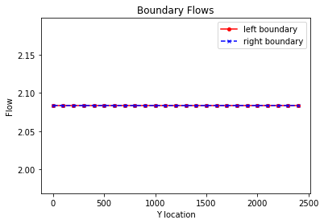20 to 15 head 52.082504=q

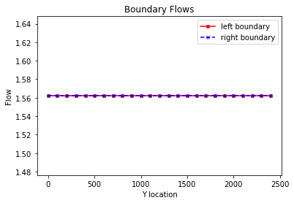 10 to 5 head 39.0525=q

* + Compare these calculations and plots and provide an explanation for why you see the behavior you do. The flow is significantly less for 10 to 5 as less and less area has water going through it as the flow continues in the unconfined system where as the flow in the confined system as fully saturated flow which allows for more water through the system.
  + The overall gradient is the same, as is the K of the medium. Is the flow the same for both boundary conditions? Why or why not? Yes it is the same as nothing has changed and the boundaries are still infinite sources and sinks

1. Now add recharge at a constant rate of 1e-4 m/day over the entire top boundary to an unconfined case with the left boundary set 7m and the right boundary set to a 2m.

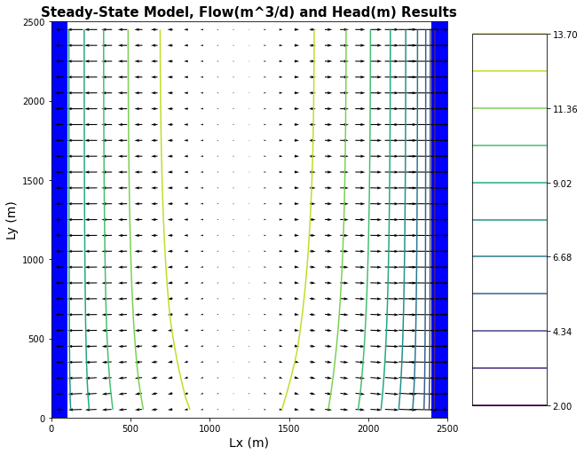

* Explain the head transect and boundary flows.
* Is flow in this system 2D or 3D? Is it represented as 2D or 3D? Explain what you mean by your answers. The flow system is in 3d but it is represented in 2d And we know this as the flow is going through less and less area as it goes to the right and there is recharge going through the top of the system and into it but we have said that there is only 1 layer to the syste, so it can be represented as a 2d model.

1. Update your model from #3 to model a system with zero recharge except for a farm located in [6:10, 6:10]. Recharge beneath the farm is 1e-4 m/day due to excess irrigation.

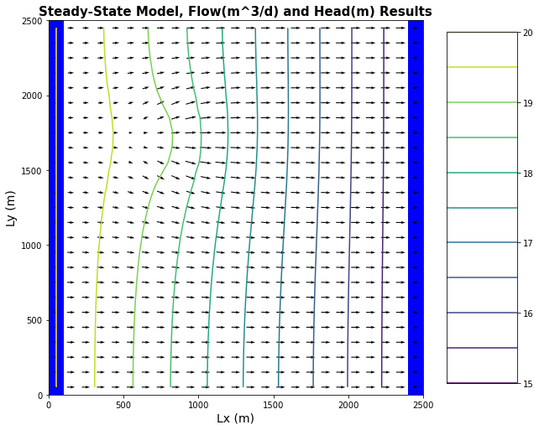

* + Calculate the annual excess irrigation, in meters, that has been applied to the farm. 500m x 500m *1x10^-4 m = 25m of water perday
  + Assuming that the crop is cotton, it is located in southern Arizona, and cotton is grown all year (for simplicity), calculate the total irrigation rate on the farm that would be associated with this amount of excess irrigation.
  + Finally, use the flux diagram to identify the area within the domain that might be subject to contamination if the recharge water was somehow tainted (you can do this by saving the plot to powerpoint and annotating it there).



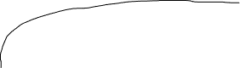

1. Lastly, start the well located at [10,15] pumping at a rate of 8 m3/day. Using one color, identify the capture zone of the well. Using a second color, show the area that might be contaminated by the irrigated farm fields (see not above you can do your annotations in powerpoint if that is easier. ).
   * Comment on the impact of the well on the pattern of potential contamination. ? Because the well is within the area that is affected by runoff from the irrigation the contamination risk now jumps to anywhere that the well water is going to
   * How will the steady state capture zone of a model with recharge differ from that in the same model without recharge? Even more water will be taken from the flux as less and less water is moving through the area and the well has captured so of the water.

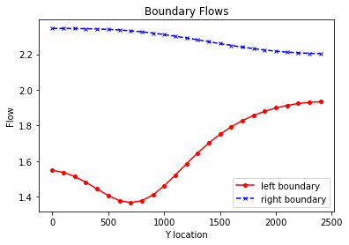

1. What does it mean for an aquifer to be unconfined? How does this impact how we calculate flow and how do we expect it to impact head gradients and fluxes? An aquafer is unconfined when its head is less than that of its thickness and it impacts the gradient in an exponential way.
2. List each layer type available in the LPF and BCF packages. Provide a brief summary explanation for each. Explain how approaches differ. l**aytyp** (*int or array of ints (nlay)*) – Layer type, contains a flag for each layer that specifies the layer type. 0 confined >0 convertible <0 convertible unless the THICKSTRT option is in effect. (default is 0). For LPF and for BCF **laycon** (*int*) – Layer type, confined (0), unconfined (1), constant T, variable S (2), variable T, variable S (default is 3)
3. How can MODFLOW, which does not model unsaturated flow, represent an unconfined aquifer? Mudflow represents an unconfined aquafer through the unconfined flow through a system
4. Define recharge. How do we represent recharge in a MODFLOW model? What package do we use and what are the assumptions of this package? Where exactly is the top boundary of the model? Recharge is when water is added back in to the groundwater system from any method we use the recharge package and it assumes that the water infiltrates perfectly at the top of the boundary at z=0