Challenge question 1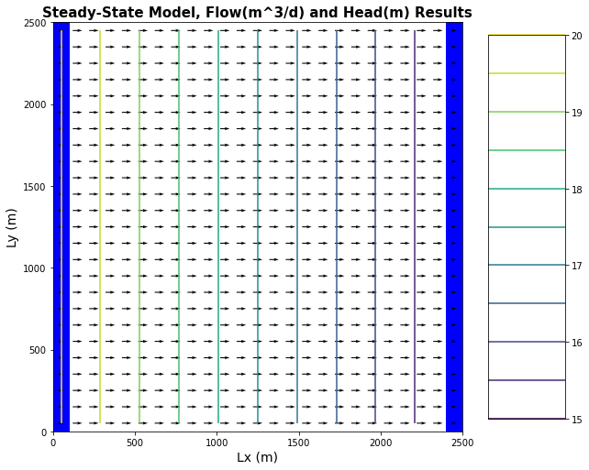

Flow lines and contour lines for confined

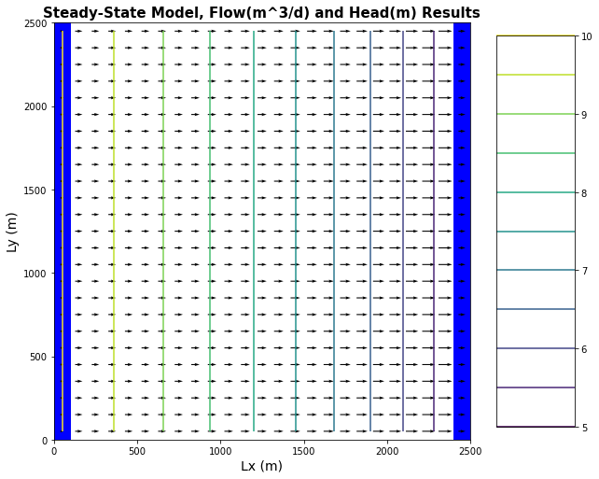

Flow lines and contour lines for unconfined

head difference is 5 between them

Challenge question 2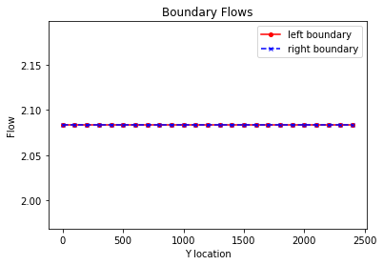20 to 15 head 52.082504=q

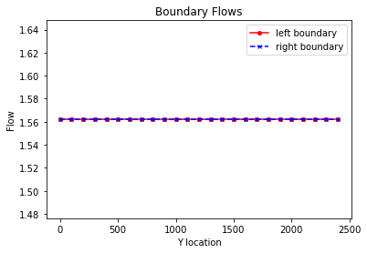 10 to 5 head 39.0525=q

Challenge question 3

Equipotential lines and head transect



Left and right flux values

Challenge question 4

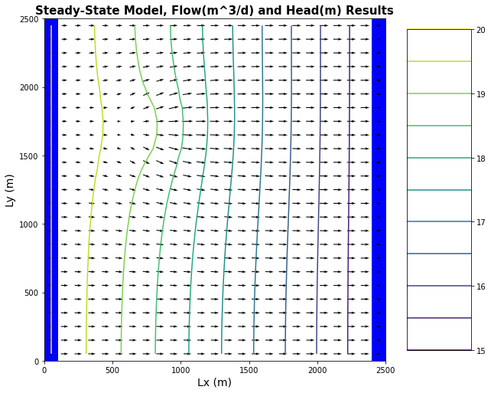

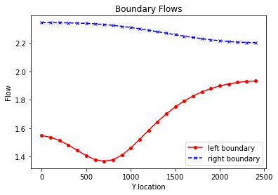

Challenge question 5