1. For the initial boundary head values and recharge and ET rates:

* plot the flow across the left and right bounaries. Explain what you see and why it makes sense. This makes sense as more water is being added towards the top from the rechage location and with evaporation along the entire system equalizes it as it also equalizes as it moves awayfrom the left side.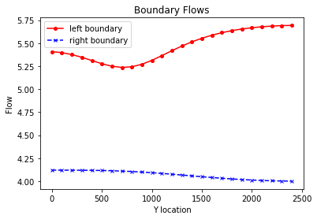
* Plot the equipotentials and flow vectors in plan view and outline (hand draw) the area that would be affected by recharge (i.e. if it were contaminated). Explain what you are seeing and why. We are seeing the flow from the irrigation spread a contaminate through the area of flow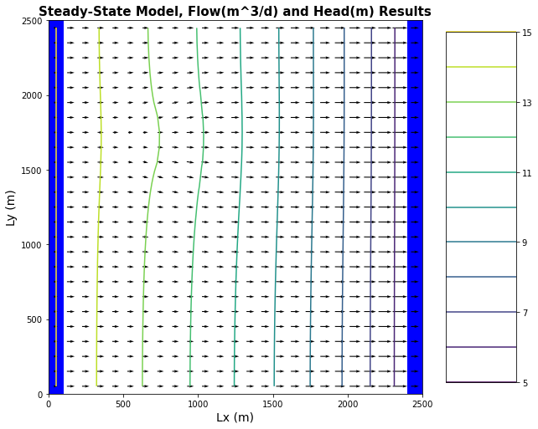
* Plot ET,Recharge and Water Table depth and explain why we see the patterns we do. Exponetial decay versus lx and a zone of depresion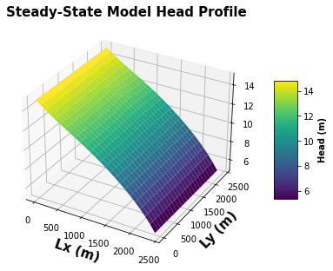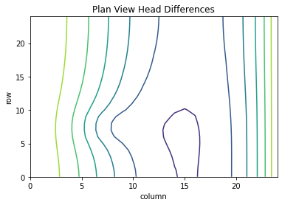

1. Calculate the water balance for the model
   * Report all of the inflows and outflows with units and show that mass is being balanced. Total ET [m3/day]: -50.97930991661269 Total Recharge [m3/day]: 16.0 left flux 136.65752 right flux 101.67799
   * Explain what controls each term in your water balance.
2. Change the extinction depth in your model.

Report the new water blance numbers Total ET [m3/day]: -34.916806392837316 Total Recharge [m3/day]: 16.0 left flux = 124.194305 right flux 105.27799

* + Provide a plot of the new head countours and fluxes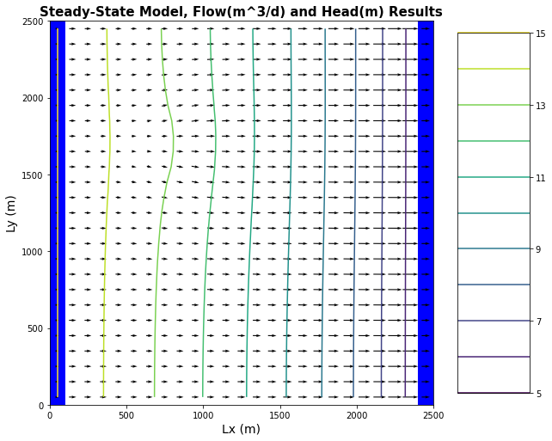
  + Explain what changed and why.

1. Now start the well pumping, extracting 20 m3/day.
   * Plot the equipotentials and flow vectors in plan view and outline (hand draw) the area that would be affected by recharge (i.e. if it were contaminated). Nothing will happeb as there is not enough water in the systemand it has broken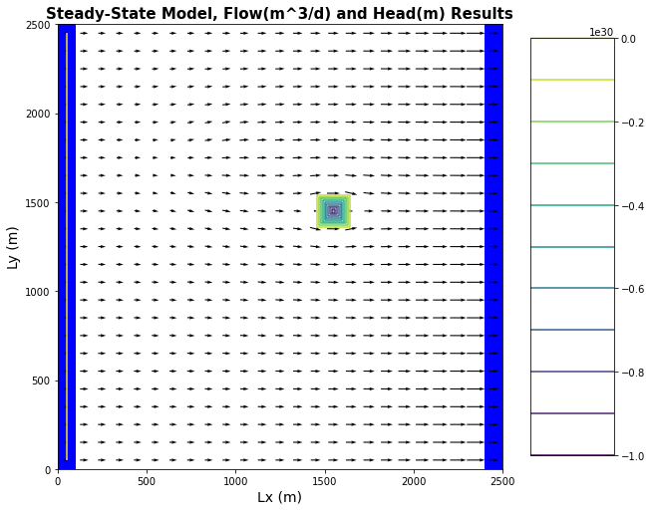
   * Plot ET,Recharge and Water Table depth and explain why we see the patterns we do. A broken graph as too much water has been taken out of the system.
   * How does the well change the zone that is affected by the recharge area? 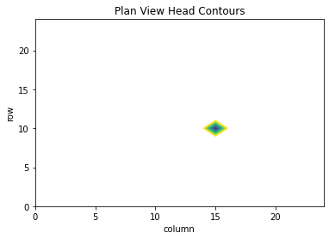
   * How does it affect the ET map? 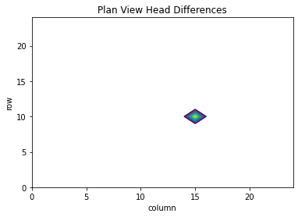
2. Write a mass balance for the well.
   * How much water is coming from a boundary? How much is originating as recharge? Most of the water has come from the boundary with a small aount being from the recharge about 16 m^2 from recharge with significantly fmore from the boundary

How do you account for the impact of ET on this mass balance?

* + At steady state, what are the effects of 'capture' by the well? The well causes a cone of depression to affect the area around it and divert water from the surrounding area

1. Define Evapotranspiration. Explain in the real world (1) the components of evapotranspiration (2) where this water is pulled from and (3) the physical drivers and controls that determine evapotranspiration rates.

Evapotranspiration is when water goes in to the atmosphere from either thermal energy or release from plants the water is pulled from ground water sources and through either thermal energy or the leaves of plants for thermoregulatory processes. Heat energy is the prominent component ET.

1. Describe how the evt package in MODFLOW models evapotranspiration. List the assumptions and simplifications that this package is making. It models ET by applying a certain amount of loss to the flow if the water head is above a certain threshold. It simplifies heat transfer and plant processes that get the water from its ground water source to the air by saying it just happens.
2. What is a land surface model? What are the differences between groundwater models like MODFLOW and land surface models that also simulate the shallow subsurface? When is each preferred over the other? A land surface model works on the surface of a model it is different from a ground water model as it has only 2 dimensions being for a surface and can simulate rivers but it cant do any subsurface modeling.