1. For the initial boundary head values and recharge and ET rates:

* plot the flow across the left and right bounaries. Explain what you see and why it makes sense. 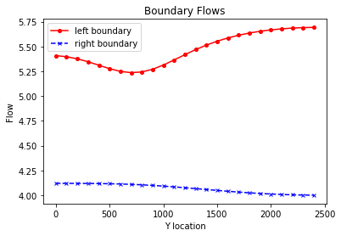
* Plot the equipotentials and flow vectors in plan view and outline (hand draw) the area that would be affected by recharge (i.e. if it were contaminated). Explain what you are seeing and why. 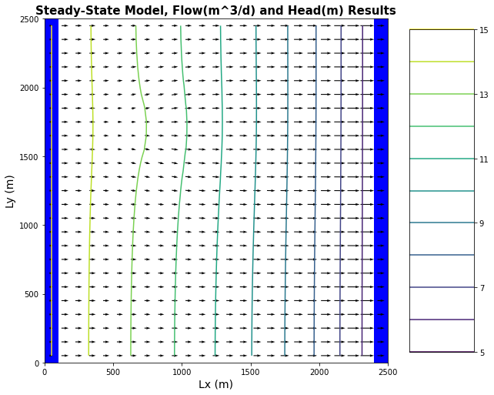
* Plot ET,Recharge and Water Table depth and explain why we see the patterns we do. 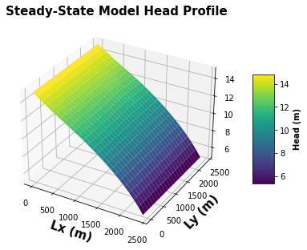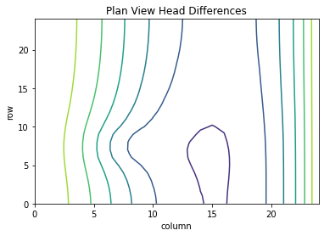

1. Calculate the water balance for the model
   * Report all of the inflows and outflows with units and show that mass is being balanced. Total ET [m3/day]: -50.97930991661269 Total Recharge [m3/day]: 16.0 left flux 136.65752 right flux 101.67799
   * Explain what controls each term in your water balance.
2. Change the extinction depth in your model.

Report the new water blance numbers Total ET [m3/day]: -34.916806392837316 Total Recharge [m3/day]: 16.0 left flux = 124.194305 right flux 105.27799

* + Provide a plot of the new head countours and fluxes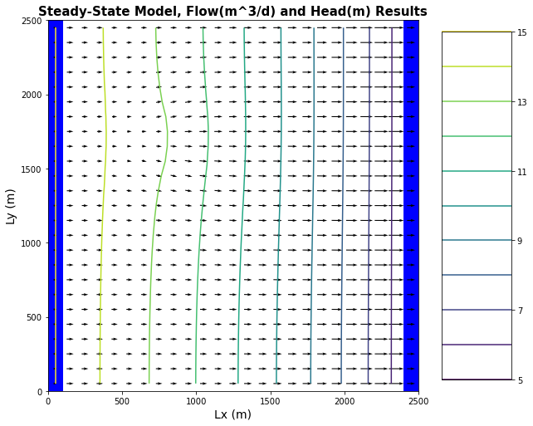
  + Explain what changed and why.

1. Now start the well pumping, extracting 20 m3/day.
   * Plot the equipotentials and flow vectors in plan view and outline (hand draw) the area that would be affected by recharge (i.e. if it were contaminated). 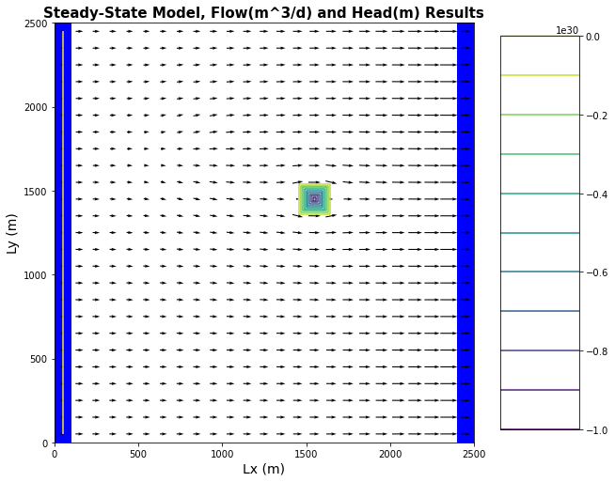
   * Plot ET,Recharge and Water Table depth and explain why we see the patterns we do.
   * How does the well change the zone that is affected by the recharge area? 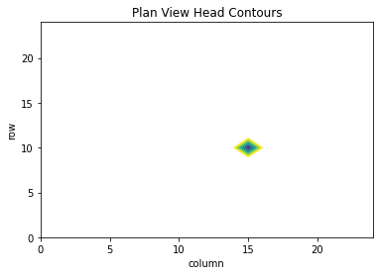
   * How does it affect the ET map? 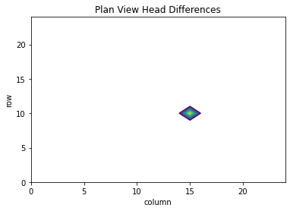
2. Write a mass balance for the well.
   * How much water is coming from a boundary? How much is originating as recharge? How do you account for the impact of ET on this mass balance?
   * At steady state, what are the effects of 'capture' by the well?