“HW_7_Disscusion_questions_Switzer”

(All images and information are based off of justin’s project information”

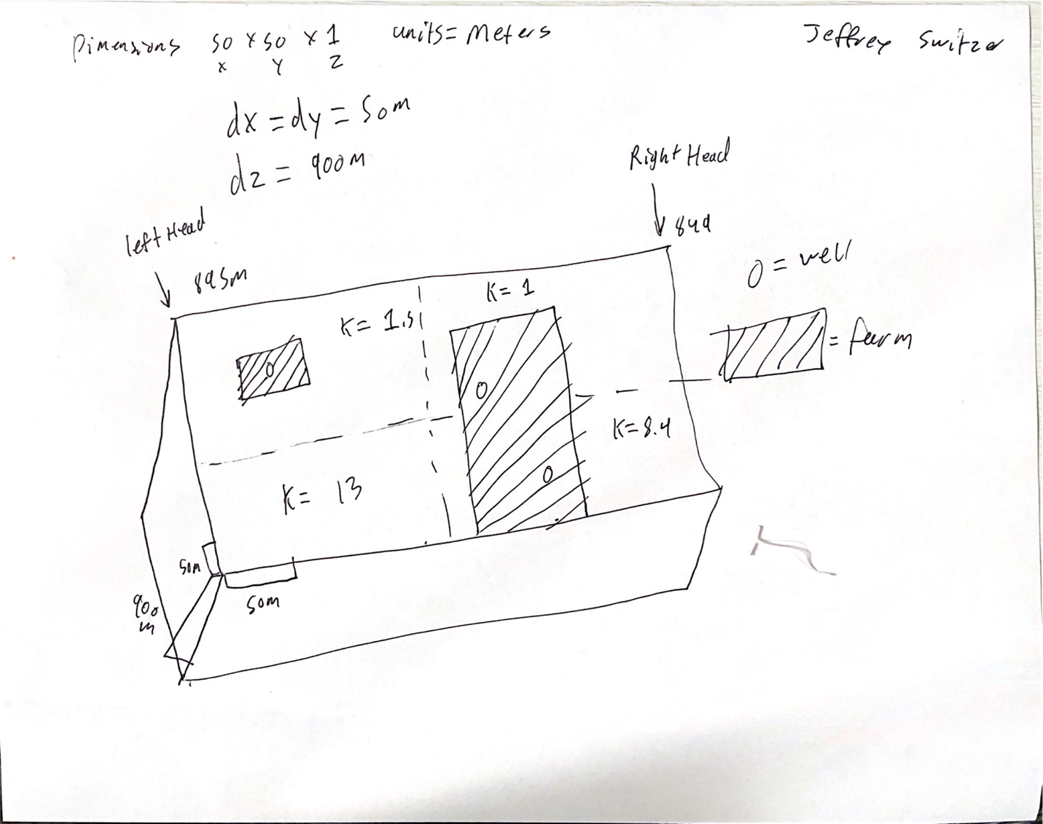

1. The grid resolution is set to 25 by 25 as this was the resolution we have been using for all of our models, due to the 350m by 350m farm we will have extra farm land on each side but it is within reasonable water input and output.

Values for the pumping rates were calculated by multiplying the irrigation needs for cotton and alfalfa by the area of the farms with a 348 m^3 pumping rate for the wildcat farm and a 10462m pumping rate split over two wells on the acme farm. ET rates were a giving value to us.

The boundary conditions are assumed to be constant head with 595m on the right and 550m on the left.

Some assumptions that are made are that there are constant heads to the left and right of the system, ET is not different on the farms than in the surrounding land, k values are constant per quadrant of the map and don’t gradually change, there is no recharge over the farm land and the farms are not wasting any water.

The three scenarios that I will be simulating if the well is as far from each other as possible, if both are in the high k section, and if wildcat farm were to get well right s in the high k zone Infront of the ACME farm.

If the ACME farms were to place their wells as far apart from each other as possible one well will be in the low k and one in the high k and the cone of depressions will not be in as close a proximate to each other, we can also see that the wells do not drop the wild cat well below the its 20 catch distance as can be seen here the head depth would need to be below the 580m depth at column 3 for this to not be able to pull but it is not.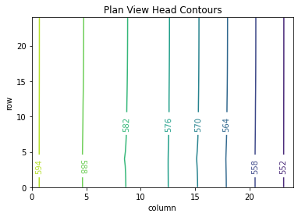 .

If they tried to put both of the well on the acme farm in the high K zone they would create a cone of depression so large that neither farm would be able to get water from their wells .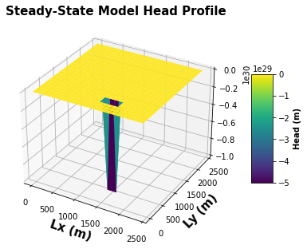

If the wildcats were to get a well in the low k zone the model doesn’t even converge so it most likely will not end well for the farms if the a new well is placed in the high k zone based of the calculations of this model.

The most likely scenario is that the wells are far apart and the wildcat well will have its water.

Glossary questions

1. What does it mean to be simulating saturated flow vs variably saturated flow? What are the advantages and disadvantages of each? Why is it much harder to solve for unsaturated flow? Integrate the concept of a linear versus a nonlinear model into your answer.

Saturated flow is when the entire column or head has water flowing through it while variable flow changes the head value but only has flow that is saturated through it. advantages to saturated flow is that it is very simple but not a accurate while variable is more accurate but harder to solve. It is harder to solve for unsaturated as it is a different equation that you have to solve for that has significantly more variables.

1. What is meant by an internal source/sink for ground water flow and how is it different than a boundary condition? Give an example.

The source or sink for ground water flow means from which boundary has water coming from it while sinks remove it from the system and they are different from bounaryies as they create or destoy water from the system rather than keep a constant head at a boundary and calc the flow.

1. What is meant by ‘forecast uncertainty’ in the context of a groundwater model? What are the sources of this uncertainty? What is required for a prediction to be as robust as possible?

Forecast uncertainties are variable we don’t know exactly in ground water flow models some come from k values over an area the ET of certain plants over an area and the resolution at which these calculations are done to change them. A prediction to be robust must be able to work with in a range of values and show what would happen without breaking