1. Plot the heads (or WTD) of the initial steady state condition. The gradient is not uniform for the initial steady state conditions - discuss the influences of recharge and the unconfined condition on this nonlinearity a small addition from recharge is what brings the curve up all along the gradient curve but because of its unconfined nature it is decreasing a an exponential rate so it looks as if the it decreasing faster but everywhere is slightly higher than it should be

b) The head along a transect between the constant head boundaries through the well at three times: the initial steady state; the final pump-on period; and the final pump-off period. 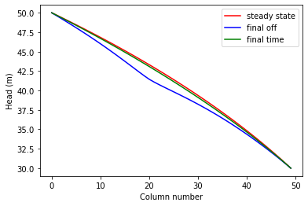

1. Determine if the system has reached steady state afert 10 years - consider a point at the well and another at the center of the domain. Based on the fact that heads are still changing at the well and the midpoint I would argue that it has not reached steady state yet.
   1. left panel showing the head at the well and right panel showing the head at the midpint of the domain, both as functions of time over the entire simulation. 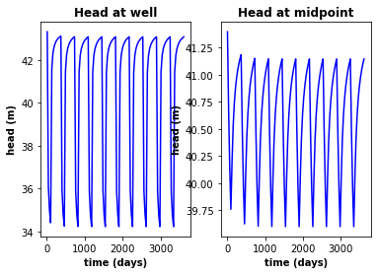

however after 100 years I can see based off the head graphs that it was already at steady state 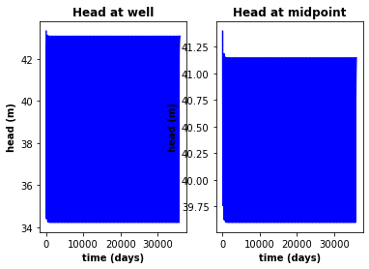

c) A contour map with flow vectors at three times: the initial steady state; the final pump-on period; and the final pump-off period. 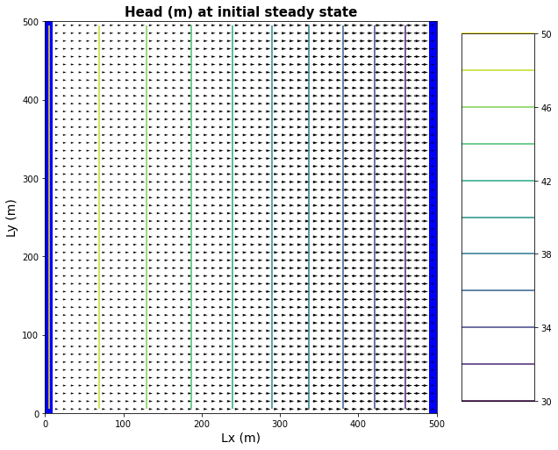

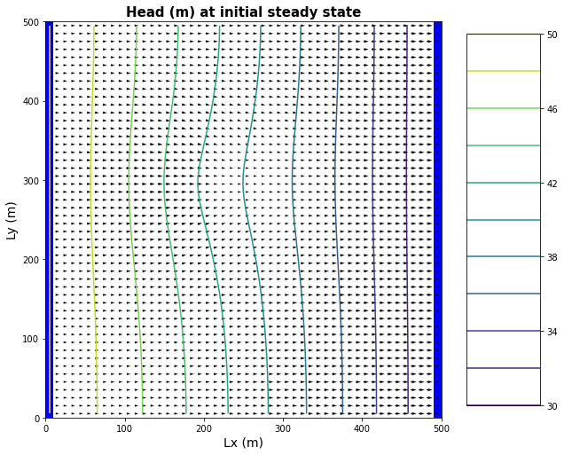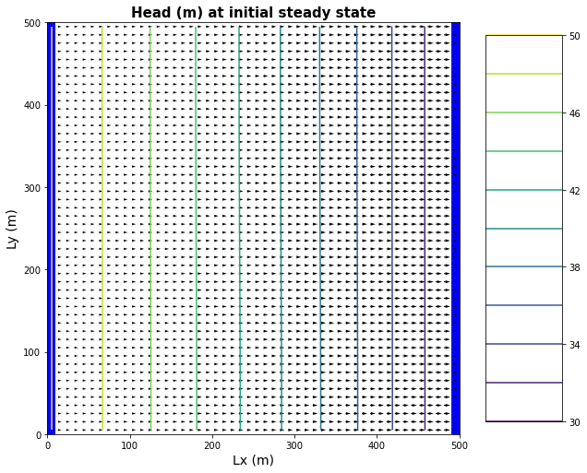

1. d) A contour map of the drawdown calculated for two periods: between the initial steady state and the final simulation time and between the final pump-on period and the final pump-off period. Find the zone of influence of the well defined in two ways:
   * Based on the drawdown from the initial steady state to the end of simulation time (end of final no-pumping stress period).
   * Based on the drawdown from the end of the last pump-on stress period to the end of simulation time.

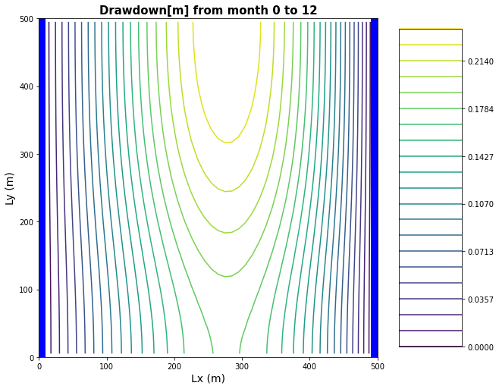 this is the pumping area of effect in its steady state form and it is affecting only a chunk in the middle where as the next countour map is from the end of the last pumping period and it is affecting the entirety of the system area

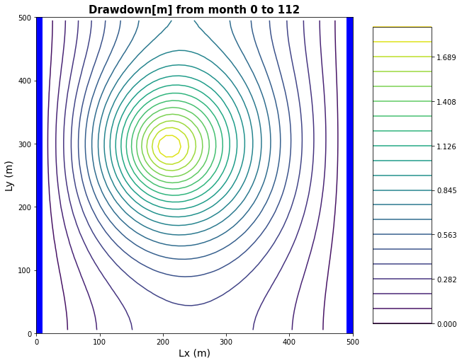

1. Explain the concept of stress periods in MODFLOW. How should you determine stress periods when setting up your model? How do they differ from timesteps?

Stress periods in modfow are essentially times when the stresses in a groundwater system are different for a certain period of time and for each time they are different they need a new stress period in modflow for the length of time it is different. Timesteps are just the number of stress periods there are

1. What is the period length in MODFLOW? How does the meaning of the period length differ for a steady state vs non steady state solution?

Period length is taken to mean how many days a stress period takes up in one year

1. What does the nstep variable signify in MODFLOW and how does it relate to the stress periods and period lengths? List the pros and cons of taking large timesteps vs. small timesteps. Is there any limit to how large a time step you can take and if so what determines this limit?

is the number of steps for which MODFLOW's solver will attain solutions within the length of each stress periods.

Large timesteps allow for a view of the aqafier will change over time especially since ground water models are slow models that happen over the course of years but this can lead to missing finer detail into what happens with the water on a monthly basis. A small time step on the other hand allows for seeing the immediate effects of wells irrigation and other such things on the system you are looking at but it require far more computing time. The length of time that is too large for the time step is where no inofrmaiton can be derived from it as to why what happened happened and this is different for every system so trial and error Is recommended.