The Challenge

1. Compare your results for the case with no ET to the modified ET case and explain how your results differ. To do this I'm expecting you will create some plots as well as looking at the water balance

NO ET

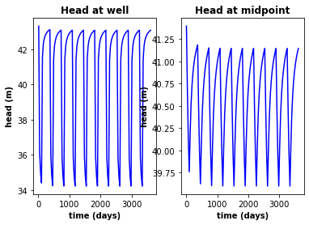

As can be seen on the graph on the right the the flow through the middle of the is roughly 41.15 m of head while for the graph below the 40.80 m or a difference of .35 m of head at the middle point. This means that the overal change from the et removes more and more water as it goes left to right. It was also seen that the water balance lost a significant portion of water around -150 cubic metters of water from left to right as apposed to the original -55 cubic meters of water

ET 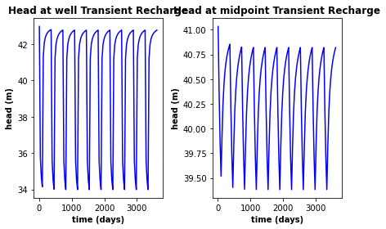

1. Modify the model so that the ET only occurs in a square area around the well that is 200m by 200m. Discuss how this changes your results using plots and water balance calculations.

This changes the flow values by drastically raising the amount of water flowing through the system from the original ET but not to the point of there being no ET to around about -75 m^3 of water leaving the system.

1. Modify the recharge in the model so that it is also transient. Its up to you how you want to modify it. Provide and explanation for the scenario you ran and explain how it impacts your results.

What is found is very similar to when ET is transient except that there is just less total water in the system as well. Around about 100 m^3 less when there is no recharge to put the numbers into perspective.

Glossary questions:

1. What are initial conditions? Describe various approaches to determining initial conditions for a groundwater model.

Initial conditions are the conditions at the start of a transient model that the model then changes depending on the parameters. The initial conditions are usually taken from observations of an area that you are turning into a model.

1. What does it mean for a groundwater model to be ‘spun up’? How can we go about achieving this and how would we know if we are done? What can happen if you run transient models on a groundwater model that is not spun up?

A groundwater model is spun up after it has gone through its transient timesteps until it is stable you can go about achieving this by making sure that you have enough periods for the system to run through. The model if transient will just no converge and the whole system while crash.

1. Groundwater is generally the slowest moving component of the hydrologic cycle. Describe (1) the speeds at which groundwater flows compared to surface water (2) the time scales over which water tables and groundwater heads respond to changes in pumping vs recharge in both confined and unconfined systems? What are the implications of these timescales for how we model groundwater systems?

The speed at which water can move over the surface can be as high as meters per second while the ground water systems are often measured in meters per day so a gear change of 1 to 360 as compared to each other.

Water table change almost immediately when pumping occurs, especially right around the well where as it can take a few hours for recharge at the surface to be felt by the water table and for permeant changes it can take years for both with recharge taking on average longer. The implications for these models is that we are guesstimating the future of the system.