1. The stream package works by having us set up the information on the stream its flow and the number of streams and which segments they go through. One type of assumption that is made is flow above the surface happening as saturated flow and by default it is assumed that the flow only goes one modflow layer down.
2. The stream moves from south to north and the flow (at least underground) pulls off to the east this is caused by the leakage in the stream

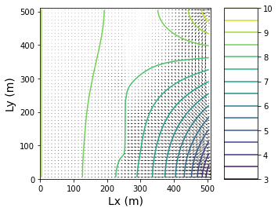 standard model

1. Due to the flow of water the waters movement across the boundary is pointed towards the north east portion of the system and it pulls water away with it so the flow in the south east is significantly less there.
2. When changing the rivers inflow to 100m^3 per day from 0 the flow in the south stabilizes as compared to the flow originally as the ground water did not need to provide water to the river to start off.

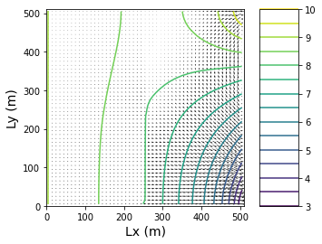 100m^3 inflow model

And by changing the recharge rate by an order of magnitude. It can be seen that the stream flow rate really feels it and is moved greatly.