a) left panel showing the head at the well and right panel showing the head at the midpint of the domain, both as functions of time over the entire simulation. 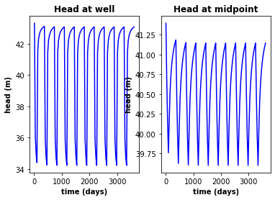

b) The head along a transect between the constant head boundaries through the well at three times: the initial steady state; the final pump-on period; and the final pump-off period. 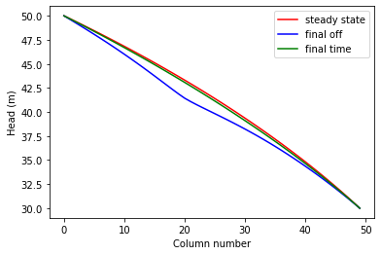

c) A contour map with flow vectors at three times: the initial steady state; the final pump-on period; and the final pump-off period. 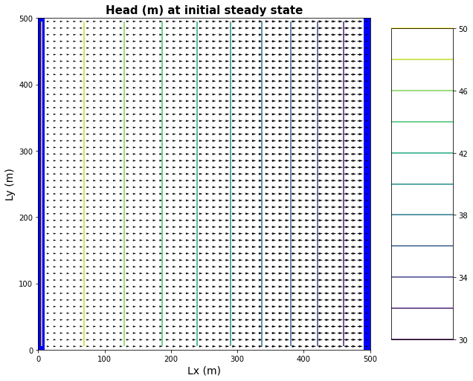

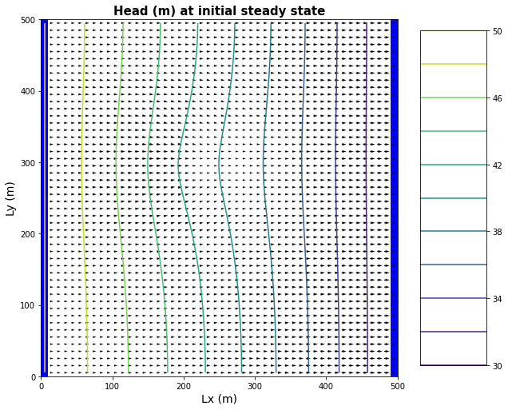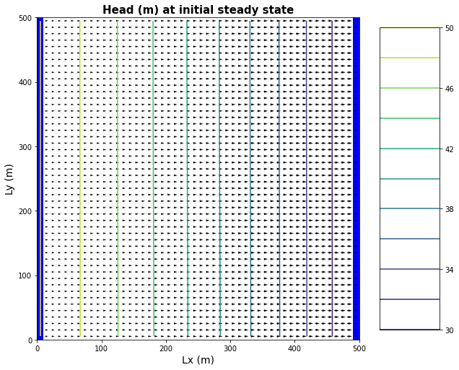

d) A contour map of the drawdown calculated for two periods: between the initial steady state and the final simulation time and between the final pump-on period and the final pump-off period.

