1. **Read the paper that summarizes the stream flow packages in Modflow and look at the flopy documentation for the str package to understand how we have implemented this in our code. Write a short explanation for how the str package works and what assumptions it is making.**

Surface water level is not modeled by MODFLOW since the program can only show us the seepage between a river and an aquifer. As a result we use conductance parameters coded into the stress period if the stream package to account for this.

1. **The code is provided to produce the first set of 'correct' figures. Use these figures to describe the nature (direction/magnitude) of stream/aquifer exchange along the stream. In particular, explain why the leakage changes magnitude or direction where these values change.**

Some of the behavior exhibited by the flow profile below (Figure 1) can be explained by the streambed conductance coded into our stream. There is a lower riverbed conductance value used for the first 21 rows of the flow domain, which accounts for the lower slope in the flow chart on the left-hand side. The changes in conductance along the stream affect the flow behavior throughout the domain and likely affect the water lost to the aquifer as well. Changes in leakage also seem to coincide with changes in conductance within the code.

Another effect on these stream behaviors could be due to recharge. After recharge is no longer being added to the system, the leakage to the aquifer increases significantly. Recharge is only added in the first 26 rows of the flow domain, and it is after this point that we see a large increase in the rate of water leaking to the aquifer from the stream. The point where recharge is no longer added to the system also coincides with relative stabilization of the head gradient at the streambed top. The decrease to zero of flow into and out of the stream around row 45 corresponds to a decrease in the head values as well as an elimination of leakage to the aquifer.

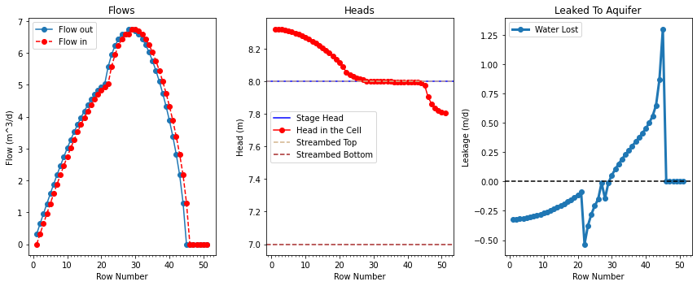

Figure 1: Plot shows flow behavior into and out of the stream, head behavior across the stream, and rates of water leaked to the aquifer along the stream length. Blue vertical lines indicate the end of the lower streambed conductance value within the flow domain, and orange lines indicate the end of recharge application within the flow domain. The rows in between the two vertical lines on each plot have a higher streambed conductance than the first 21 rows of the flow domain.

1. **Use the head distribution to describe the movement of water across the boundaries and into/out of the stream.**

Water does not move very fast across the left boundary as indicated by the flowlines and confirmed by the wide distribution of head contours in Figure 2 below. There is not much flow entering the stream in the top half of the domain as the flow curves from the right boundary out toward the middle of the domain, and then away from the stream. More water moves through the middle of the stream as the conductance increases and still more at the bottom of the stream (top, middle, and bottom from the perspective of plan view). The most water movement occurs in the bottom right corner of the domain where the head contours are closest together and the flow lines have the greatest magnitude. Water is likely moving quickly away from the stream and across the right hand boundary through this corner of the domain.

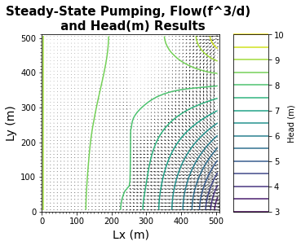

Figure 2: Flow lines and head contours of the flow domain with a stream running parallel to the Ly axis through the middle of the flow domain. Head contours show an area of steep head decline in the bottom right corner.

1. **Choose two things to explore (e.g. impact of streambed K or inflow into the river or recharge rate). Produce a plot for each to compare to the base plots and use the plots to explain the impact of the hydrologic change.**

The first variation I explored was changing the streambed conductance. I shifted the conductance for the first 21 rows from cond/100 to cond/1000 and the conductance through 21:26 from cond/10 to cond/5. These changes created the plot below (Figure 3). The most immediate change is that the slopes of the flow plot have changed significantly from the baseline. The slope for the first 21 rows is much lower and the slope between 21:26 is much steeper than in the baseline plot. The head plot has also changed. The stabilized area seems to have shortened, and the lower head zone on the right side of the plot has lengthened. The rate of water pulled from the aquifer has increased and water lost to the aquifer has decreased from the baseline.

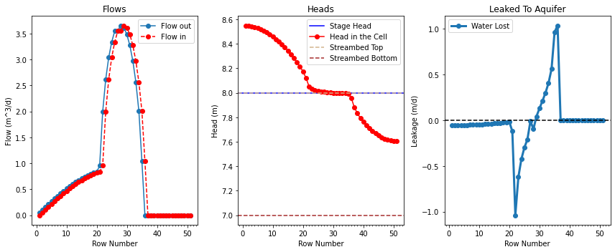

Figure 3: Plot of flow, head, and leakage rate behavior for the changed streambed conductance run.

When changing the recharge rate from 5e-5 to 1e-5, different behavior from either of the two runs was observed. The slope of the lower conductance region was increased as seen in the flow plot below (Figure 4), and water loss rate to the aquifer increased compared to the baseline.

