**Discussion Questions:**

**1.) Create a conceptual model of the homogenous MODFLOW model: This should be an illustration that shows the locations and values of constant head boundaries, the number of grid cells and their spacing as well as any other model properties. You should also include in here a cross section with your predicted head gradient and direction of flow. You can draw this by hand if you would like.**

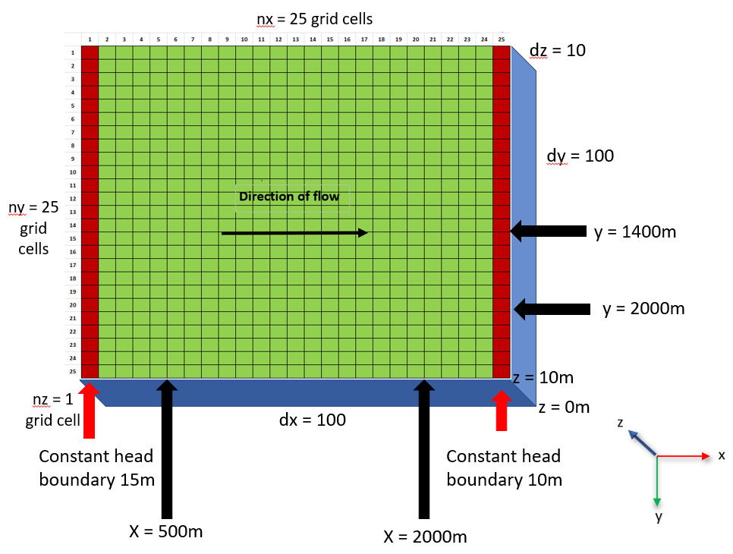

Figure : This figure shows a conceptual model of a homogeneous MODFLOW model. The left constant head boundary is set to 15 m and the right constant head boundary is set to 10 m. Conceptual model is courtesy of this week’s discussion leaders Adam, Diana, and Jake.

The conceptual model above shows all the MODFLOW model properties included in the model set up. Flow moves from left to right across the grid since the head decreases from left to right. Each cell in the grid has the x-y-z dimensions 100 m x 100 m x 10 m.

Figure : Cross-section of predicted head gradient for a homogeneous MODFLOW model. Plot is courtesy of this week’s discussion leaders Adam, Diana, and Jake.

The graph above shows that the head decreases constantly with distance in the homogeneous domain.

**2.) Show, based on the flux with horizontal distance from a constant head boundary, that the model is steady state. Repeat this for a homogenous and a heterogenous case where you place different K values in series in the direction of flow (Note: to modify the K values you should change the `.bcf` file, just be careful because spacing matters! Note 2: see the excel sheet for an example calculating flux. Keep in mind that heads are calculated at the center of a cell and the K values are defined across the entirety of a cell)**

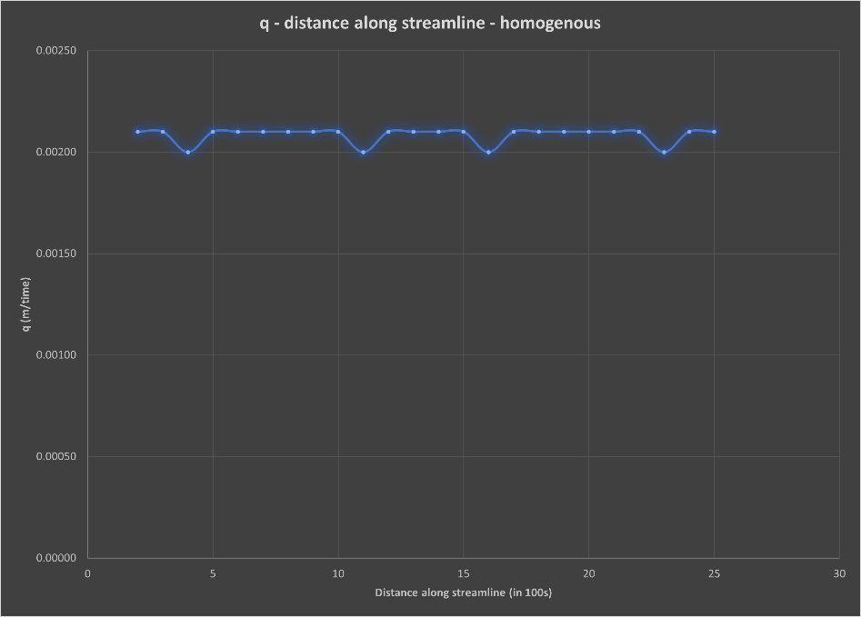

Figure : Flux v. distance along a streamline for a homogeneous MODFLOW model.

This plot shows that the flow is steady state since the flux at the start and end points of the streamline remains constant at the same value, in spite of any deviations along the streamline. This is true for the heterogeneous MODFLOW model as well, as is shown by the figure below. This figure has a much larger peak in flux due to the high conductivity zone in the middle of the model, however, the model can still be seen to operate under steady state conditions as the start and end points along the streamline are the same.

Figure : Flux along a streamline for a heterogeneous MODFLOW model with two high conductivity columns (K = 10 m/d) in the middle of the model domain (columns 11 & 12). Plot is courtesy of this week’s discussion leaders Adam, Diana, and Jake.

**3.) Show the steady state head contour in plan view for the homogeneous and heterogeneous (zones in series) condition. Use this plot to defend a contention that flow is 1D. Then, drawing on your first assignment, use the results to explain WHY the equivalent hydraulic conductivity, Keq, is closer to the lower of the two K values.**

Figure : Hydraulic head behavior within the homogeneous domain. Head does not vary along the Y direction. However, the graph above indicates that the head decreases in the X direction. This shows that flow moves from left to right in the homogeneous domain.

Figure : Hydraulic head of a heterogeneous MODFLOW model with two high conductivity columns (K = 10 m/d) in the middle of the model domain (columns 11 & 12). High K zone indicated by darker line in the middle of the plot around x = 1000 above. Plot is courtesy of this week’s discussion leaders Adam, Diana, and Jake.

For both the homogeneous and heterogeneous MODFLOW models, moving along the y-axis does not produce a change in head values. However, the head values decrease along the x-axis for both the homogeneous and heterogeneous plots. This indicates that flow is only moving along the x-axis, and is therefore one dimensional. As with our previous assignment, the lower K makes up a larger portion of the head values in the model, so these values dominate the harmonic average and drive the Keq toward the lower K value.

**4.) Build a model based on a homogeneous domain with a square region of lower K in the middle of the domain. What can you learn based on your explanation of what controls the effective K for a 1D flow system now that you are applying it to a 2D system? What do you think the Keq of this entire system would be compared to the high and low K values? Explain why it is much more difficult to develop a direct solution for this 2D system than it was for a 1D system (including the zones placed in series).**

Figure : This plot shows the hydraulic head behavior of a heterogeneous domain with a low conductivity zone in the middle of the domain. This zone seems to create a kind of funneling effect where the flow curves through the low K zone initially and then is directed out through the middle zone thereafter (at about x = 900 m onward).

At the edges of the domain, the head appears to behave as a homogeneous domain would with relatively constant decreases in flow behavior. However, there is a direct relationship between variability in head values and proximity to the low conductivity zone. The head profile for the outer edges of this heterogeneous domain indicate behavior similar to a homogeneous domain. A head profile taken through the middle of the low K zone has a larger portion made up of high K values. This suggests that the Keq would lean toward the higher K values rather than the lower K values as the 1D situations tended to.

Figure : Head profile plot taken at the center of the low K zone (cell 13). Plot is for class discussion figures supplied by Adam, Diana, and Jake.

Figure : Head profile at edges of heterogeneous domain with low K zone at its center. Profile was taken at cell 24 for plots generated for class discussion by Adam, Diana, and Jake.

However, the interactions between these two pieces, the outer edges and the inner low K zone, are confusing to me and I do not understand how they fit together. One challenge is that flow within these systems does not move in right angles from x-direction to y-direction, so flow is more complex to model when it is moving in more than one direction.

**5.) For steady state conditions, there are equivalent Type I and Type II boundary conditions. What would the Type II boundary condition be that would result in the same equipotentials for the first model? What is the value of the constant flux? What about the second model? What are the values of the constant flux on the left and right boundaries? What is fundamentally different about the equivalent Type II boundary for the third model compared to the first two?**

Instead of a constant head boundary condition we could use a constant flux boundary condition. I think the constant flux could be anything, as long as it could infiltrate into the pore space without creating ponding. I am a bit confused on how to determine an exact value for the constant flux. The second model would likely have the same flux value on each boundary side as the first model. For the third model the flux would be the same on the left boundary as the first two models, but the right boundary would likely have a constant flux value of zero. The flow is much more complicated in the third model and there could be more head changes created by the convolution of the flow paths.

**Glossary Questions:**

**1. What is MODFLOW? What is a MODFLOW package (provide at least 2 examples)? What are the inputs to a MODFLOW model?**

MODFLOW is an application that allows users to create files that models flow behavior in various groundwater systems. A MODFLOW package is one of the input files that users can adjust to direct MODFLOW how to model a system to the user’s specifications. The package used in our class so far is the BCF (Block-Centered Flow) package which appears as a .bcf file on each user’s computer. Other packages include the WEL (Well) package and RIV (River) package, among many others. The inputs to a MODFLOW model include .bas, .dis, .nam, .oc, and .pcg files.

**2. What is the relationship between head gradients and hydraulic conductivity in steady state systems?**

Hydraulic conductivity and head are linearly connected. Changes in hydraulic conductivity will directly affect the head gradient of a groundwater system.

**3. What is a model node? A model cell? Use a simple diagram to show the relationship between heads defined at nodes and properties defined in cells.**

Hydraulic conductivity values are usually node-centered meaning that they are connected to points centered within each model cell. A cell has a given width within the model.

For a heterogeneous system, the hydraulic head will be calculated for each cell (blue box), whereas the hydraulic conductivity will be calculated between each node (blue dots). (The opposite: head calculated at nodes and K calculated for each cell)

**4. What is the difference between TypeI and Type II boundary conditions and under what conditions might you use each? Provide at least 2 examples for locations where we might use Type I or Type II boundaries to represent a feature in the real world.**

Type I boundaries apply when we have constant head boundaries and are used for 1D situations or when we want to model a head gradient. Type II boundaries are used when we have a constant flux at play and are more useful for 2D situations. Type I boundaries are more useful for modeling something like an experiment in a lab when you have flow column with water running through a tube. Type II boundaries are more helpful for modeling an aquifer with groundwater wells.