**HW #3 Figures**

Figure 1: Left and right boundary flows for a heterogeneous flow domain with K = 1, and an inclusion of K = 0.1. Both flows are equal as shown by the plots lining up exactly. Plots 1-4 refer to this domain.

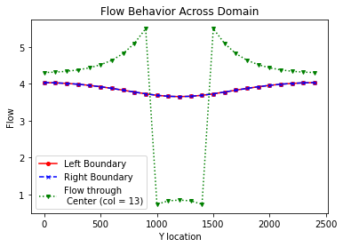

Figure 2: Flow behavior across a center column within the flow domain. The low flow zone indicates the area in the flow domain where conductivity is lower.

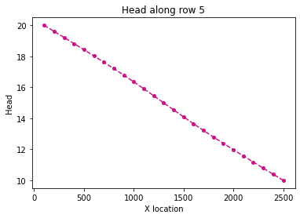

Figure 3: Head profile along the relatively homogeneous edge of the domain.

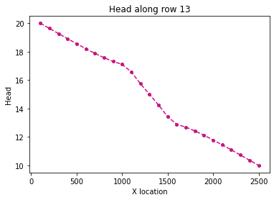

Figure 4: Head profile through the center of the low conductivity zone. Changes in slope indicate when flow passes through different conductivities in the domain.

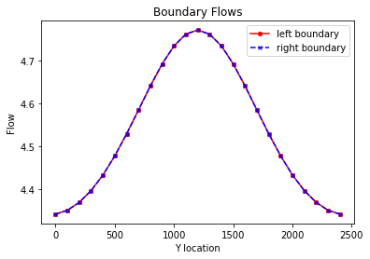

Figure 5: Boundary flows for a heterogeneous domain with a high conductivity zone in the center of the domain (K = 1 at edges, K = 100 at center). Flow is steady state as flow in = flow out.

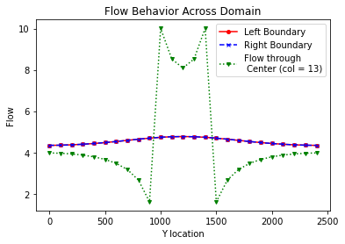

Figure 6: Flow behavior through a center column in the domain. The plot is flipped from the case of a low conductivity zone in the center of the domain.

Figure 7: Head profile along the edges of the heterogeneous domain. Plot shows relatively homogeneous behavior.

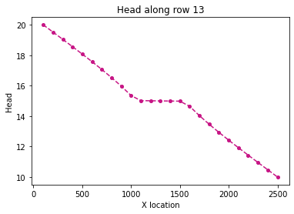

Figure 8: Head profile through the center of the high conductivity zone. The head stabilizes as it passes through the higher conductivity area and then continues to drop throughout the domain.

|  |  |  |  |  |  |  |
| --- | --- | --- | --- | --- | --- | --- |
|  |  | **K = 0.1** | **K = 0.01** | **K = 1** | **K = 10** | **K = 100** |
| **Flux in = Flux out** | | 96.64535 | 94.87048 | 104.16667 | 111.683235 | 113.3824 |
| **Keq_flux** |  | 9.664535 | 9.487048 | 10.41666 | 11.16832 | 11.33824 |
| **Keq_flux_soln** |  | 0.966 | 0.949 | 1.042 | 1.117 | 1.134 |
| **Keq_harm** | | 0.735294 | 0.201613 | 1 | 1.037344 | 1.041233 |
| **Keq_arth** |  | 0.964 | 0.9604 | 1 | 1.36 | 4.96 |

Figure 9: Flux values for each hydraulic conductivity case, as well as Keq values calculated using flux, the harmonic mean method, and the arithmetic method. Highlighted values of flux were not entirely balanced. There appear to be issues in values of Keq agreeing with each other with indicates there is likely an issue in calculation with the Keq_flux method.