**Challenge Questions**

**2.) For the initial well location, plot the total flow into the left (constant head = 20) and out of the right (constant head = 10) boundaries. (The code, as provided, makes this plot for you.)**

* **Explain why the values are not constant along the boundary (relate to the definition of a Type I boundary).**
* **Explain the shapes of the flow distributions and why they are not the same for the left (inflow) and right (outflow) boundaries.**
* **You are still modeling stead state conditions? So, what is supplying water to the well?**

Since we have set up our model with constant head boundaries at the left and right boundaries of the homogeneous domain, the flow within the domain must adjust to maintain these conditions. The presence of the well in the center of the flow domain is likely the cause of the mirrored flow behavior along the y locations (as seen below). The well is drawing some water out of the system, but since it is a lower K value than the surrounding matrix, much of the water will accelerate around that point, which is why the upstream (left) boundary exhibits the increase in flow rate at the center of the y locations. The water that has accelerated around the well is likely to remain diverted, and this could create a zone of low flow that could propagate through the remainder of the flow domain. This could cause the low flow dip that is seen in the right boundary profile on the plot below. Even though some water is lost to the well, we are still modeling steady state conditions since the inflow is still matching the outflow, and it appears that our storage is not changing. It could be that our rate of outflow from the well is small enough that any gained storage area within the flow domain is immediately filled by incoming flow. This could maintain the no-change storage conditions and keep the system steady state. There could be an unknown factor at play that is influencing the supply of water to the well that is not accounted for in this analysis.

Figure : Flow through the left and right boundaries of the homogeneous domain with the pumping well at location [0,12,12].

**3.) Plot series of the flow left-to-right along a vertical line that passes through the center of the well [:,12].**

* **How do you interpret the flow along this transect? (Hint, also look at the flow along a transect just upgradient from the well [:,11]).**

The flow through the homogeneous domain is relatively constant until just before reaching the pumping well. In column 11, as seen in Figure 2, the flow when nearing the pumping well increasing significantly. However, as soon as flow enters the well, the flow rate sees an equally large drop in magnitude (Figure 3). This could show that flow accelerates toward the well and then is withdrawn through the well resulting in the drop in flow rate at the well itself. However, there could be another explanation that I have not captured here.

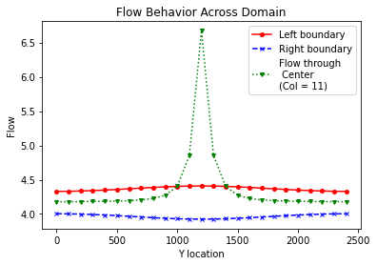

Figure : Flow through the left and right boundaries of the homogeneous domain, as well as through Column 11 (green markers). The flow through Column 11 increases significantly through the middle of the domain. This plot shows that flow increases through the center of the domain just before reaching the pumping well in Column 12 (see next figure).

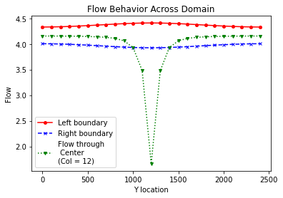

Figure : Flow through left and right boundaries of the homogeneous domain, as well as through the center column of the domain (Column 12). The flow decreases through the center of the domain. This indicates the point at which the flow reaches the pumping well.

**4.) Then, look at the plot of equipotentials (i.e. the constant head lines, this is the last plot in the example) and flow vectors. Describe how water flows through the domain. To aid in your description, draw a line through all of the flow vectors that terminate in the well. This approximates the capture zone of the well. Use this to refine your description of the flow system, being as specific as possible about where water that ends up being extracted by the well originates on the inflow boundary.**

Flow moves across the domain from left to right. It is most constant in its flow paths at the top and bottom boundaries of the homogeneous domain and exhibits much more variation the closer the flow paths come to the pumping well. The capture zone of the well is likely the area circled in red on Figure 4 as these flow vectors are the most distorted from their original horizontal position. These flows likely originated in the centermost three to five rows of the inflow boundary.

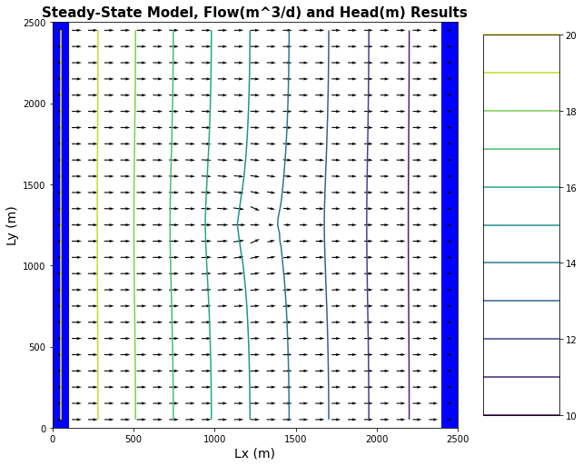



Figure : Steady state flow vectors and equipotential lines of the homogeneous domain. Well location can be noted on the plot by the presence of a low flow arrow in the center of the domain which indicates where water is being pumped from the domain. Equipotential lines can be seen to curve in response to the presence of the pumping well.

**5.) Then, look at the plan view drawdown plot.**

* **Why aren't the drawdown contours circles? Either explain why this is correct, or fix the plot.**
* **Why are the drawdown contours not equally spaced?**

The drawdown contours for the correct base model plot are somewhat oval in shape. Since the well is centered in the flow domain, it is not interacting with any other boundary conditions in the flow domain that would greatly distort the shape of the drawdown contours. As such, the well shows concentric drawdown contours that become less concentrated with distance from the well (Figure 5). This indicates that the capture zone is weakening over distance. The contours are not equally spaced as drawdown will occur more rapidly closer to the well. The greater the distance from the well, the weaker the impact of the well on the surrounding flow.

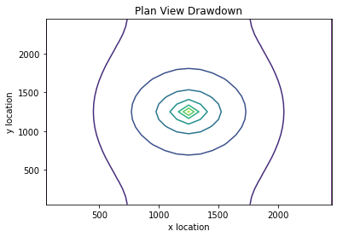

Figure : Drawdown plot of the base model for the homogeneous domain. Drawdown is constant and drawing equally from all directions as shown by the relatively concentric drawdown circles.

**6.) Move the well to [0,5,5]. Use all plots necessary to describe fully how water is flowing through the domain with the well in this location. Be sure to include the drawdown plot in your discussion - compare this plot to the equipotentials and flow vectors.**

The flow through the domain boundaries for the moved well shows different behavior than that of the original well location. There is still a high increase in flow toward the center of the well on the left boundary (see Figure 6), however there is not a matching decrease in flow on the right boundary as was seen in the base model case.

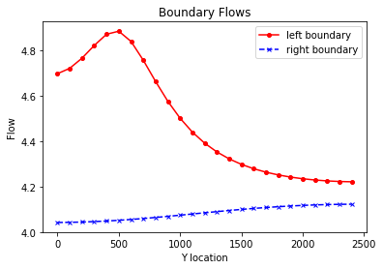

Figure : Left and right boundary flows for the homogeneous domain, with the pumping well at location [0,5,5]. Note high increase in flow through the left boundary near the center of the well.

Flow is still moving through the domain similarly to the base model case, with a high increase in flow through the column just before reaching the pumping well (Figure 7) and a large decrease in flow once the well is reached (Figure 8).

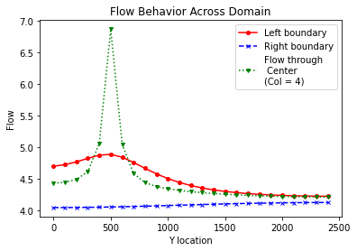

Figure : Flow through the left and right boundaries of the homogeneous domain, as well as through Column 4. Flow increases near the pumping well. Plot seems correct in shape, yet I would expect the drawdown to be further toward the 2500 end of the y-axis. Something seems wrong with the way the Y location is plotting, although I’m not sure how to fix it in the code.

Figure : Flow through the left and right boundaries of the homogeneous domain, as well as through the center of the well (through Column 5). Flow drops significantly which is consistent with flow being drawn out through the pumping well. Plot seems correct in shape, yet I would expect the drawdown to be further toward the 2500 end of the y-axis. Something seems wrong with the way the Y location is plotting, although I’m not sure how to fix it in the code.

The flow vector and equipotential plot shows that the well is now located in the upper left-hand corner of the homogeneous domain, as indicated by the distortion of the equipotential lines. The red circled area is part of the capture area of the pumping well since these flow vectors are the most different from their original flow trajectory.

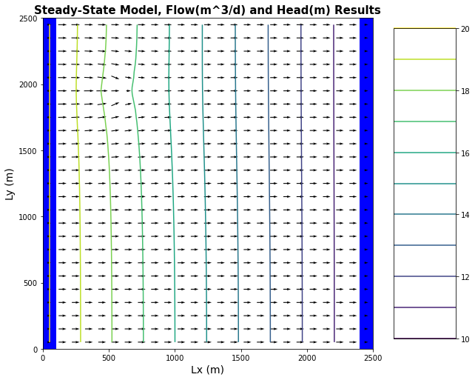



Figure : Flow vectors and equipotential lines for the moved well case. The moved well is located in the upper left corner of the homogeneous domain as indicated by the bending of the equipotential lines, and the small flow vector at the well location.

The drawdown plot of the moved well case is interesting because it shows the interaction of the well with the nearby boundary conditions. The head on the left is constant so the drawdown cannot continue expanding in that direction. This leads to more constrained drawdown near the constant head boundary. The contour lines are closer together indicating that drawdown is occurring at a faster rate on the left than on the right of the well. The equipotential lines at the top of the flow domain are perpendicular to flow because there is a no-flow boundary imposed at the top and bottom boundaries. This is what causes the drawdown contours to spread out and become relatively linear near the top boundary of the flow domain.

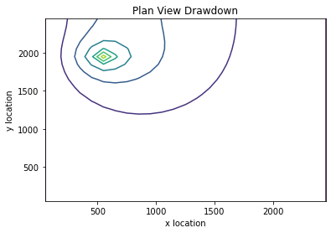

Figure : Drawdown for the moved well case in the homogeneous domain. Drawdown is asymmetric at the well with greater drawdown occurring on the left-hand side of the well, than the right-hand side.

**Glossary Questions**

**1.) What are equipotentials? How do we create them from MODFLOW Models?**

Equipotential lines are drawn perpendicular to flow vectors and indicate constant head areas within the flow domain. Everywhere along an equipotential line will have the same head value. Conceptually they can be thought of as similar to elevation contours. We can use the head values generated by MODFLOW to plot them with flow vectors and create equipotential “maps” of a flow domain. The head values for each y-column become the equipotential lines when plotted on a grid.

**2.) What are flowlines? (BONUS thought experiment: How can you impose a no flow boundary based on symmetry? Give it a shot to explain WHY this works in a couple of sentences.)**

Flowlines are lines that indicate the direction of groundwater flow on a figure or plot. They are made up of connections between individual flow vectors and are perpendicular to equipotential lines.

**3.) What are flow nets? And how does a flow net vary from a map of equipotentials with flow lines drawn on it?**

Flow nets are the network of flowlines and equipotential lines that are created by the intersection these two line types at 90° angles. They map out groundwater flow behavior in a two-dimensional, cross-sectional way. This is what makes flow nets different than a map of equipotential lines with flow lines drawn on it. The latter is, for the moment, giving us a plan view of the behavior of equipotential and flow in the X and Y directions. Flow nets would instead give us equipotential in the X and Z directions.

Figure : Examples of flow net structures and uses in modeling groundwater behavior.

**4.) Define the concept of 'capture' in a way that a non-expert might understand? (e.g. think about our homework problem, if the right boundary represented a stream, what would the impact of the well be on the stream?)**

The well is acting as a sort of straw for the groundwater. Whenever it is pumping, it is sucking up a certain amount of water. The straw can only suck up so much water depending on what the pumping rate is. A higher pumping rate means that it will pump more water out. At the bottom of the well, imagine there is a small circle. The harder you suck, the bigger the circle gets. This circle is capture. Higher pumping rates lead to greater capture.