**Base Model Figures (Well at [0,12,12])**

Figure 1: Flow through the left and right boundaries of the homogeneous domain with the pumping well at location [0,12,12].

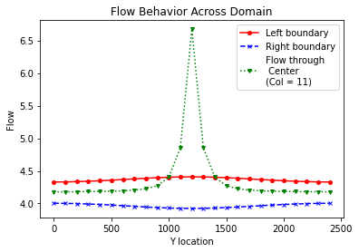

Figure 2: Flow through the left and right boundaries of the homogeneous domain, as well as through Column 11 (green markers). The flow through Column 11 increases significantly through the middle of the domain. This plot shows that flow increases through the center of the domain just before reaching the pumping well in Column 12 (see next figure).

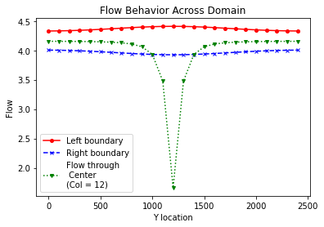

Figure 3: Flow through left and right boundaries of the homogeneous domain, as well as through the center column of the domain (Column 12). The flow decreases through the center of the domain. This indicates the point at which the flow reaches the pumping well.

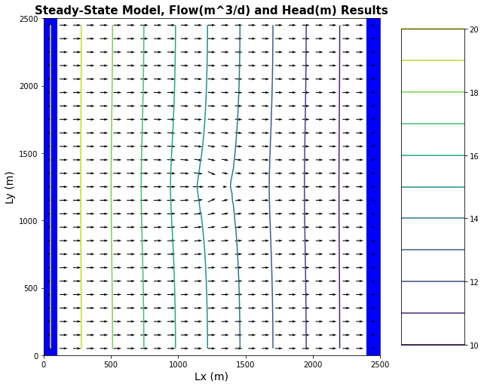

Figure 4: Steady state flow vectors and equipotential lines of the homogeneous domain. Well location can be noted on the plot by the presence of a low flow arrow in the center of the domain which indicates where water is being pumped from the domain. Equipotential lines can be seen to curve in response to the presence of the pumping well.

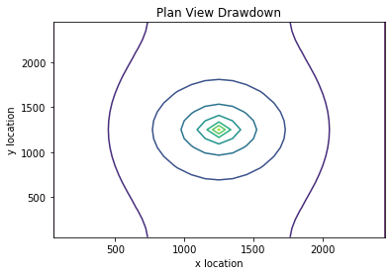

Figure 5: Drawdown plot of the base model for the homogeneous domain. Drawdown is constant, and drawing equally from all directions as shown by the relatively concentric drawdown circles.

**Moved Well Figures (Well at [0, 5, 5,])**

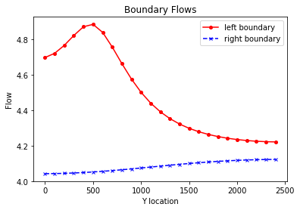

Figure 6: Left and right boundary flows for the homogeneous domain, with the pumping well at location [0,5,5].

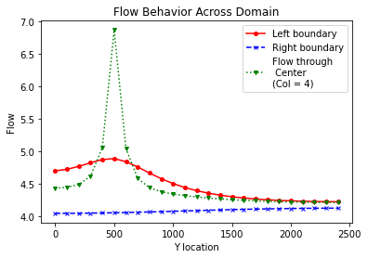

Figure 7: Flow through the left and right boundaries of the homogeneous domain, as well as through Column 4. Flow increases near the pumping well. Plot seems correct in shape, yet I would expect the drawdown to be further toward the 2500 end of the y-axis. Something seems wrong with the way the Y location is plotting, although I’m not sure how to fix it in the code.

Figure 8: Flow through the left and right boundaries of the homogeneous domain, as well as through the center of the well (through Column 5). Flow drops significantly which is consistent with flow being drawn out through the pumping well. Plot seems correct in shape, yet I would expect the drawdown to be further toward the 2500 end of the y-axis. Something seems wrong with the way the Y location is plotting, although I’m not sure how to fix it in the code.

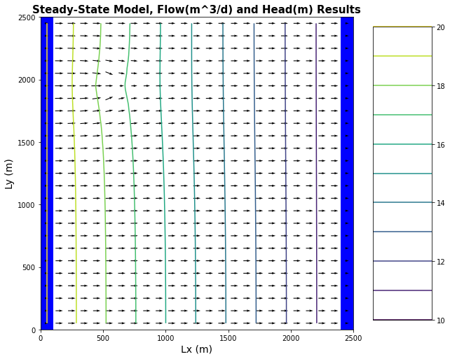

Figure 9: Flow vectors and equipotential lines for the moved well case. The moved well is located in the upper left corner of the homogeneous domain as indicated by the bending of the equipotential lines, and the small flow vector at the well location.

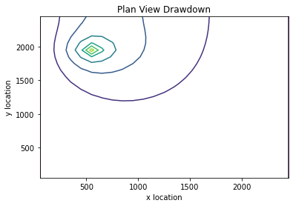

Figure 10: Drawdown for the moved well case in the homogeneous domain. Drawdown is asymmetric at the well with greater drawdown occurring on the left-hand side of the well, than the right-hand side.