**GROUNDWATER MODELING - HOMEWORK #5 Figures**

* Case #1 (Confined): Left boundary Head = 26 m, Right boundary Head = 22 m.
* Case #2 (Unconfined): Left boundary Head = 9 m, Right boundary Head = 5 m.
* Case #3 (Unconfined): Left boundary Head = 7 m, Right boundary Head = 2 m. Recharge of 1e-04 m/day across the land surface [:,:].
* Case #4 (Unconfined): Left boundary Head = 7 m, Right boundary Head = 2 m. Recharge of 1e-04 m/day in [6:10, 6:10].
* Case #5 (Unconfined): Left boundary Head = 7 m, Right boundary Head = 2 m. Recharge of 1e-04 m/day in [6:10, 6:10]. Well pumping 8 m/day in [0,10,15].

**Challenge 1:**

* Plot the equipotentials and flow lines for both simulations.

CASE 1. Confined System

Left Head Boundary = 26 m

Right Head Boundary = 22 m

CASE 2. Unconfined System

Left Head Boundary = 9 m

Right Head Boundary = 5 m

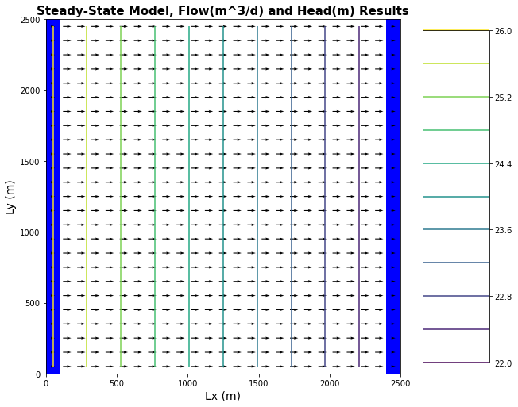 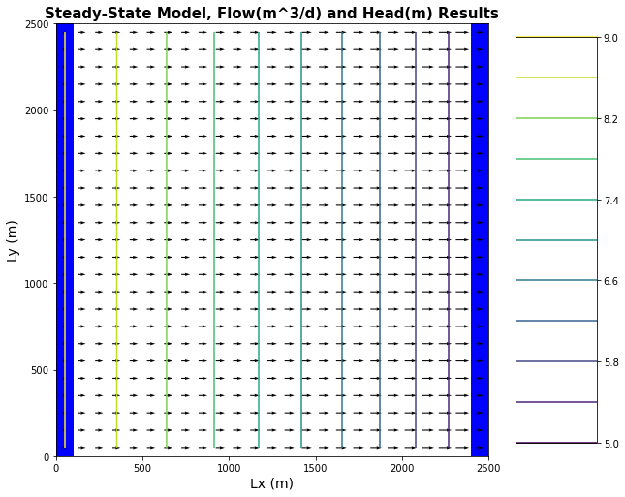

*Figure 1: Plots of equipotential lines and flow vectors for confined and unconfined aquifer models. Plot on*

*the left models confined conditions, plot on the right models unconfined conditions.*

* Describe how the two head profiles differ and explain why this is the case.

Confined: Equipotential lines will be equally spaced for the confined aquifer, because have linear change in head behavior across the flow domain.

Unconfined: Equipotential lines get closer together across the flow domain. Change in head gradient across the domain is increasing over the domain.



* Plot the head difference between the two simulations.

CASE 2. Unconfined System

Left Head Boundary = 9 m

Right Head Boundary = 5 m

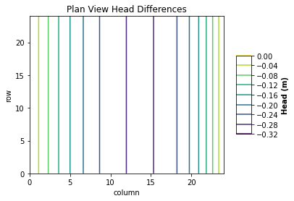

*Figure 2: Plot of head differences for unconfined aquifer model.*

**Challenge 2:**

* Report the total flux across the left and right boundaries for confined and unconfined simulations.
* Plot the flux values for the left and right boundaries for both cases.

CASE 1. Confined System

Left Head Boundary = 26 m

Right Head Boundary = 22 m

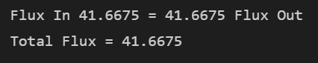

CASE 2. Unconfined System

Left Head Boundary = 9 m

Right Head Boundary = 5 m

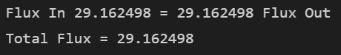

Calculations for both cases were performed in Python.

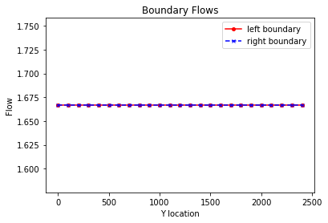 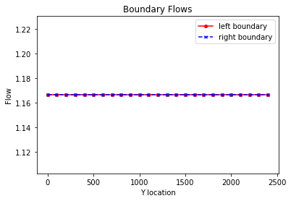

*Figure 3: Plot of flux through left and right boundary of confined aquifer model (left) and unconfined aquifer model (right).*

**Challenge 3:**

* Head transect or equipotential lines for the recharging case.

CASE 3. Unconfined System

Left Head Boundary = 7 m

Right Head Boundary = 2 m

Recharge of 1e-04 m/day across the land surface boundary [:,:].

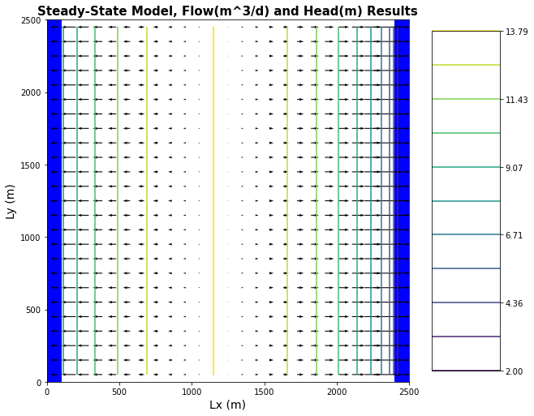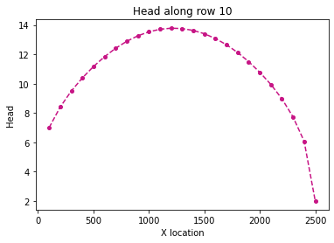

*Figure 4: Equipotential and flow vector plot (left) and head gradient plot (right) for an unconfined aquifer, Case 3 model. Left head boundary = 7 m, right head boundary = 2 m.*

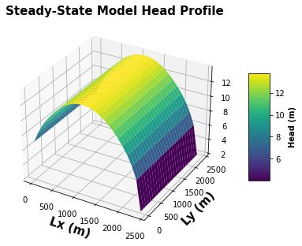

*Figure 5: Unconfined aquifer 3-D head profile for Case 3 model.*

CASE 4. Unconfined System

Left Head Boundary = 7 m

Right Head Boundary = 2 m

Recharge of 1e-04 m/day in [6:10, 6:10].

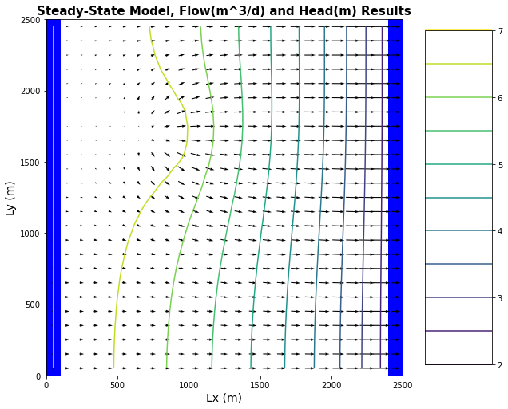 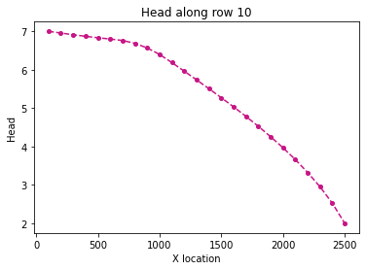

*Figure 6: Equipotential and flow vector plot (left) and head gradient plot (right) for an unconfined aquifer Case 4 model. Left head boundary = 7 m, right head boundary = 2 m.*

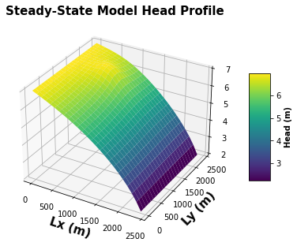

*Figure 7: Unconfined aquifer 3-D head profile for Case 4 model. Note the location of the recharge area, [6:10, 6:10], by the lighter yellow head zone in the upper left corner of the flow domain.*

* Plot the flux values for the left and right boundaries for both cases.

CASE 3. Unconfined System

Left Head Boundary = 7 m

Right Head Boundary = 2 m

Recharge of 1e-04 m/day

in [:, :].

CASE 4. Unconfined System

Left Head Boundary = 7 m

Right Head Boundary = 2 m

Recharge of 1e-04 m/day in [6:10, 6:10]

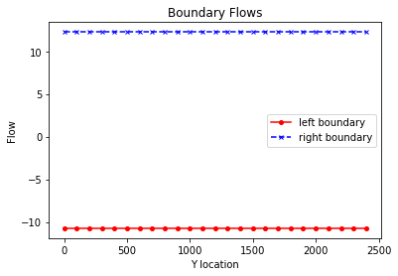 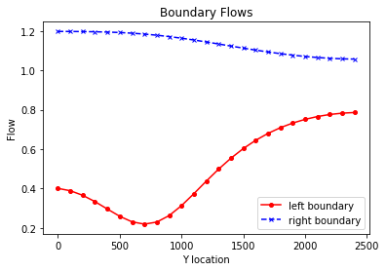

*Figure 8: Unconfined aquifer left and right boundary flows for Case 3 (left) and Case 4 (right). Case 3 is under recharge conditions across the whole land surface of the aquifer. Case 4 only has recharge in the area [6:10, 6:10].*

**Challenge 4:**

* Report the total excess irrigation applied per year in m.
* Report the total calculated irrigation per year and your assumed efficiency rate.
* Plot the flux values and equipotential lines and annotate them with the potential contamination zone

CASE 4. Unconfined System

Left Head Boundary = 7 m

Right Head Boundary = 2 m

Recharge of 1e-04 m/day in [6:10, 6:10].

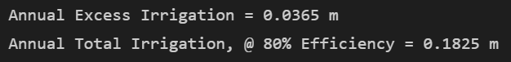

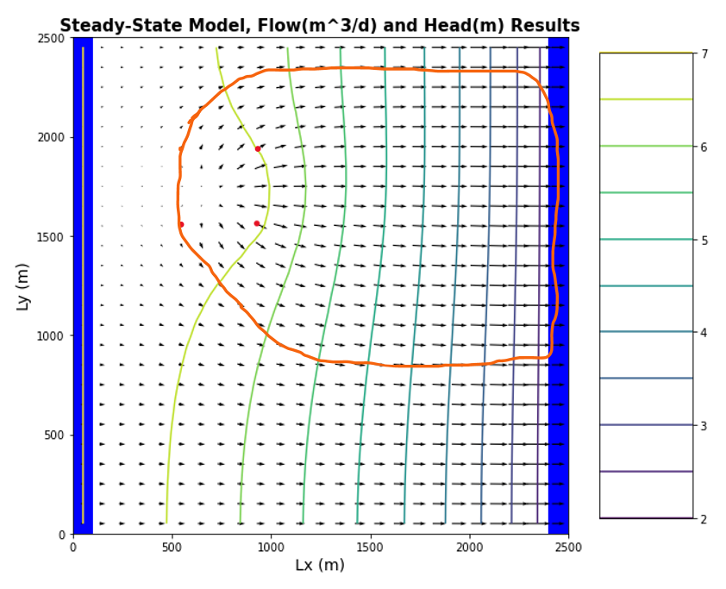

*Figure 9: Case 4 flux vectors and equipotential lines. Red dots indicate the corners of the recharge area, and orange lines represent the potentially contaminated zone within the aquifer.*

**Challenge 5:**

* Plot the annotated flux plot showing contamination and capture zones in different colors.

CASE 5. Unconfined System

Left Head Boundary = 7 m

Right Head Boundary = 2 m

Recharge of 1e-04 m/day in [6:10, 6:10].

Well @ [0,10,15], pumping at a rate of 8 m/day.

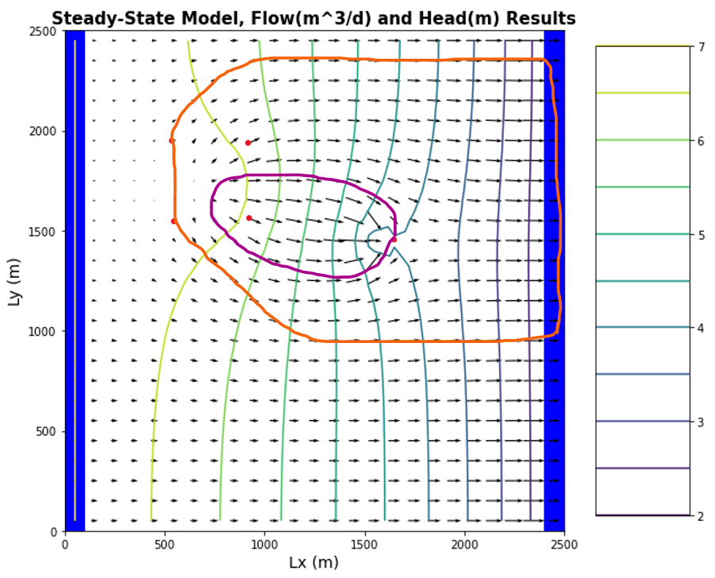

*Figure 10: Case 5 flux vectors and equipotential lines, with the addition of a pumping well at [0,10,15] . Red dots indicate the corners of the recharge area and the dot furthest to the right marks the location of the pumping well. Orange lines represent the potentially contaminated zone within the aquifer, purple lines indicate the potential capture zone of the well.*

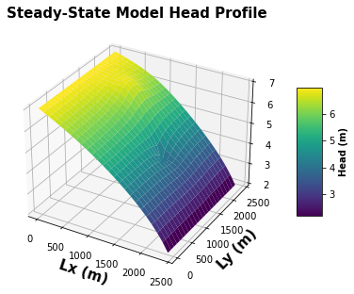

*Figure 11: Case 5 head profile. Yellow area in the upper-left corner indicates the recharge zone. Blue dip in center-right marks pumping well at [0,10,15].*