**Challenge Questions**

**Challenge 1: For the initial boundary head values and recharge and ET rates:**

* **plot the flow across the left and right boundaries.** **Explain what you see and why it makes sense.**

Figure 1: Flow across the left and right boundaries of the homogeneous domain. Flow across the left boundary drops considerably near the y-location of the recharge zone. With this decrease on the left boundary there is an accompanying slight increase along the right boundary.

The flow decreases along the left boundary, especially as it nears the recharge zone within the flow domain. This is due to the constant head boundaries at play and the need to preserve steady state conditions in the system. Water is being instantaneously added to the system in the recharge zone, so the incoming flow through the left boundary (red line above) must decrease to compensate for the added water. The right boundary (blue line above) sees an increase in flow as a result of these changes as well.

* **Plot the equipotentials and flow vectors in plan view and outline (hand draw) the area that would be affected by recharge (i.e. if it were contaminated). Explain what you are seeing and why.**

Figure 2: Equipotential lines and flow vectors for the initial model parameters. Recharge area is marked by red dots. Potential contamination zone is marked by orange circled area.

The recharge zone is relatively small, but the flow paths moving away from this area carry the potentially contaminated water much further away through the flow domain. This creates a large contaminant plume within the groundwater area, as shown by the orange circled area on the plot above.

* **Plot ET, Recharge, and Water Table depth and explain why we see the patterns we do.**

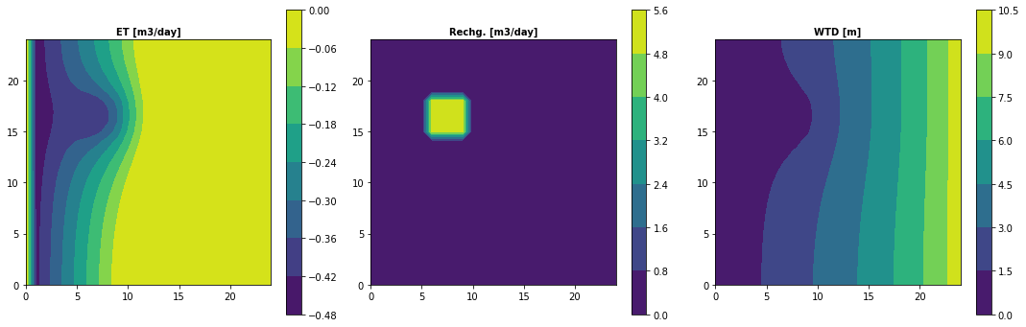

Figure 3: Plot shows evapotranspiration rate, recharge rate, and depth to the water table for the homogeneous domain. Evapotranspiration is very low in most of the domain, but is prominent near the recharge zone. Area of high recharge is noted by the yellow region in the middle chart. Depth to the water table is lowest at the left side of the domain and around the recharge zone, and increases toward the right side of the domain.

For the plot above (Figure 3) the evapotranspiration (ET) extinction depth is set to 3 m. This means that ET will be zero when the water table is below 3 m. The first plot above shows the behavior of ET in the model. The middle plot shows the area where recharge is occurring in the flow domain. The last plot shows the variation of water table depth (WTD) throughout the homogeneous domain. The linear connection between ET and water table depth is clearly visible when comparing the ET and WTD plots above. With an extinction depth of 3 m, we would expect the ET to approach zero when the WTD is greater than 3 m. The water table depth reaches 3 m at about the 10th cell into the domain. This is also approximately where the ET reaches zero. These plots, therefore, show a clear connection between ET and WTD.

**Challenge 2: Calculate the water balance for the model.**

* **Explain what controls each term in your water balance.**

$$F_{in}=total flow into the system$$

$$F_{out}=total flow out of the system$$

$$f_{L}=total flux through the left side of the domain$$

$$f_{R}=total flux through the right side of the domain$$

$$R=total recharge into the system$$

$${ET}_{t}=total ET affecting the system$$

$$F_{in}=f_{L}+R$$

$$F_{out}=f_{R}-{ET}_{t}$$

$$F_{in}=F_{out}$$

$$F_{in}=\left(106.444 m^{3}/day\right)+\left(80.000 m^{3}/day\right)$$

$$F_{out}=\left(116.093 m^{3}/day\right)-\left(-70.352 m^{3}/day\right)$$

$$F_{in}=F_{out}$$

$$186.444 m^{3}/day=186.444 m^{3}/day$$

The flux terms $\left(f_{L} \&{ f}_{R}\right)$ in the water balance above are controlled by the constant head boundaries at the left and right of the flow domain. These terms will adjust as needed as the model changes in order to maintain steady state conditions. Total recharge $\left(R\right)$ is controlled by user input but will remain constant between simulations as needed. For our assignment, the total recharge is a sum of the recharge rate over each of the cells it is applied across. This gives us a constant recharge of 80 m3/day for the assignment. Total evapotranspiration $\left({ET}_{t} \right)$ is a sum of the ET flux rate we set in the model parameters multiplied over the total domain area. For the signs to balance, the ET was subtracted from the right flux because ET has a negative value. The total inflow $\left(F_{in} \right)$ is a result of the fluxes entering the system, and the total outflow $\left(F_{out} \right)$ accounts for all the fluxes leaving the system. These two terms should balance if the system is steady state.

**Challenge 3: Change the extinction depth in your model**

* **Extinction Depth = 10 m**
$$F_{in}=\left(147.906 m^{3}/day\right)+\left(80.000 m^{3}/day\right)$$

$$F_{out}=\left(73.793 m^{3}/day\right)-\left(-154.113 m^{3}/day\right)$$

$$F_{in}=F_{out}$$

$$227.906 m^{3}/day=227.906 m^{3}/day$$

* **Explain what changed and why.**

All the terms in the new water balance equation represent the same parameters. The increase in the extinction depth of the model allows for greater evapotranspiration within the domain. This is shown by the more negative ET rate seen in this case than in Challenge 2. The left and right boundary fluxes also adjusted accordingly to balance the increase in ET. The left boundary flux is much higher, whereas the right boundary flux is much lower. The recharge remains the same.

**Challenge 4: Now start the well pumping, extracting 20 m3/day**

* **Plot the equipotentials and flow vectors in plan view and outline (hand draw) the area that would be affected by recharge (i.e. if it were contaminated)** **and explain why we see the patterns we do.**
* **How does the well change the zone that is affected by the recharge area?**

Figure 5: Equipotential lines and flow vectors for the homogeneous domain where the ET extinction depth is 10 m and a pumping well is active in the homogeneous domain. The pumping well is located at [0,10,15] and is pumping at a rate of 20 m3/day. The recharge zone of the aquifer is marked by a square of red points and the well is marked by another red point to the right of this zone. The potential contamination area from the recharge is outlined in orange.

The addition of the pumping well causes some of the flow lines (Figure 5) emerging from the recharge zone to bend toward the pumping well rather than all of them continuing away toward the right boundary of the domain. A small portion of the contaminated flow will be captured by the pumping well.

* **Plot ET, Recharge and Water Table depth**
* **How does the well affect the ET map?**

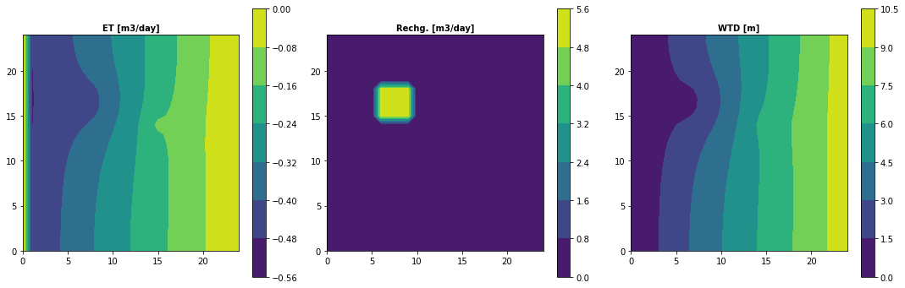

Figure 6: Plot shows ET, recharge, and depth to the water table for a homogeneous domain with an active pumping well. The recharge zone present in the domain can be noted on all three charts in the top left corner of each plot. The pumping well can be seen on both the ET and WTD plots as there are slight bumps in the opposite direction to those caused by ET on each plot.

The well is clearly visible on both the ET and the WTD plots above (Figure 6). The extinction depth is now 10 m, so the relationship between ET and WTD is still at play. The ET begins to drop off once the WTD reaches 10 m or so.

**Challenge 5: Write a mass balance for the well**

$$F_{in}=total flow into the system$$

$$F_{out}=total flow out of the system$$

$$f_{L}=total flux through the left side of the domain$$

$$f_{R}=total flux through the right side of the domain$$

$$R=total recharge into the system$$

$${ET}_{t}=total ET affecting the system$$

$$W=total water removed by well from the system$$

$$F_{in}=f_{L}+R$$

$$F_{out}=f_{R}-{ET}_{t}-W$$

$$F_{in}=F_{out}$$

$$F_{in}=\left(153.165 m^{3}/day\right)+\left(80.000 m^{3}/day\right)$$

$$F_{out}=\left(64.532 m^{3}/day\right)-\left(-148.633 m^{3}/day\right)-\left(-20 m^{3}/day\right)$$

$$F_{in}=F_{out}$$

$$233.165 m^{3}/day=233.165 m^{3}/day$$

* **How much water is coming from a boundary? How much is originating as recharge? How do you account for the impact of ET on this mass balance?**
* **At steady state, what are the effects of 'capture' by the well?**

All the terms in this water balance equation represent the same parameters as previous equations, with the addition of a well term $\left(W\right)$ which represents the pumping rate of the well. The increase in the extinction depth of the model to 10 m still allows for greater evapotranspiration within the domain. The left and right boundary fluxes also adjusted to balance the increase in ET. The left boundary flux is higher, whereas the right boundary flux decreased. The recharge remains the same as all other scenarios. The effect of capture is very low.