**Model Structure & Overview**

X = 0 m

X = 2500 m

Y = 2500 m

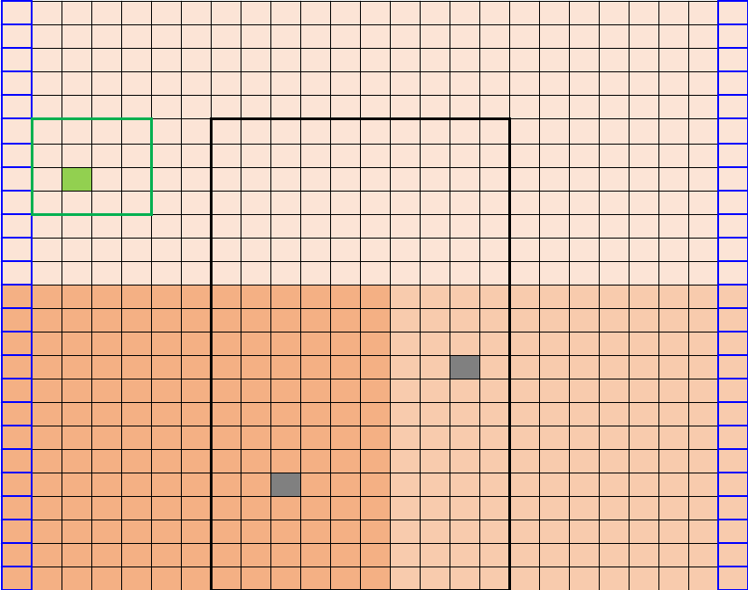

Z = 1500 m

Z = 0 m

Z

Y

X

Constant Head Boundary = 1495 m

Constant Head Boundary = 1455 m

Y = 0 m

K = 1

Direction of Flow

2

1

K = 8

K = 13

Figure : Conceptual model of the area around Wildcat and ACME farms. Each cell in the domain has the x-y-z dimensions 100 m x 100 m x 1500 m. Constant head boundaries are located along the left and right edges of the flow domain. A higher head value is set along the left boundary than the right boundary in order to induce flow from left to right within the system. Constant head boundary values were adjusted during some scenarios of the model, but all scenarios model unconfined flow (i.e., where head values are lower than the depth of Z layer). The hydraulic conductivity values of the domain are indicated by the orange background in each of the three areas within the domain. Wildcat Farm is indicated by the green outlined area and the well on its property is noted by the green cell. ACME Farm is outlined in Black, and its two proposed wells are indicated by the two gray cells.

The conceptual model above (Figure 1) illustrates the design of the farm model used for the three Wildcat and ACME Farm scenarios. The model grid has dx = dy = 100 m, and dz = 1500 m, so each cell in the model has the x-y-z dimensions 100 m x 100 x 1500 m. The total width and height of the domain is 2500 m x 2500 m since there are 25 rows and 25 columns in the domain. This grid resolution was selected to make the sizes of the farms of reasonable coverage within the model surface area. The z depth was selected to ensure the model ran appropriately despite changes to other model parameters.

Constant head boundaries at the left and right sides of the model domain were set at 1495 m (left boundary) and 1455 m (right boundary). These values were selected to model a water table difference of 40 ft between the two edges of the flow domain. These constant head boundaries ensure that the model is set up to operate under steady-state conditions. Hydraulic conductivity values were inferred from data taken at the observation wells at each corner of the model surface. The selected values are similar to, but not exactly the same as, the observed values taken at the observation wells. The top half of the domain was assumed to have a homogeneous hydraulic conductivity of 1 m/d. The southwest corner of the domain had a hydraulic conductivity of 13 m/d and the southeast corner had a hydraulic conductivity value of 8 m/d.

Pumping rates and recharge for the wells in the flow domain for the first two runs of the model were calculated using the equations below:

$$C_{c}=cotton consumptive use=41.2 in/yr$$

$$C_{a}=alfalfa consumptive use=74.3 in/yr$$

$$CE=irrigation efficiency coefficient$$

$$I_{W}=irrigation rate for Wildcat Farm (m/d)$$

$$R_{W}=recharge rate for Wildcat Farm (m/d)$$

$$I_{A}=irrigation rate for ACME Farm (m/d)$$

$$R_{A}=recharge rate for ACME Farm (m/d)$$

$$C_{c}=0.00287 m/d$$

$$CE=0.8$$

$$I_{W}=\frac{C_{c}}{CE}$$

$$I_{W}=\frac{\left(0.00287 m/d\right)}{\left(0.8\right)}$$

$$I_{W}=0.00358 m/d$$

$$R_{W}=\left(0.00358 m/d\right)*\left(1-0.8\right)$$

$$R_{W}=0.000717 m/d$$

$$C_{a}=0.00517 m/d$$

$$CE=0.8$$

$$I_{A}=\frac{C_{c}}{CE}$$

$$I_{A}=\frac{\left(0.00517 m/d\right)}{\left(0.8\right)}$$

$$I_{A}=0.00646 m/d$$

$$R_{A}=\left(0.00646 m/d\right)*\left(1-0.8\right)$$

$$R_{A}=0.00129 m/d$$

The irrigation rates (IW and IA) that were found above were multiplied by the areas of Wildcat and ACME Farms, respectively, to find the total pumping rates needed to supply the crops for each farm. The pumping rate for ACME Farm Well 1 was multiplied by 2/3, and ACME Farm Well 2’s rate was multiplied by 1/3. This was due to the assumption that 2/3 of the water on the farm would be supplied by the well in the highest K zone, and 1/3 of the water would be pumped by the well in the next highest K zone. The recharge values calculated in these equations were also applied to each farm area, and a background recharge of 1e-4 was applied to all of the non-irrigated areas in the flow domain. Only the recharge values calculated above were applied to the farm areas. Background recharge was not included in the total recharge values for the two farms. No evapotranspiration (ET) was incorporated into the domain for the first two runs of the model. However, an ET value of 100 m/d was added to the third run of the model to attempt to dry Wildcat Farm’s well. This value was selected at random.

Run 1 of the model used the parameters outlined in the preceding paragraphs. Run 2 differed from this baseline model by having a different set of K values and a lower crop irrigation efficiency value for ACME Farm. The top half of the domain for Run 2 was assumed to have a homogeneous hydraulic conductivity of 2 m/d. The southwest corner of the domain had a hydraulic conductivity of 10 m/d and the southeast corner had a hydraulic conductivity value of 8 m/d. For this run the irrigation efficiency value for ACME Farm was lowered from 0.8 to 0.4. For Run 3 of the model, a single homogeneous K field of K = 5.975 was used instead of three K values. Additionally, instead of calculating the pumping and recharge rates using the equations above, the consumptive water use for each farm was assumed to be equal to total irrigation. For this iteration of the model, it was also assumed that there was no excess recharge resulting from irrigation. Recharge across the farm areas was set to the background value of 1e-4. ET was added into the third model run as well at a value of 100 m/d with an extinction depth of 100 m.

**Model Run 1**

The first run of the model was used as the baseline model from which each of the other two scenarios were adjusted. The chart below (Figure 2) shows the visible recharge that was produced within the bounds of each farm, as well as some variation in the water table depths along the boundaries of the hydraulic conductivity zones (Figure 3).

Figure : Plots of total recharge and water table depths across the heterogeneous flow domain. Recharge is taken as a total of all recharge values entering the domain. Water table depths can be seen to deflect in the center of the domain where the K values change from K = 1 to K = 13 and K = 8 (all K values are in m/d).

Figure 3 shows the deflection in the water table depths lines up with changes in hydraulic conductivity within the flow domain.

Figure : Hydraulic conductivity distribution for the heterogeneous flow domain. The top half of the domain has K = 1 m/d, the SW corner has K = 13 m/d, and the SE corner has K = 8 m/d. Boundaries between K regions correspond to deflections in water table depths seen on Figure 2.

The model is operating under steady-state conditions, as equations to balance the inflows and outflows of the model confirmed (see Section 11.6 in ipynb). The outcome of this version of the model shows that pumping at the ACME wells will have minimal effect on water levels at Wildcat Farm (Figure 4).

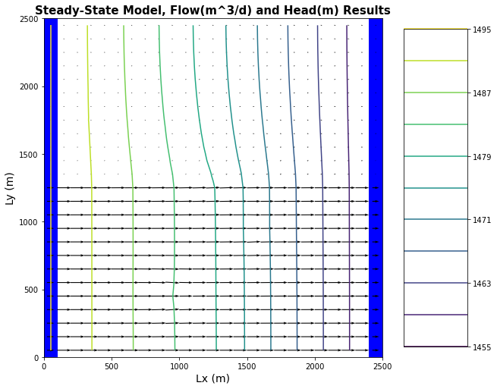

Figure : Flow lines and equipotential head lines of Run 1 of the heterogeneous model. Minimal flow can be seen through the low K zone in the top half of the domain, and much higher flow can be seen through the higher K zones in the bottom half of the domain. Effect of pumping at ACME_Well1 can be seen near the (1000, 500) point on the chart above, in the curvature of the equipotential line. The effect of pumping at ACME_Well2 can be seen slightly near (1500, 900). Pumping on Wildcat Farm is not visible due to the low flow values present in the top half of the flow domain.

Due to the makeup of the hydraulic conductivities in the subsurface there is not much flow around Wildcat Farm’s well, however, the depths to groundwater shown in Figure 2 indicate that the well is still fully supplied even with pumping on ACME farm. This run of the model does not take into account ET.

**Model Run 2**

The slightly different hydraulic conductivities and lower crop irrigation efficiency for the ACME farm crops had a slight difference on the model results compared to Run 1. The decrease in irrigation efficiency increased both the total pumping rate of the ACME farm wells as well as the amount of water being recharged to the aquifer. The amount of overall recharge across the domain was increased dramatically as can be seen in Figure 5. Note that recharge on Wildcat Farm is no longer distinguishable from the background recharge. This is likely due to the increase in the recharge scale as the maximum recharge is now 80 m3/d compared to a maximum of 14 m3/d during Run 1.

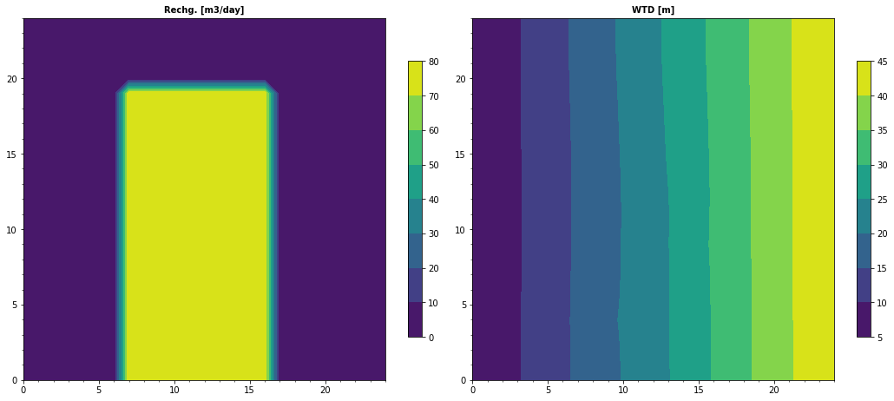

Figure : Recharge and water table depth charts for Run 2 of the model. The decrease in irrigation efficiency from 0.8 to 0.4 resulted in higher overall recharge across the domain. The changes made to hydraulic conductivity values in Run 2 seem to have evened out the distortions seen in water table depths during Run 1 (Figure 2). Effects of pumping at ACME wells 1 & 2 can be seen near (10, 5) and (15, 10) on the water table depth chart above. Overall water table depths were not affected by the changes to the model.

The deflection seen in the Model Run 1 water table depth chart as a result of the hydraulic conductivity values are not as prominent in the second run of the model. The effects of pumping on ACME Farm are more noticeable on the water table depth chart, than in Run 1. This is likely due to the increased pumping rate produced by the decrease in irrigation efficiency. The crops will only use about 40% of the water pumped out for irrigation so most of that water is returned to the aquifer as recharge. The irrigation efficiency was decreased by half, which resulted in a doubled pumping rate to meet demand. The effects of the doubled pumping rate on ACME Farm can be seen on the equipotential plot below (Figure 6). ET was not included in Run 2 of the model.

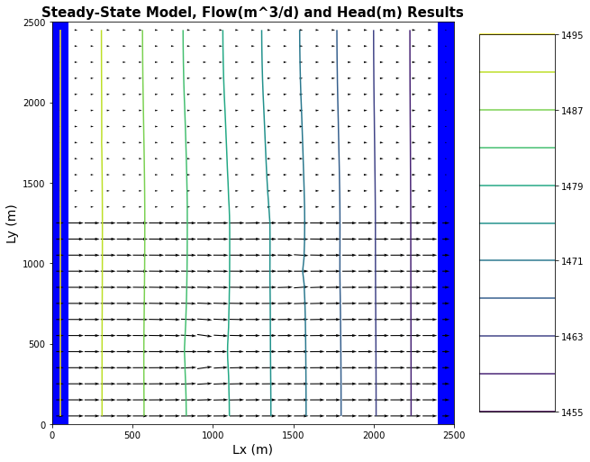

Figure : Run 2 equipotential and flow lines for a heterogeneous system. Doubling the pumping rate on ACME farm has caused more noticeable deflection of the flowlines in the model toward the wells than in Run 1.

**Model Run 3**

The third run of the model was very different than the first two runs and created the only situation of the three in which Wildcat Farm’s well ran dry. First, the K values were normalized to a homogeneous value of 5.975 across the entire domain rather than multiple values in a heterogeneous system (as in Runs 1 and 2). Then, rather than calculating the total irrigation values using the equations above (p. 2), the consumptive use of each crop used on the respective farms was used as the irrigation rates. This change in irrigation source resulted in lower pumping rates for both farms than either of the previous two scenarios. There was assumed to be no additional recharge resulting from the irrigation of the crops, so the background recharge value of 1e-4 m/day was applied to the entire domain. This run of the model accounted for ET by applying a background ET value of 100 m/day with an extinction depth of 100 m to the whole domain. These changes from the baseline model parameters in Run 1 yielded much lower water table depths when compared to Run 1 and 2 (see Figure 7).

Figure : Plot of ET, recharge, and water table depths in a homogeneous flow domain.

This figure shows that the zones of greatest ET correspond to the locations where the water table is shallowest. The WTD of 90-105 is consistent with the 100 m extinction depth of the ET and explains why there is minimal ET in that region of the domain. The WTD on the left side of the domain is lower than 20 m underneath Wildcat Farm’s well, so the well will go dry in this scenario. ACME Farm’s wells have a screening depth of 200 m, so they are both still deep enough to access water 105 m deep. A 3D profile of the head values provides more information about head and flow behavior in the domain (Figure 8).

Figure : Homogeneous domain, 3D head behavior plot.

The sharply sloping edges of the domain are likely affected by the constant head boundaries, however the middle of the domain shows that the flow patterns are mostly constant along the extinction depth of the ET (indicated by the flat region in the middle of the figure). Water flows into the middle of the domain and is removed from the system by the pumping wells on ACME farm (Figure 9). This system is still in steady state, although there seems to be a slight error in the calculation. This is shown by the significant figures being off by a small amount (see Figure 10).

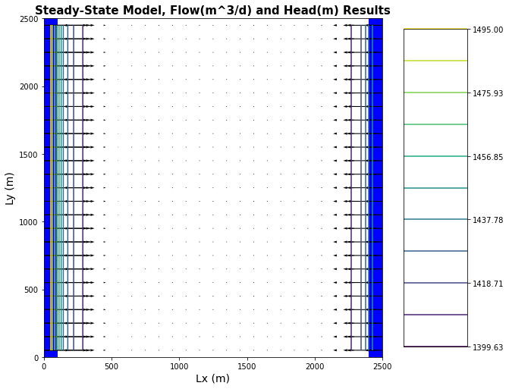

Figure : Equipotential and flow lines for Run 3 of the model. Flow lines point toward the center of the model from both sides of the domain. The system is still at steady state, so water is being removed from the system by the wells on ACME Farm.



Figure : Steady state inflow and outflow totals for Run 3 of the model. Numbers essentially balance, but are off by a couple of significant figures.

**Conclusions**

Based on the outcomes of the three models, the best-case scenario would be the outcome of the first run of the model. Model Run 2 provides a slightly less advantageous result for ACME Farm. Since Run 2 reduces the crop irrigation efficiency, ACME Farm may decide to drill another well to compensate for their water needs. This could put Wildcat Farm’s well at risk. Run 3 of the model provided the most information about potential conditions under which the Wildcat well might go dry. However, ET would need to be included in all three models to truly compare the results in an unbiased way.

**Glossary questions**

1. What does it mean to be simulating saturated flow vs variably saturated flow? What are the advantages and disadvantages of each? Why is it much harder to solve for unsaturated flow? Integrate the concept of a linear versus a nonlinear model into your answer.
2. What is meant by an internal source/sink for ground water flow and how is it different than a boundary condition? Give an example.

3. What is meant by ‘forecast uncertainty’ in the context of a groundwater model? What are the sources of this uncertainty? What is required for a prediction to be as robust as possible?