**\*\*Please know that planning El Dia and Earth Week events is compromising my work in all classes and research. Spring break will help some, will carve more time to dive deeper into building HW7 model\*\***

**Challenge 1**

1. **Plot the flow across the left and right boundaries. Explain what you see and why it makes sense. (Figure 1)**

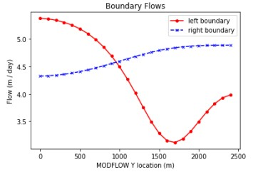The left boundary experiences its greatest flux at the bottom (y=0) but takes a parabolic dip to a minimum at y=1600. The right boundary has less fluctuation with a slight increase along the y-axis. ET occurs across the whole domain at an order of magnitude lower than the recharge, which is localized in the upper left quadrant of the domain. This manifests in a reduction of flow because the head gradient decreases.

1. **Plot equipotentials and flow vectors in plan view and outline the area**

**that would be affect by recharge if** *Figure 1 Flow across left and right boundaries***contaminated. Explain what you are seeing and why. (Figure 2)**

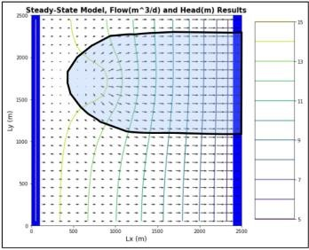Flux is driven by hydraulic gradient, dh/dl. The reduced head at the localized point of recharge decreases the amount of lateral flow and allows it to spread tangentially until it is far enough from that point. Then the flow vectors become parallel again as the head gradient increases and becomes more even. So, the contamination zone is dictated by the rate of recharge and distribution of head equipotentials. The zone stops growing when the head gradient becomes more even again.

1. **Plot ET, recharge, and water table depth and explain what you are**

**seeing and why. (Figure 3)**

*Figure 2 Equipotentials and flow vectors for extinction depth 1 meter* Background ET is constant at 5e-5 m3/day.

The whole domain would be yellow if there were no recharge. The gradient shown is the introduction of recharge and how it reduces ET loss. The water table depth corresponds to this distribution; closer to the ground surface where recharge is occurring, and deeper where it is not.

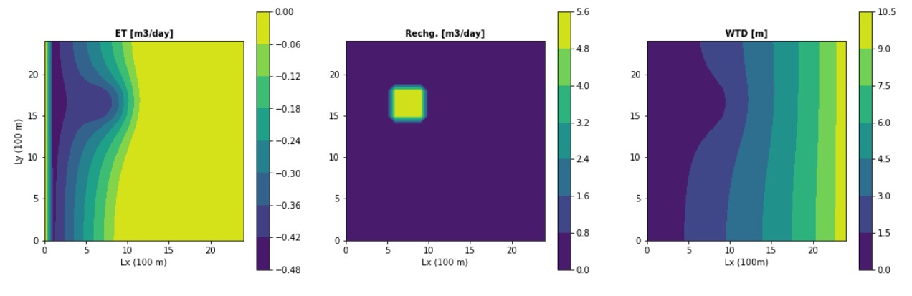

*Figure 3 ET, Recharge, and WTD for extinction depth 1m*

**Challenge 2: Calculate the water balance for the model (Figure 4) and explain what controls each term in your water balance.**

Sources: Q_in and Recharge

Sinks: ET

Q_in is controlled by the assigned constant head gradient. Q_in plus recharge equals the total flux introduced into the system. ET is a sink that, with Q_out, balances the equation.

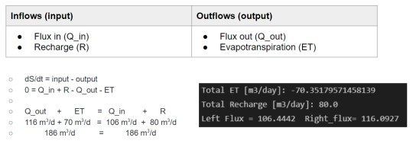

*Figure 4 Water balance for extinction depth 1 m*

**Challenge 3: Change the extinction depth in the model (changed to 1 m)**

1. **Report the new water balance numbers (Figure 5)**
2. **Plot the new head contours and fluxes (Figure 6)**
3. **Explain what changed and why**

Extinction depth defines the water level at which ET will become zero. In our first run of the model the extinction depth was 3 meters. Now, it is one meter. This means that ET will have less impact on the domain because the water table will quickly trigger the change to zero ET.

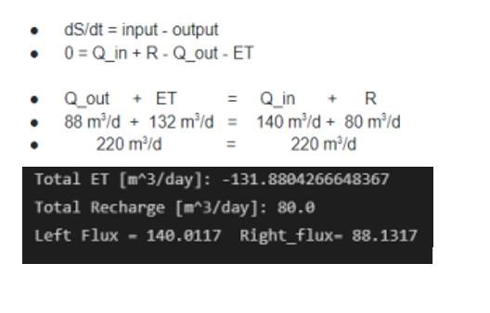

*Figure 5 Water balance for extinction depth 8m*

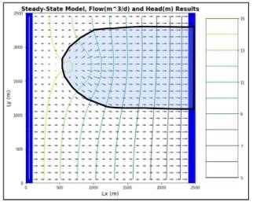

*Figure 6 Equipotentials and flow vectors for extinction depth 1m*

**Challenge 4: Pumping well at -20 m3/day, extinction depth at 8 meters to compare**

1. **Plot equipotentials and flow vectors in plan view and outline the area that would be affected by recharge if contaminated (Figure 7)**
2. **Plot ET, recharge, and water table depth and explain the patterns (Figure 8)**

Extinction depth = 8m, pumping = -20 m3/day, ET = 5e-5, recharge = 5e-4

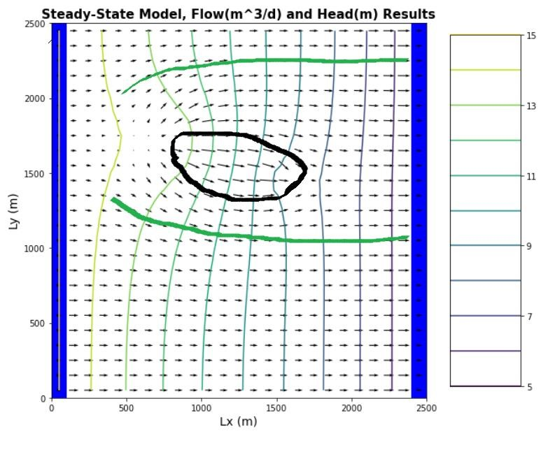

*Figure*

*7*

*Exti*

*nction dep*

*th of 8m for*

*contra*

*st; equipotentials and flow vectors*

The change in extinction depth significantly increases the amount of loss to ET because it remains active for as long as it takes the water table to drop the additional 7 feet. The relationship between ET and water table depth also increases the rate of water table decline.

1. **How does the well change the zone that is affected by the recharge area?**

The well captures only a small portion of the contamination and is largely circumnavigated by the recharged flow. For full remediation there would need to be a line of two to three wells transecting the domain.

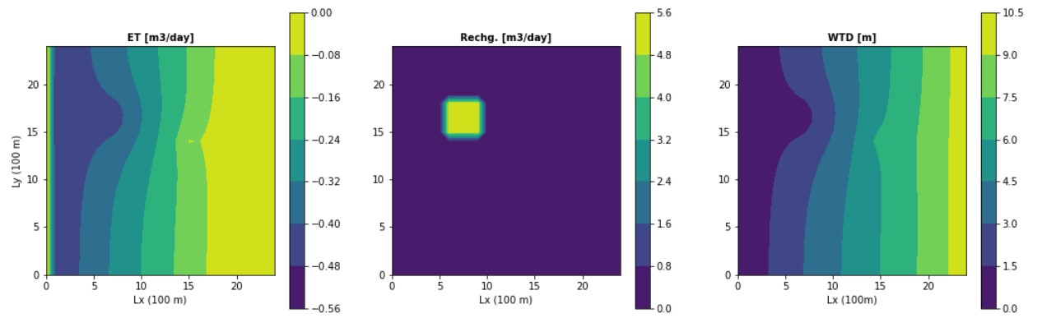

*Figure 8 ET, recharge, and WTD for extinction depth 8m*

1. **How does the well affect the ET map?**

The well creates a localized zone of reduced ET, likely because the drawdown accelerates the water table exceeding the extinction depth and reaching zero ET.

**Challenge 5: Write a mass balance for the well**

Total ET = -131.88 m3/day

Total recharge = 80.0 m3/day

Left flux = 88.13 m3/day

Right flux = 140.01 m3/day