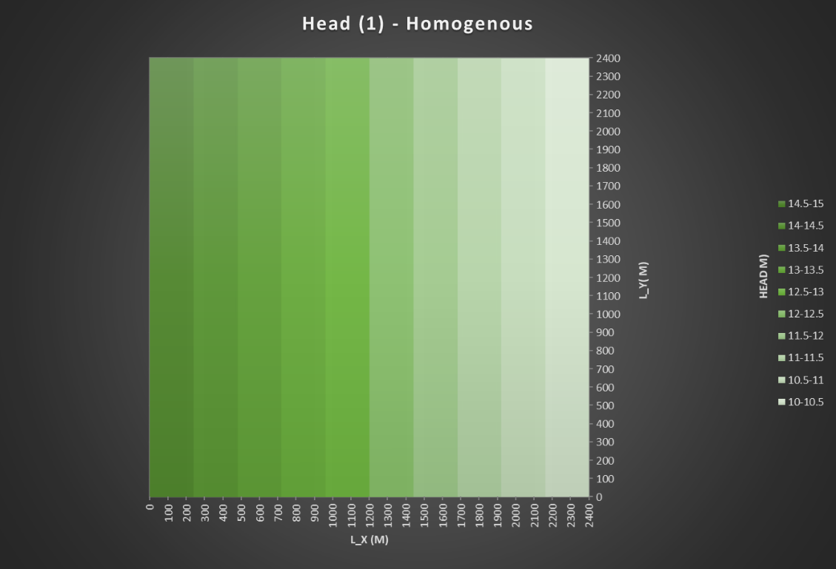

Figure 1 Homogenous K-values with horizontal flow

Figure 2 Heterogenous K-values with horizontal flow

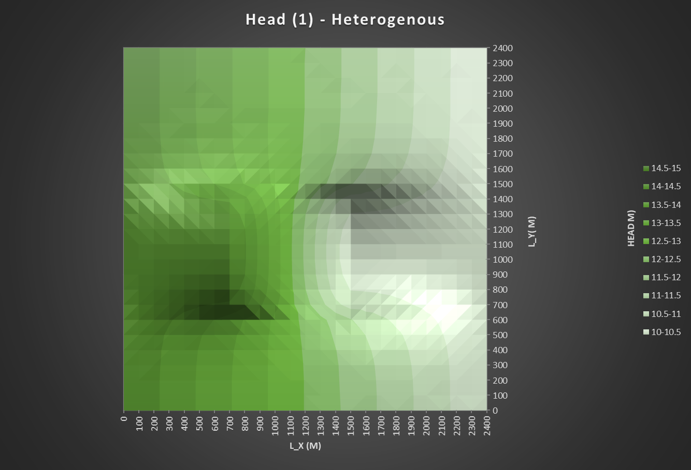

Figure 3 Heterogenous K-values in central box format with horizontal flow

Figure 4 Conceptual model of flow through homogenous K-value soil