**HW7 – Model Report**

**Summary:**

Model description: The grid resolution used in the model is 100 x 100 x 300 meters (dx, dy, dz) and the dimensions are 25 x 25 x 1 (columns, rows, layers). This resolution was chosen to simplify the solving process while preserving an accurate level of real-world representation. *Note: This resolution renders Wildcat Farm with a smaller area, 9e4 m2 as opposed to 1.21e5 m2. To accommodate this simplification, the recharge rate was increased to contribute an equivalent volume of water between the model area and reality.*

Parameter selection: The parameters selected for the model in all scenarios were: an ET rate of 5e-5 m/d with an extinction depth of 9m because there is little variation in non-irrigated acreage (NIA) vegetation across all three scenarios; consumptive use of 2.87e-3 m/d for cotton grown on Wildcat Farm and 5.87e-3 m/d for alfalfa grown on ACME Farm Corporation because the question specifically asked to evaluate these two crop choices; background recharge of 1e-4 m/d because of observed seasonal averages; soil porosity of 0.35, specific yield of 0.3, and specific storage of 0.001 from best available data; and type 1 boundary conditions on the western and eastern boundaries with respective specified head values of 295m and 248m which were inferred from the four observation wells provided in the initial study.

Pumping rates: Pumping rates were obtained using the following formula:

where,

*C­c* = consumptive use, m/d

*Ai* = irrigated acreage, m2

The coefficient, 1.2, can be decomposed into 1 which represents the consumptive volume of water and 0.2 is the chosen fraction that could be expected to recharge the water table.

Pumping rate for Wildcat Farm remained constant in all scenarios at 4.18e2 m3/d because there was never a question of their needs changing.

Meanwhile, ACME Farm Co. pumping rates changed depending on the scenario which will be explained later in the report under the scenario discussion section.

**Discussion:**

Scenario 1: Hydraulic conductivities were obtained from observation wells and a gradient was generated to reflect a rough K-value distribution in the model area, as seen in Figure 1. The pumping rate for ACME Farm Co. was obtained using the formula mentioned in the *Pumping Rates* subsection above and pumping effort was divided between the two pumps according to the following table.

|  |  |  |
| --- | --- | --- |
| Pump Name | Location | Pumping rate (m3/d) |
| ACME well 1, q1 | (0, 22, 9) | -8.367e3 |
| ACME well 2, q2 | (0, 13, 13) | -4.183e3 |
| Wildcat well, wc_q | (0, 8, 2) | -4.181e2 |

The pumping effort was split between the ACME wells to take advantage of the hydraulic conductivity in the lower portion of the model where K-values are higher so the lower well, q1, is pumping two thirds of the irrigation needs and the upper well, q2, pumps the remaining one third. There spatial distribution was chosen to allow a sufficient distance between the two ACME wells, with consideration for the Wildcat well, q3.

In this scenario, Wildcat Farm’s well does not go dry as seen in Figure 2 because the head contour shows a value of 288m well into the model’s interior which suggests the 20m deep Wildcat well can still access the water table. The third plot, *WTD [m]*, in Figure 4 corroborates this conclusion because the 18m WTD band reaches even further into the model, safely assuring the availability of water for Wildcat Farm. In fact, ACME Farm Co.’s wells have little effect on the water table near Wildcat Farm (-0.8m to -1.6m) as seen in Figure 3 which shows the head difference between the model and a linear drop in head across the domain.

Scenario 2: In this scenario, the hydraulic conductivities were the same as in scenario 1, see Figure 1 or 5. The pumping rate for ACME and Wildcat wells were also kept constant. However, in this second scenario, an injection well as was added to simulate a scenario where the a nearby farmer uses CAP water to develop long-term storage credits.

|  |  |  |
| --- | --- | --- |
| Pump Name | Location | Pumping rate (m3/d) |
| ACME well 1, q1 | (0, 22, 9) | -8.367e3 |
| ACME well 2, q2 | (0, 13, 13) | -4.183e3 |
| Wildcat well, wc_q | (0, 8, 2) | -4.181e2 |
| CAP well, cap_q | (0, 14, 3) | 2e3 |

This has surprisingly little effect on the system as can be seen in a comparison between Figure 3 and Figure 7 which makes sense because the boundary conditions are kept the same which results in less flow passing through the left boundary to satisfy the head gradient across the system. Wildcat Farm once again does not have to worry about the WTD falling too deep out of reach of their well. In fact, some of the only difference that can be observed is in the first plot of Figure 8, *ET [m3/d]*, which shows a slight extension of evapotranspiration occurring due to the input of water from the injection well.

It is shown, however that the injection well affects drawdown downgradient of the two ACME wells, however. Above the upper well and between both of the ACME wells, there is less drawdown difference observed in Figure 7 than can be seen in Figure 3 but east of the lower ACME well, there is a greater head difference. This makes sense because the lower well is intercepting the injection water input, but this means the injection well is supplying a lot of water to both wells.

Scenario 3: In this scenario, there is no more injection well and the ACME pumping rates have decreased to reflect a policy decision requiring drip irrigation in non-Active Management Area agricultural lands that irrigate water intensive crops. *Note: Recharge was kept the same to preserve the model from crashing.* Furthermore, the domain was set to a homogenous K-value of 3 m/d to see if there could be any significant influence expected from overestimating K-value distribution.

|  |  |  |
| --- | --- | --- |
| Pump Name | Location | Pumping rate (m3/d) |
| ACME well 1, q1 | (0, 22, 9) | -5.05e3 |
| ACME well 2, q2 | (0, 13, 14) | -5e3 |
| Wildcat well, wc_q | (0, 8, 2) | -4.181e2 |

This scenario preserves the WTD even further into the interior of the model as seen in the third plot of Figure 11. In fact, there is a WTD of 12m well into the middle of the model which provides Wildcat Farms with the largest assurance that they will have plenty of water as necessary to irrigate their cotton.

In Figure 10, we can see the low K-value soil result in large head differences around the ACME wells which can be expected but the cones of depression around the ACME wells were so extreme, that there was little room to increase pumping rate if the farm needed.

**Recommendations:**

In these three scenarios, no conditions explored produced negative outcomes for Wildcat Farm that dropped the water table depth to below 20m within its well location. As such, there are little recommendations to make to Wildcat Farm to prevent a lack of access to water. In all three scenarios, however, the most likely outcome would be the third scenario because there are current talks to update water policy for irrigators not utilizing drip irrigation and crops that are water intensive. Furthermore, the K-value distribution utilized in the first two scenarios are not very demonstrative of actual distributions. Thus, the homogenous and averaged value of 3 m/d used across the domain would be most likely.

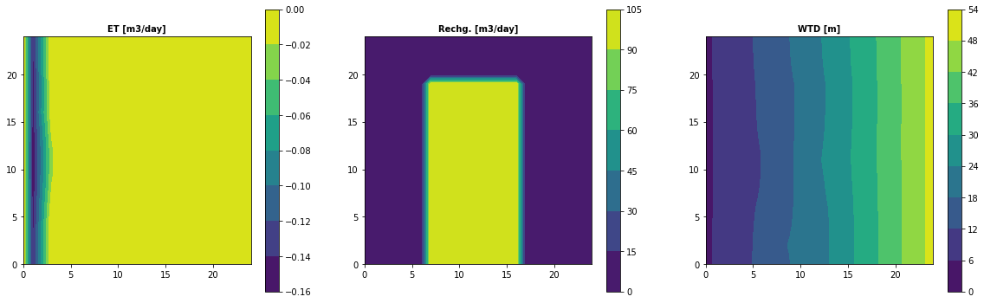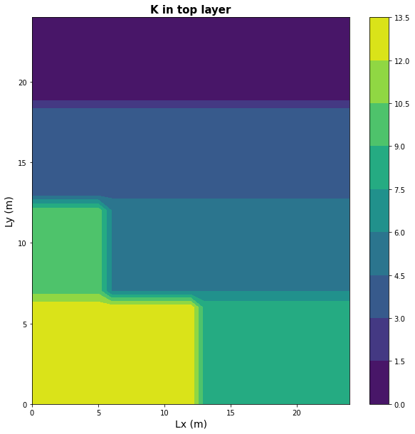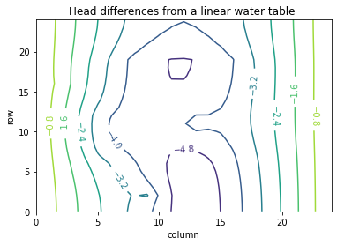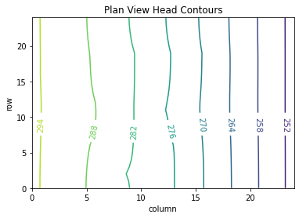Scenario 1 figures

Figure 1

Figure 3

Figure 2

Figure 4

Scenario 2 figures

Figure 8

Figure 5

Figure 7

Figure 6

Scenario 3 figures

Figure 11

Figure 10

Figure 9