**Well at initial location**

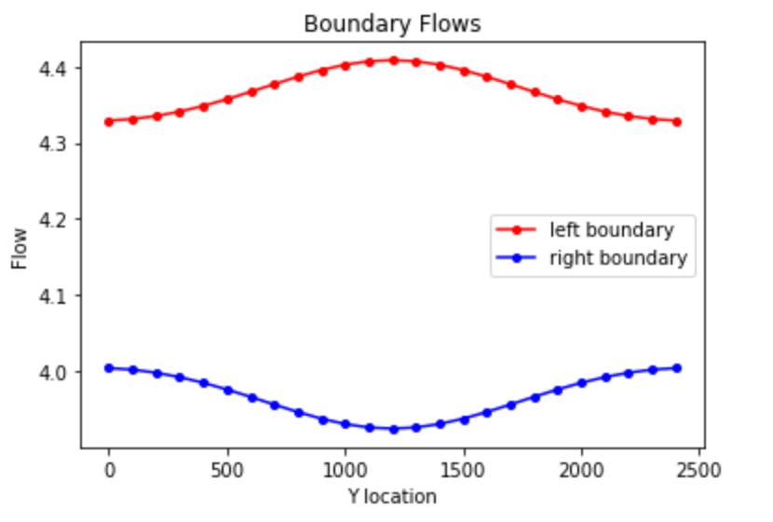

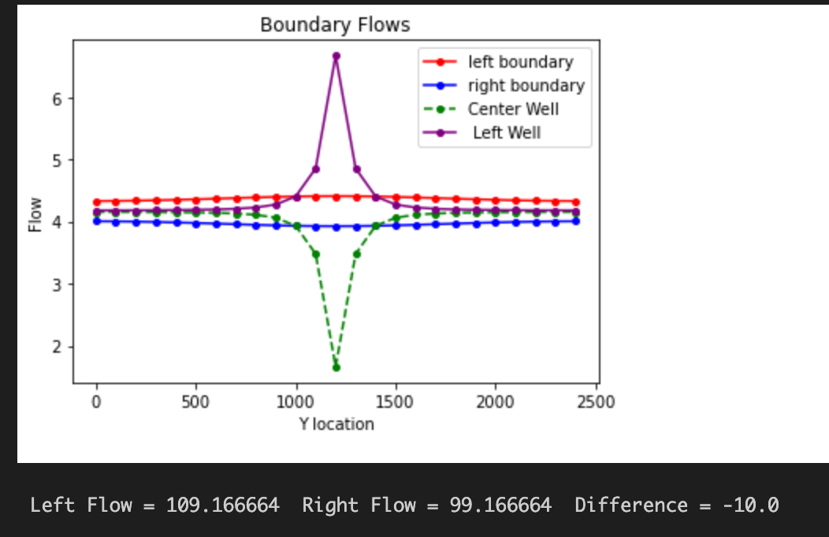

**Figure 1: 1a)** Base case boundary flows for the initial location of the well. **1b)** Base case flux through the midline of the domain. **1c)** Equipotential lines with flow vectors through the midline of the domain. **1d)** Base head contours and plan drawdown at the pumping rate of -10 m 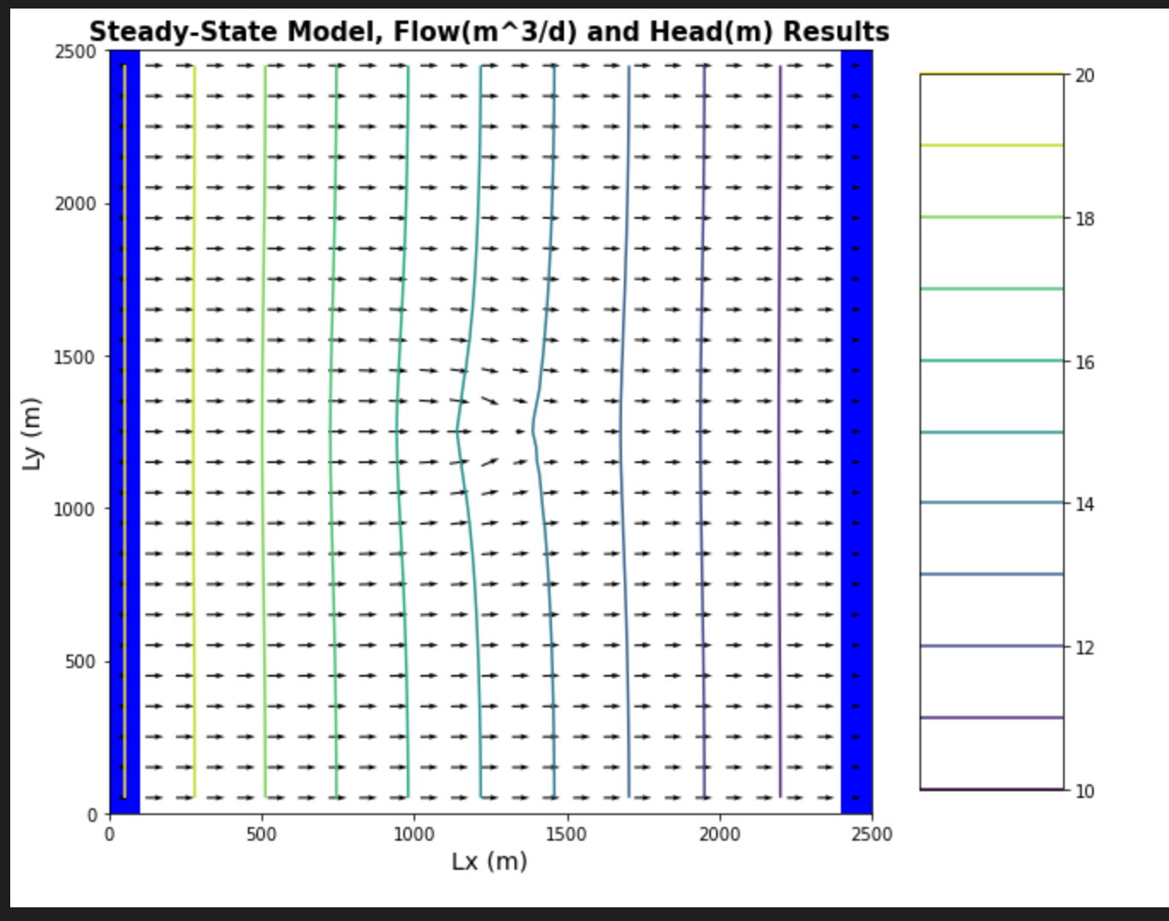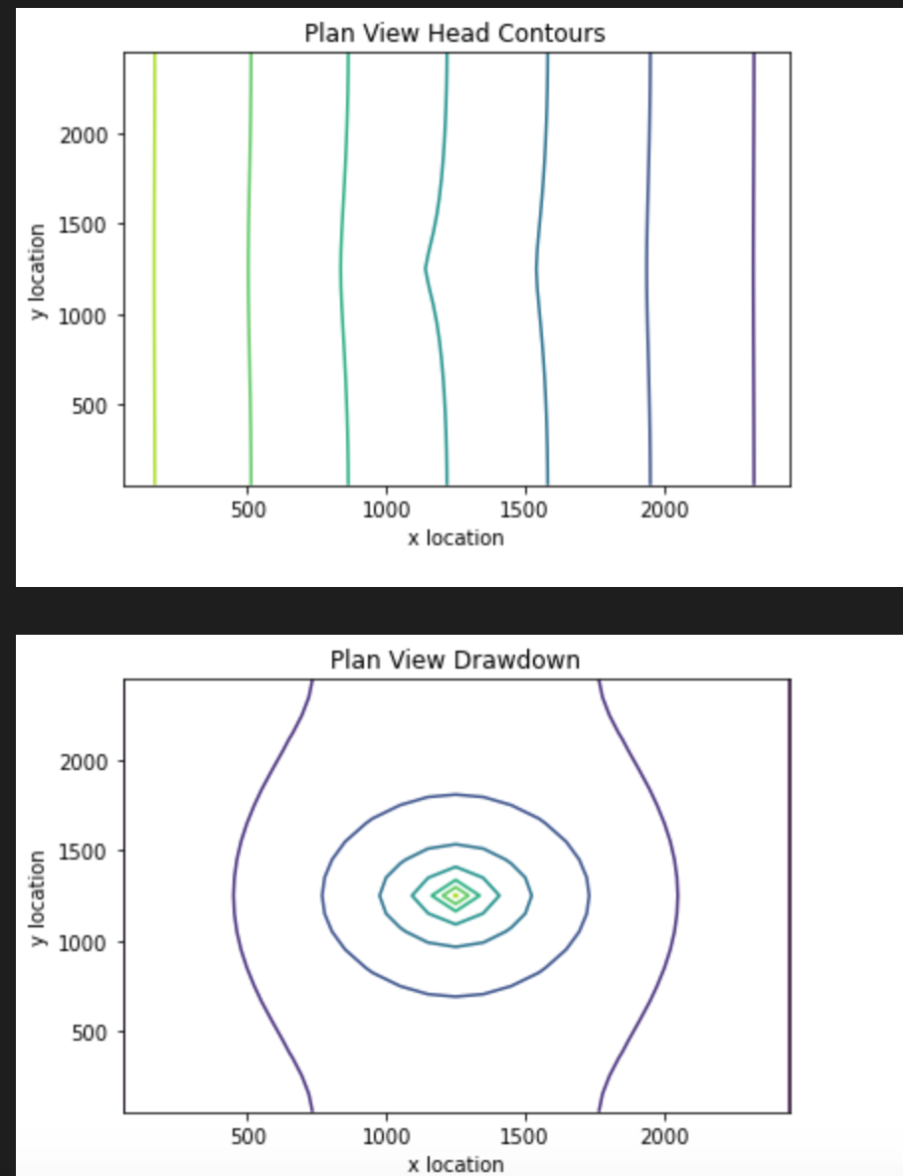

**Moved well**



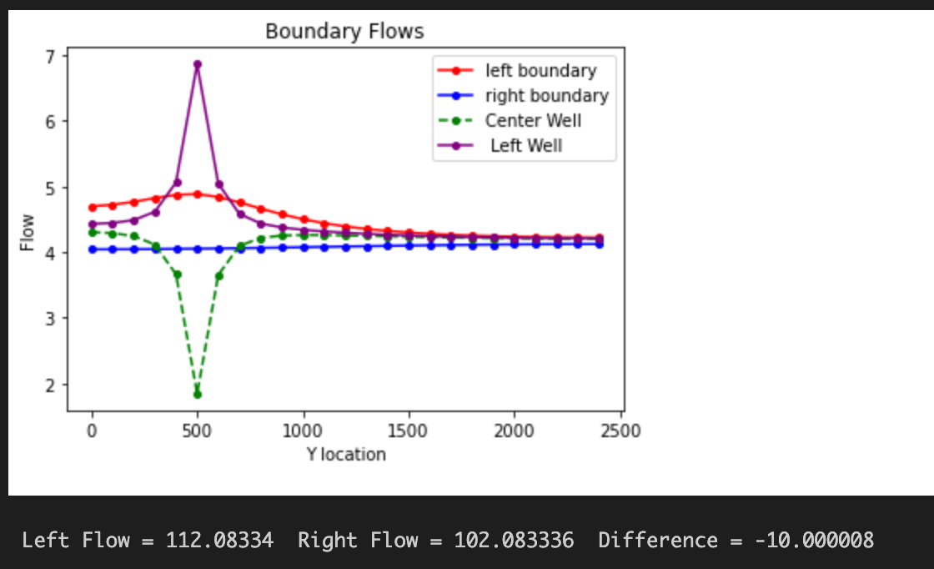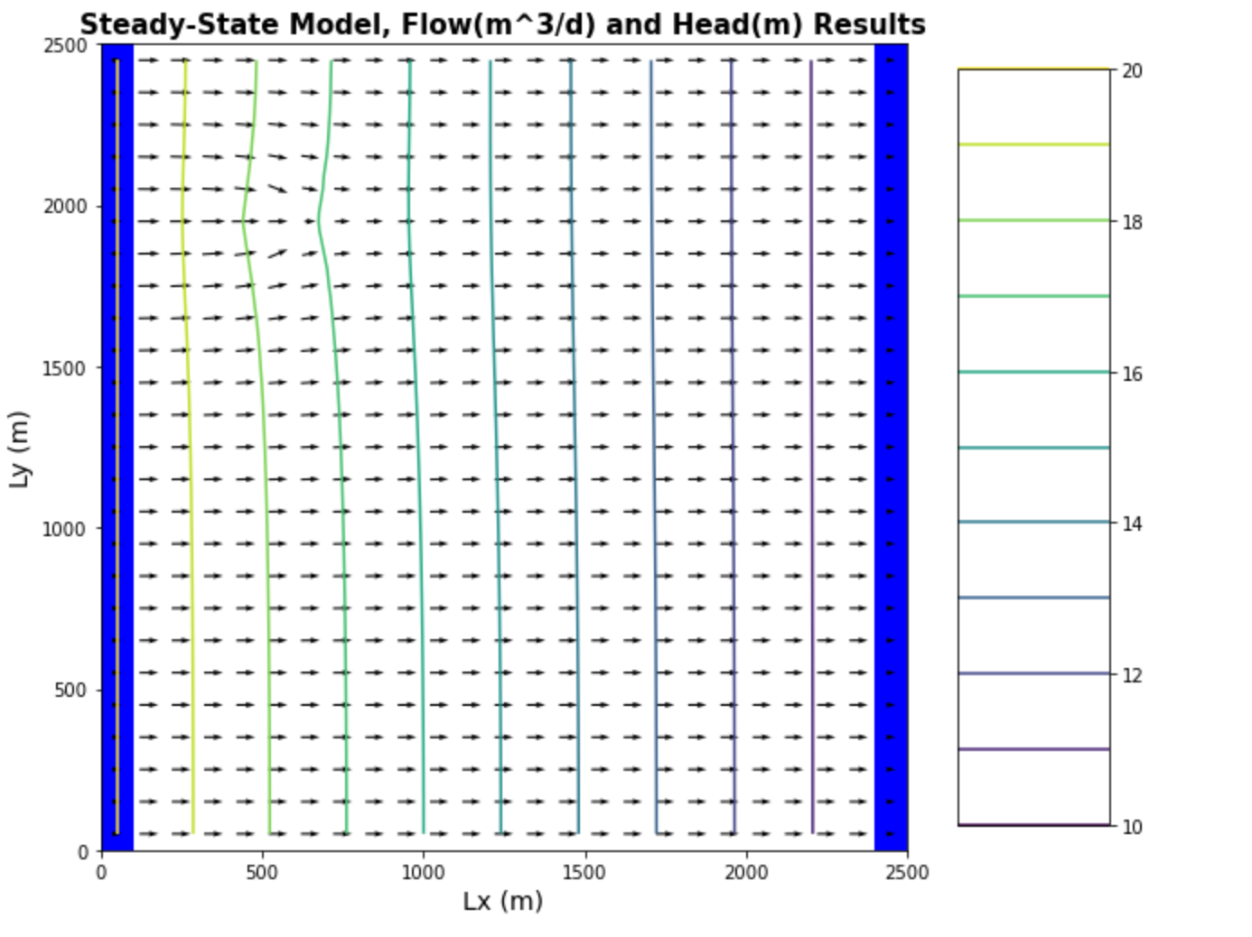

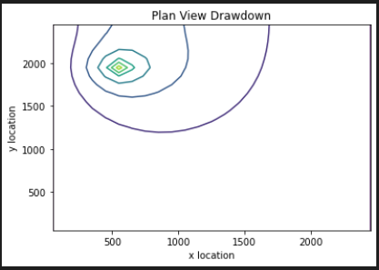

**Figure 2: 2a)** Equipotential lines with flow vectors for the moved well. **2b)** Base case boundary flows for the moved well. **2c)** Head contours and plan drawdown at the pumping rate of -10 m for the moved well

**BONUS FIGURES:**

**Pumping Rate - 5 m^3/day:**

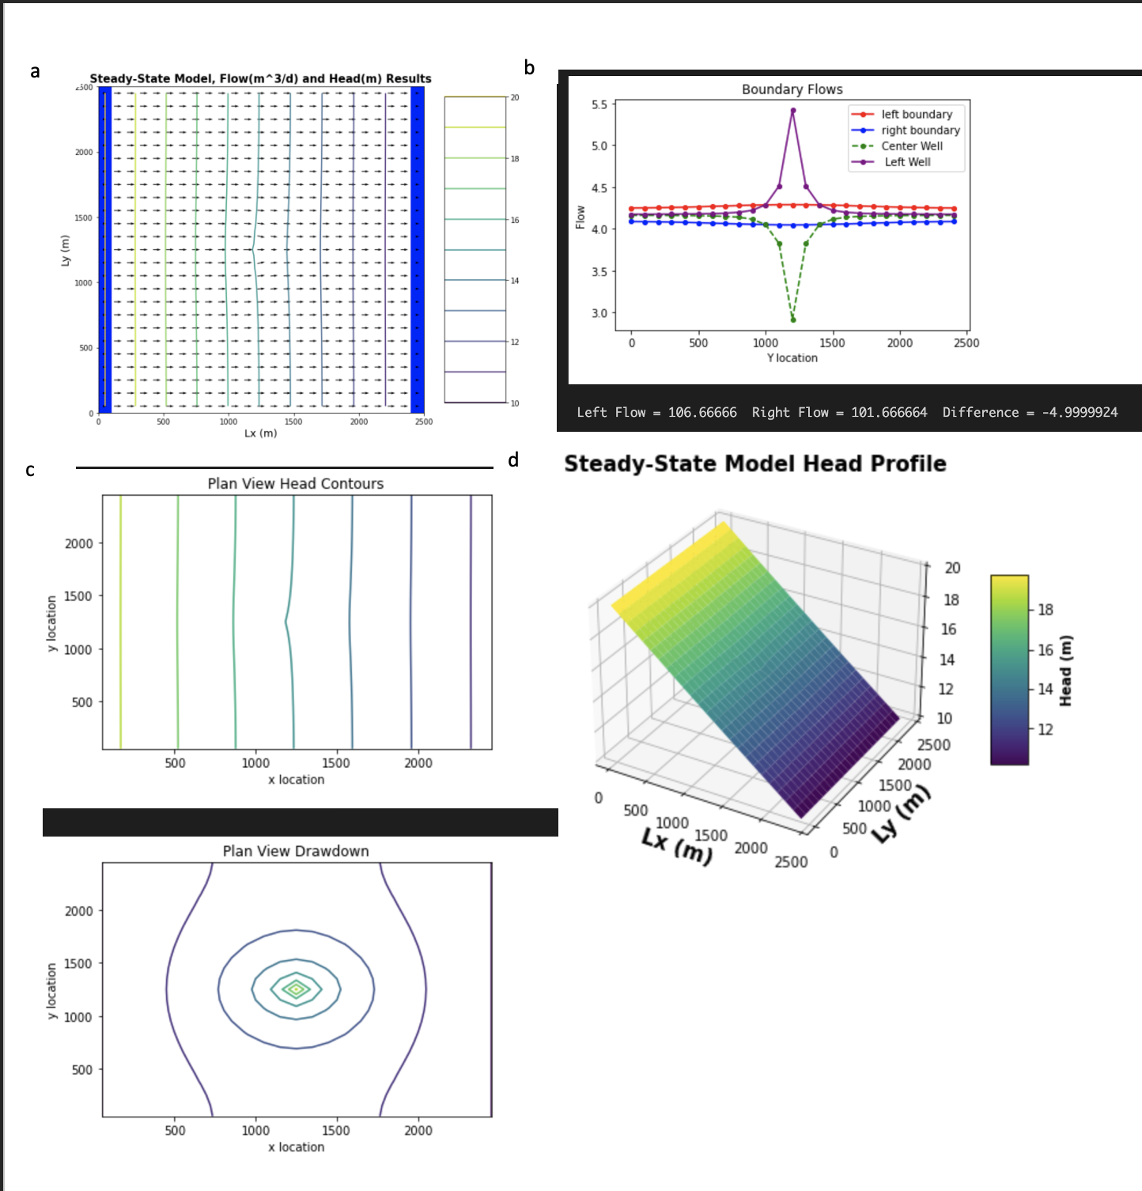

**Figure 3: 3a)** Equipotential line plot with flow vectors for the moved well with a pumping rate of -5 m^3/day. **3b)** Line plot of boundary flows with center and left of well marked for the well with pumping rate of -5 m^3 /day. **3c)** Contour plot of drawdown with piping rate 5m^3/day. **3d)** Steady state head profile with pumping rate of -5 m^3/day.

**Pumping Rate - 20 m^3/day**

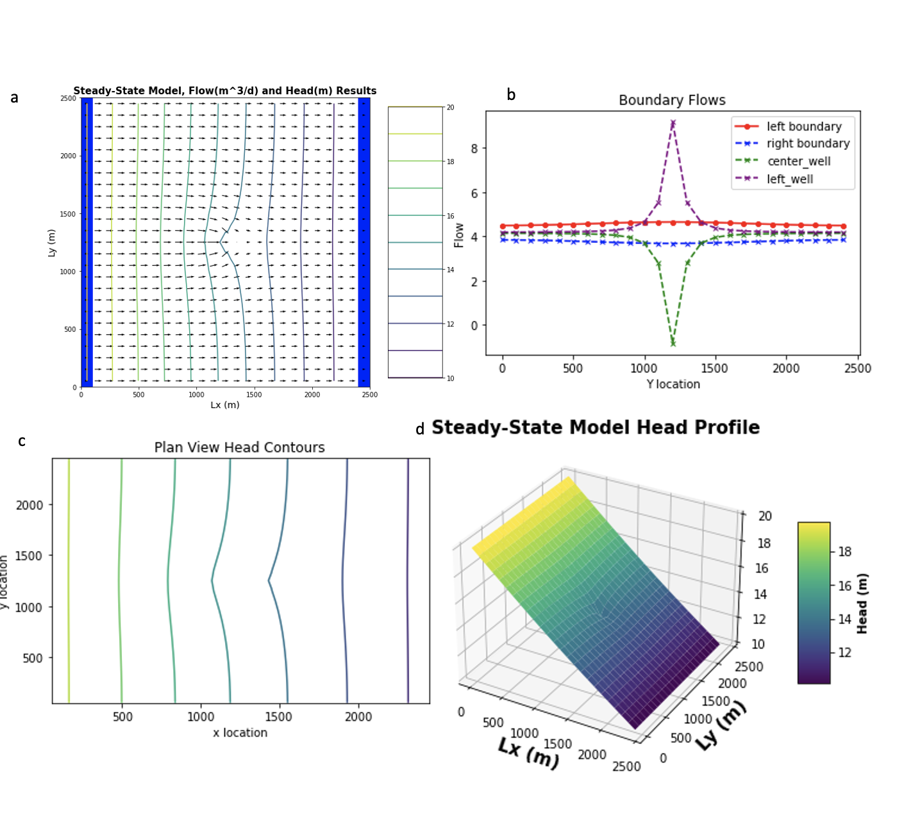

**Figure 4:** **4a)** Equipotentials and flow lines for the well in the center of the domain [:,12,12] with a pumping rate of -20 m^3/day. **4b)** flow lines for the well with the center [,12] and just left of the well [,11] denoted in green and purple. **4c)** plane view contour lines for the well with a pumping rate of -20 m^3/day. **4d)** Steady state head profile for the well with a pumping rate of -20 m^3/day.

**Pumping Rate - 25 m^3/day:**

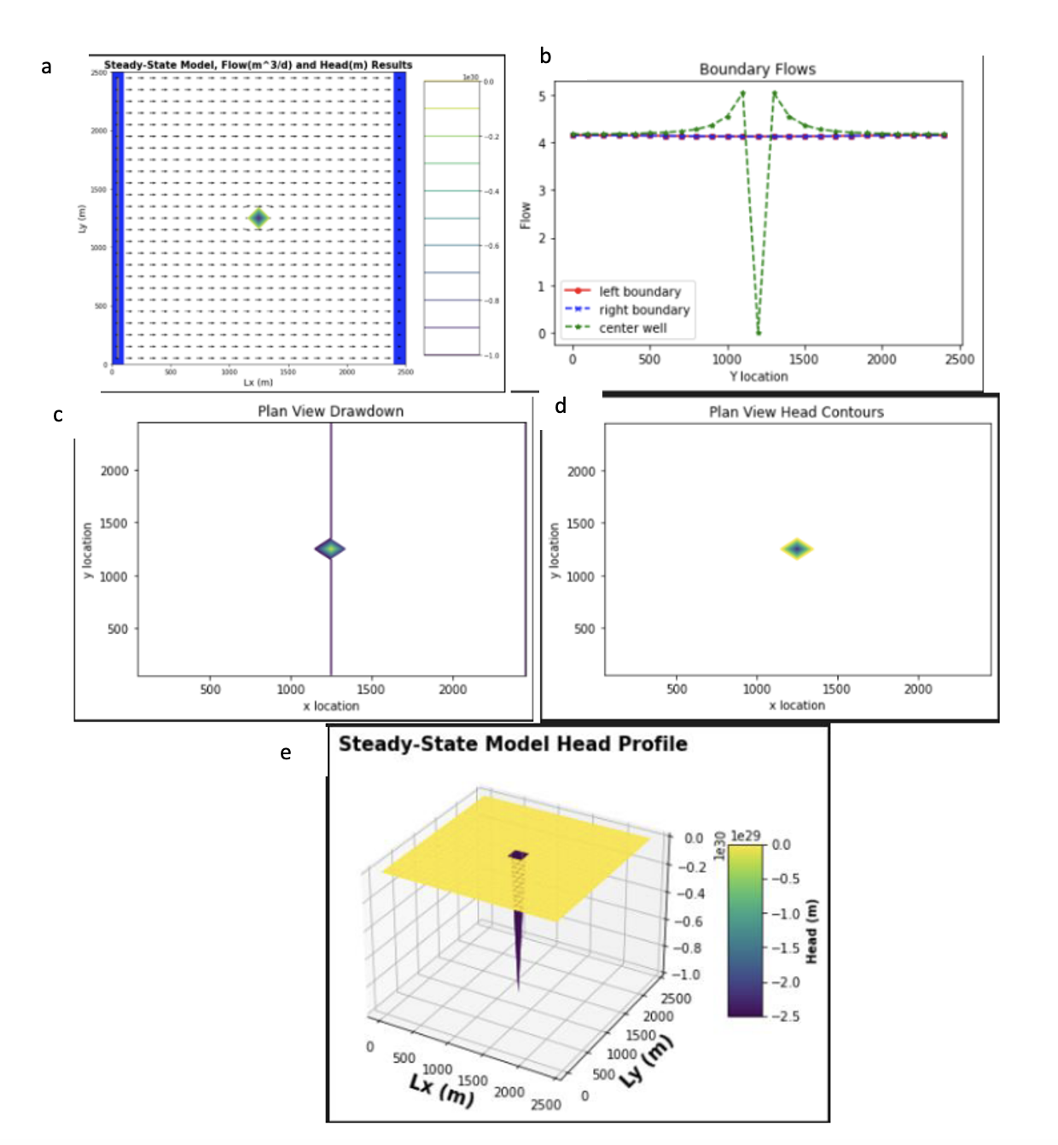

**Figure 5: 5a)** Flow lines and equipotential head for the well located at (12,12) with a pumping rate of -25 m3/day. **5b)** Flow lines on the left and right boundary compared to the flow on the center of the well location (:,12) **5c)** Drawdown of the well located at the center of the domain with a rate of -25 m3/day. **5d)** Head contour of the domain. **5e)** Head 3D profile of the system with a negative head of 2.5 m in the place where the well is located.