**Minimum Figures and calcualtions to submit:** Challenge 1

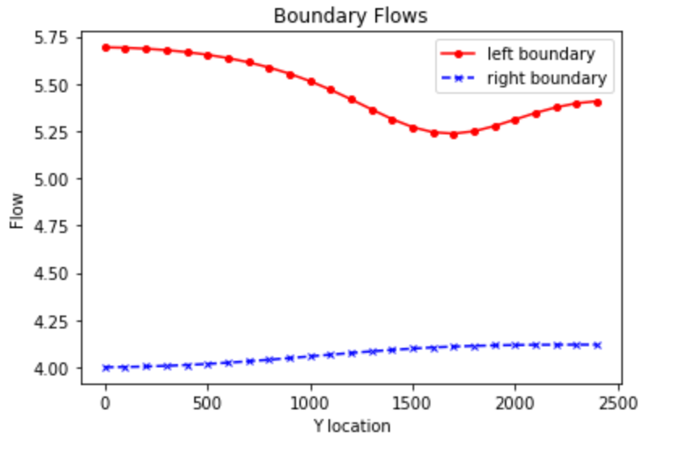

Figure : Flows across the left and right boundary for the initial conditions with the well not pumping, recharge in the upper left of the domain and evapotranspiration across the whole domain.



Figure : Equipotentials and flow vectors for the initial model set up. Green outline is where we would expect to see contamination ( in black).



Figure : Total ET, Recharge and both left and right fluxes as well as the values for recahrge, et and the water table depth plots.

Challenge 2

Figure : Water budget with all the different components in m^3/day. Total water budget is calculated as Recharge + left flux - right flux - ET and is very close to zero. The lack of it being 0 exactly is potentially due to rounding.

Challenge 3

Figure : ET, Water table depth and recharge for the extinction depth of 6m

Figure : Head profile and flows for the extinction depth of 6m

Figure : Water Budget for extinction depth of 6 m

Challenge 4

Figure 8: Head profiles and flow arrows for the pumping well and recharge area

Figure 9: Plots of the ET, recharge and water table depth with the pumping well, recharge and ET all turned on

Challenge 5 - Report the water balance numbers for the well.

Figure 10: Water Budget for the well pumping at 20 m^3/day and the other fluxes. Value is a little less than 0 because the difference in the inflows and outflows is slightly smaller than the pumping rate of the well which I hard coded to be -20 m^3/day