Jen Steyaert

HW 3 Figures

1. Challenge Q 1:

Figure : Boundary flows from left and right boundaries for K inclusion = 0.1

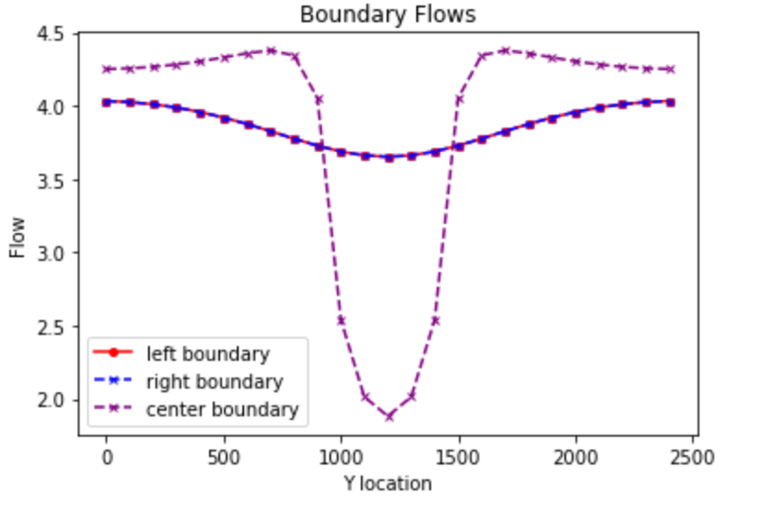

Figure : Boundary flows with flow through center of low K box

|  |  |  |  |  |  |
| --- | --- | --- | --- | --- | --- |
| **K_all** | **K_inclusion** | **K_eff** | **q (one row)** | **dH/dL** | **q_total** |
| 1 | 0.01 | 0.04807692 | -1.92308E-05 | -0.0004 | -0.0004808 |
| 1 | 0.1 | 0.35714286 | -0.000142857 | -0.0004 | -0.0035714 |
| 1 | 1 | 1 | 0.9996 | 0.9996 | 24.99 |
| 1 | 10 | 1.2195122 | 2.438536585 | 1.9996 | 60.9634146 |
| 1 | 100 | 1.24688279 | 3.740149626 | 2.9996 | 93.5037406 |

Figure : Table of total q with the different K values. We used the harmonic mean and then multiplied the q per row by 25 to get total q

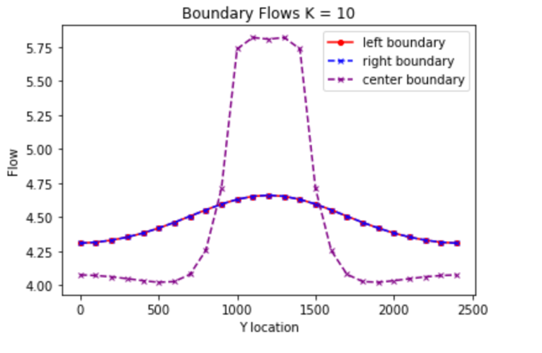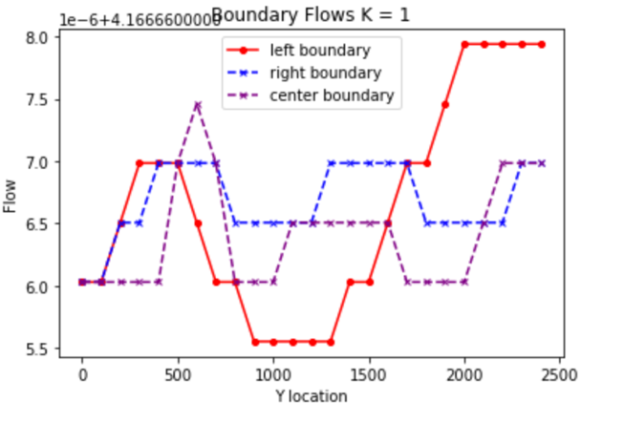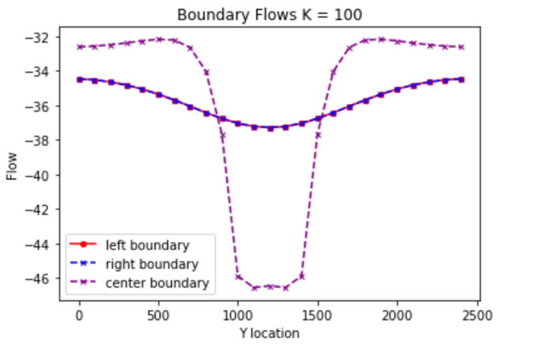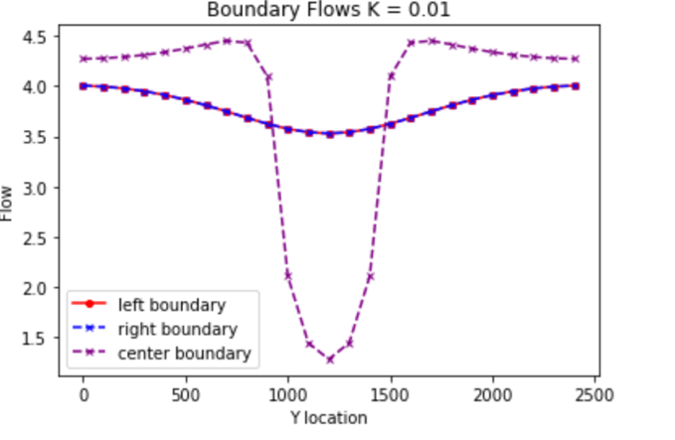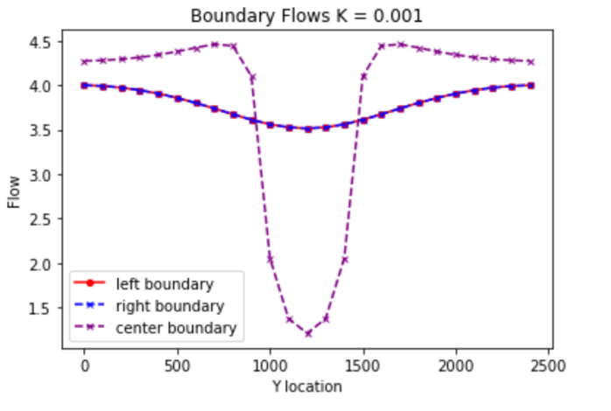

Figure 4: Panel of plots with varying K levels and amount of flow. In the low K (less than 0) the flow diverges around the box and with high K the flow funnels through the box.