**Justin Headley HW5 Figures HWRS 582 2/22/22**

1. Challenge 1:
   * Equipotentials and flow lines for confined and unconfined simulations

Figure : Confined - L Head 18m, R Head 12m Equipotentials and Flow Lines

Figure : Unconfined - L Head 8m, Right Head 2m Equipotentials and Flow Lines

* + Head difference between the two simulations

Figure : Confined Head Differences

Figure : Unconfined Head Differences

Challenge 2:

* + Report the total flux across the left and right boundaries for confined and unconfined simulations
  + Plot the flux values for the left and right boundaries for both cases

Figure : Confined Boundary Flows

Figure : Unconfined Boundary Flow

Challenge 3:

* + Head transect or equipotential lines for the recharge case

Figure : Uniform Recharge

Figure : Recharge at [6,10]

* + Plot the flux values for the left and right boundaries for both cases

Figure : Uniform Recharge Flow

Figure : Flow with Recharge at [6,10]

Challenge 4:

* + Report the total excess irrigation applied per year in m
  + Report the total calculated irrigation per year and your assumed efficiency rate

|  |  |  |  |
| --- | --- | --- | --- |
| Recharge Rate | | 0.0001 | m/day |
| Excess Irrigation | | 0.0365 | m/year |
|  |  |  |  |
| Cotton Requirement | | 0.28 | in/day |
| Source: cottoninc.com | | 0.0071 | m/day |
|  |  |  |  |
| **Total Irrigation Rate** | |  |  |
| **Cotton Req + Excess** | | **0.0072** | **m/day** |

* + Plot the flux values and equipotential lines and annotate it with the potential contamination zone Chart

    Description automatically generated

Figure : Amber is the contamination zone

Challenge 5:

* + Plot the annotated flux plot showing contamination and capture zones in different colors

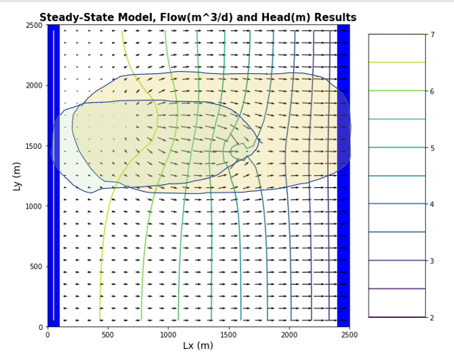

Figure : Amber is contamination zone, green is well capture zone