Justin Headley GW Modeling HW3 Plots

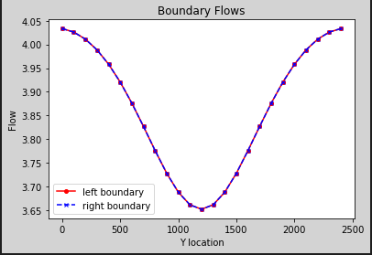

Figure 1: Challenge #1. Flow plotted into left boundary and out of right boundary. (Plots are overlapping).

I don’t understand how to do anything else, without just copying code of people who already know Python.