Starlivia Kaska

HWRS 482

Dr. Laura Condon

February 1, 2022

HW2 Figures

1. **Conceptual Model**

|  |  |  |  |  |  |  |  |  |  |  |  |  |  |  |  |  |  |  |  |  |  |  |  |  |
| --- | --- | --- | --- | --- | --- | --- | --- | --- | --- | --- | --- | --- | --- | --- | --- | --- | --- | --- | --- | --- | --- | --- | --- | --- |
|  |  |  |  |  |  |  |  |  |  |  |  |  |  |  |  |  |  |  |  |  |  |  |  |  |
|  |  |  |  |  |  |  |  |  |  |  |  |  |  |  |  |  |  |  |  |  |  |  |  |  |
|  |  |  |  |  |  |  |  |  |  |  |  |  |  |  |  |  |  |  |  |  |  |  |  |  |
|  |  |  |  |  |  |  |  |  |  |  |  |  |  |  |  |  |  |  |  |  |  |  |  |  |
|  |  |  |  |  |  |  |  |  |  |  |  |  |  |  |  |  |  |  |  |  |  |  |  |  |
|  |  |  |  |  |  |  |  |  |  |  |  |  |  |  |  |  |  |  |  |  |  |  |  |  |
|  |  |  |  |  |  |  |  |  |  |  |  |  |  |  |  |  |  |  |  |  |  |  |  |  |
|  |  |  |  |  |  |  |  |  |  |  |  |  |  |  |  |  |  |  |  |  |  |  |  |  |
|  |  |  |  |  |  |  |  |  |  |  |  |  |  |  |  |  |  |  |  |  |  |  |  |  |
|  |  |  |  |  |  |  |  |  |  |  |  |  |  |  |  |  |  |  |  |  |  |  |  |  |
|  |  |  |  |  |  |  |  |  |  |  |  |  |  |  |  |  |  |  |  |  |  |  |  |  |
|  |  |  |  |  |  |  |  |  |  |  |  |  |  |  |  |  |  |  |  |  |  |  |  |  |
|  |  |  |  |  |  |  |  |  |  |  |  |  |  |  |  |  |  |  |  |  |  |  |  |  |
|  |  |  |  |  |  |  |  |  |  |  |  |  |  |  |  |  |  |  |  |  |  |  |  |  |
|  |  |  |  |  |  |  |  |  |  |  |  |  |  |  |  |  |  |  |  |  |  |  |  |  |
|  |  |  |  |  |  |  |  |  |  |  |  |  |  |  |  |  |  |  |  |  |  |  |  |  |
|  |  |  |  |  |  |  |  |  |  |  |  |  |  |  |  |  |  |  |  |  |  |  |  |  |
|  |  |  |  |  |  |  |  |  |  |  |  |  |  |  |  |  |  |  |  |  |  |  |  |  |
|  |  |  |  |  |  |  |  |  |  |  |  |  |  |  |  |  |  |  |  |  |  |  |  |  |
|  |  |  |  |  |  |  |  |  |  |  |  |  |  |  |  |  |  |  |  |  |  |  |  |  |
|  |  |  |  |  |  |  |  |  |  |  |  |  |  |  |  |  |  |  |  |  |  |  |  |  |
|  |  |  |  |  |  |  |  |  |  |  |  |  |  |  |  |  |  |  |  |  |  |  |  |  |
|  |  |  |  |  |  |  |  |  |  |  |  |  |  |  |  |  |  |  |  |  |  |  |  |  |
|  |  |  |  |  |  |  |  |  |  |  |  |  |  |  |  |  |  |  |  |  |  |  |  |  |
|  |  |  |  |  |  |  |  |  |  |  |  |  |  |  |  |  |  |  |  |  |  |  |  |  |

1. **Flux with horizontal distance and model is steady state.**

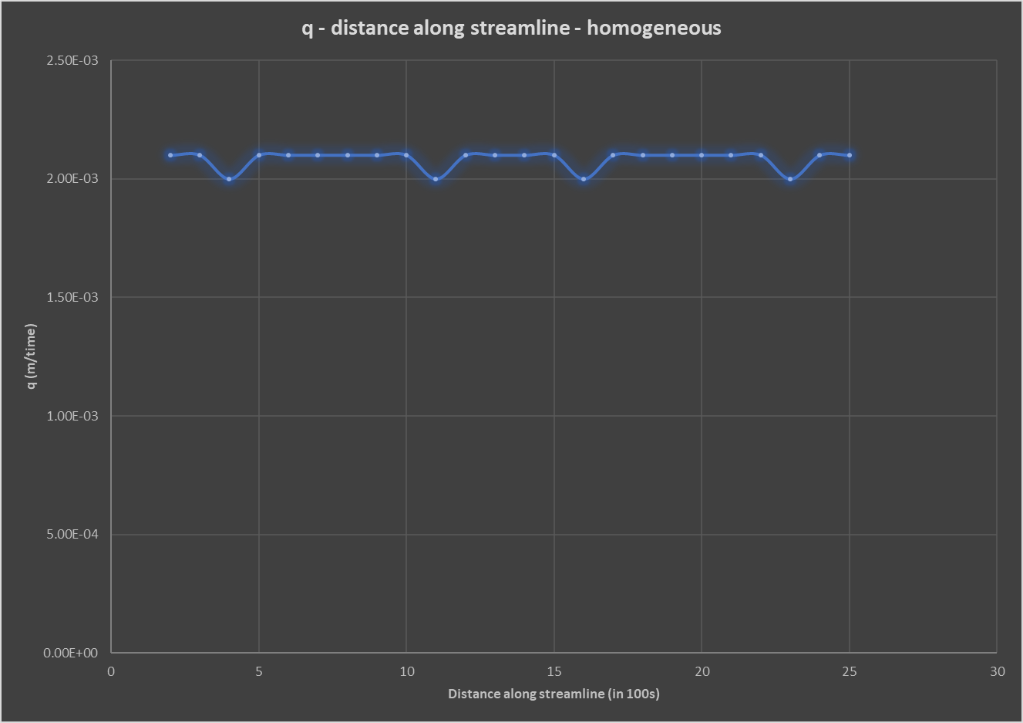

Figure 1. This figure shows the flux of a homogeneous case without the harmonic average.

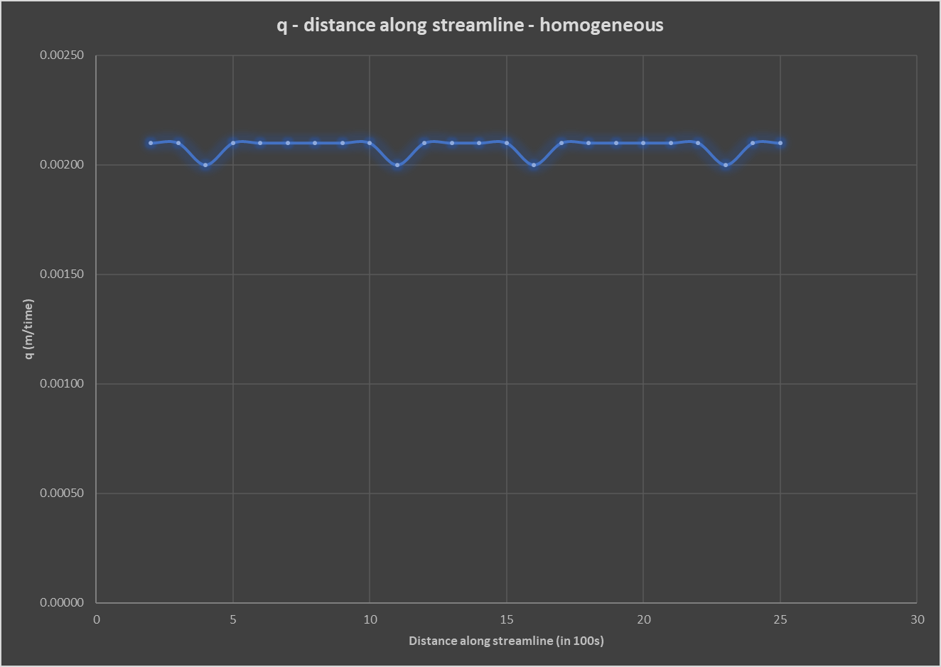

Figure 2. The flux for a homogeneous case, accounting for spatial differences in the hydraulic conductivity and taking the harmonic average

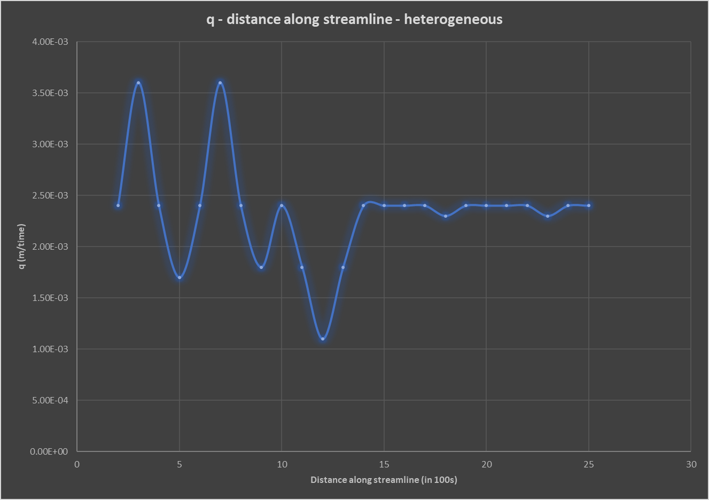

Figure 3. This figure shows the flux of a heterogeneous case without the harmonic average.

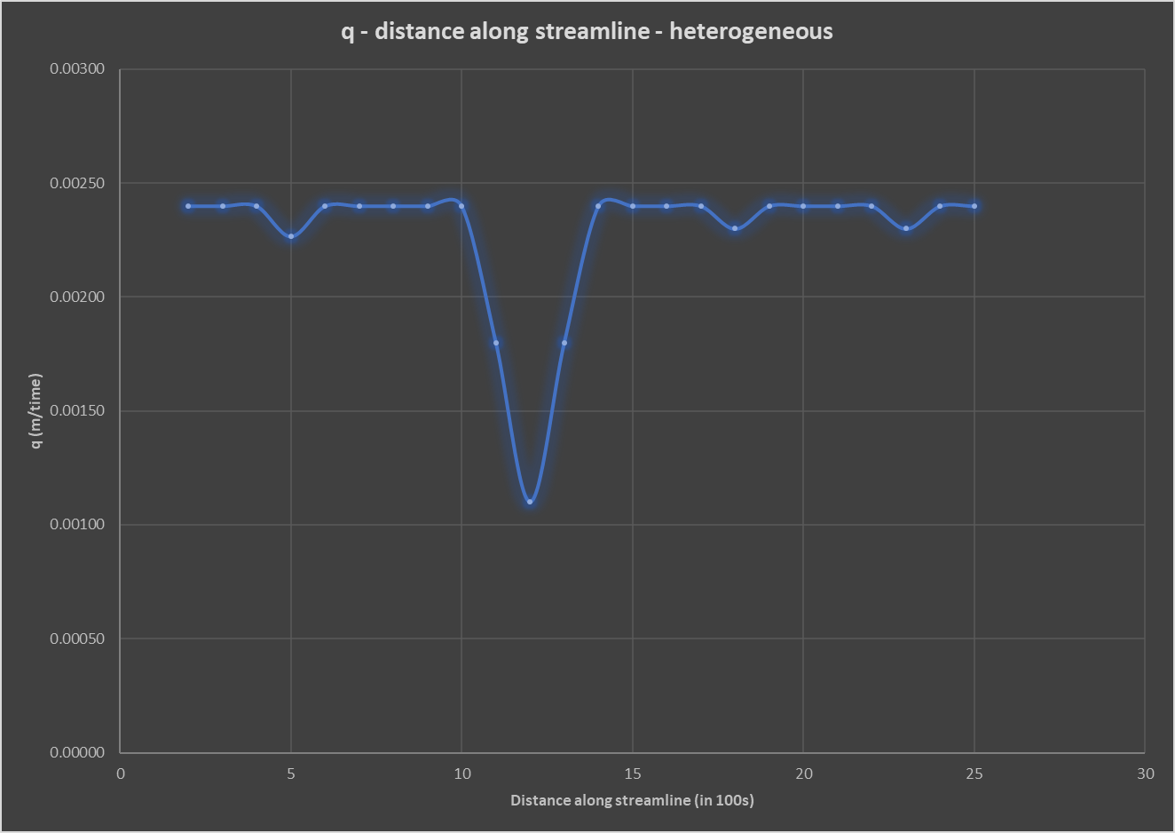

Figure 4. The flux for a heterogeneous case, accounting for spatial differences in the hydraulic conductivity and taking the harmonic average

1. **Steady state head contours in plan view.**

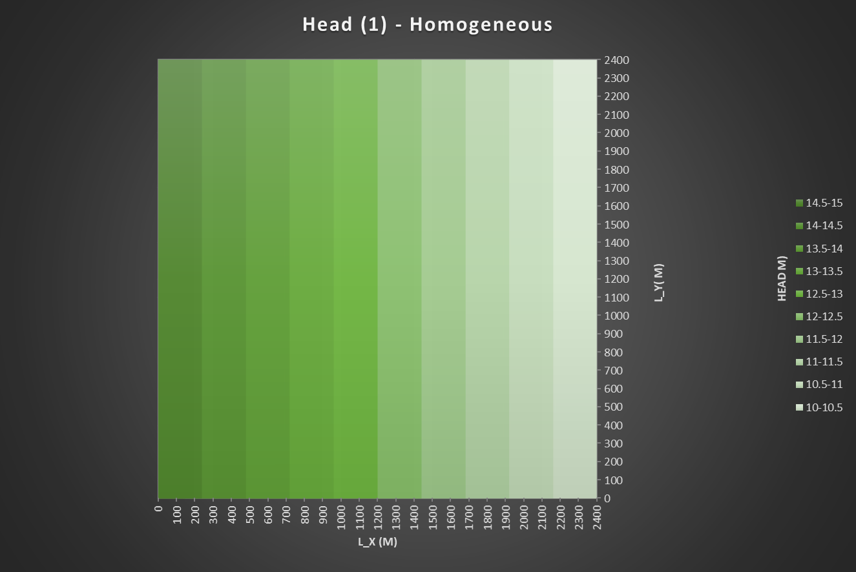

Figure 5. Homogeneous case with K values of 1.00 in each cell of the grid.

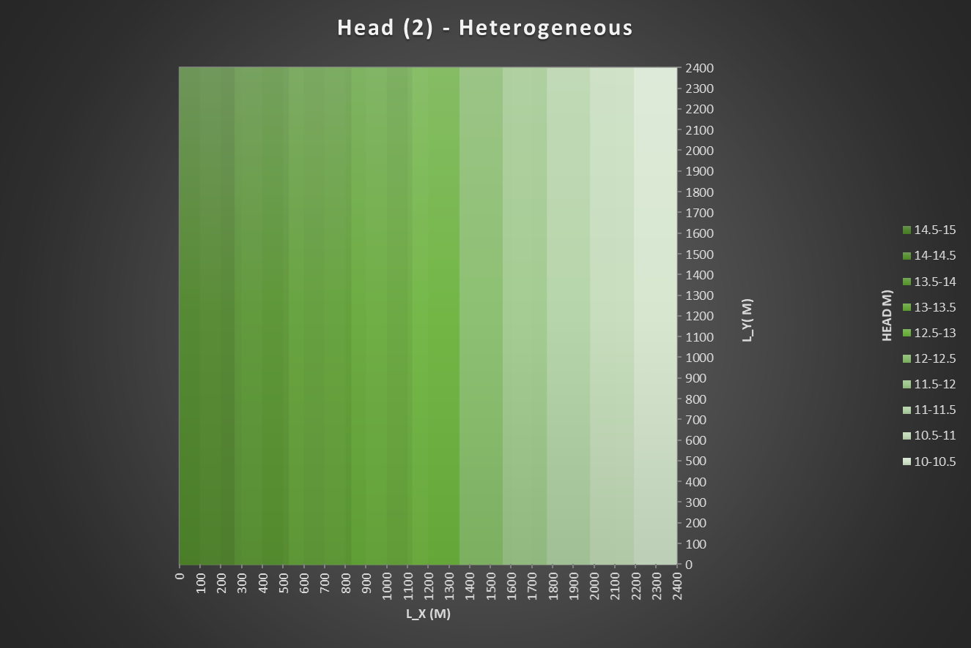

Figure 6**.** Heterogeneous case with K values of 1.00 and 2.00 in series (only a few of the columns in the grid were changed to 2.00).

1. **Square region of lower K in the middle of the domain.**

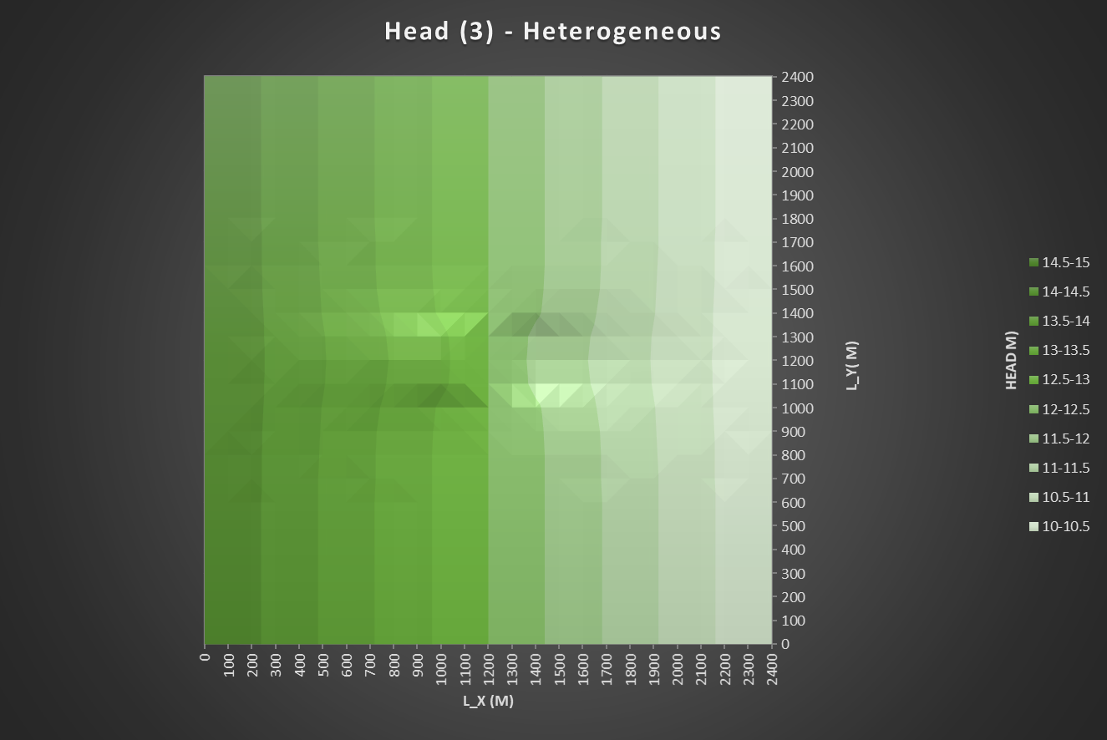

Figure 7. Heterogeneous head contour of center with a lower K value. Region in the center was 3x3 with K values of 0.5 in all 9 cells.