Starlivia Kaska

HWRS 482

Dr. Laura Condon

April 5, 2022

HW10: The Challenge

**1.Compare the impact of pumping on the single layer model vs the multi-layer model. What physical explanation do you have for the differences?**

Figure 1. The figure above shows side by side plots of a one layer system with a well (2500,2500) and a three layer system with a well at (2500,2500) in the bottom layer only. The plots show the flow vectors and head contours for the two scenarios.

The explanation for the difference in the two plots seems to be the layers and the location of the well. The location (bottom layer) of the well in the three-layer system causes a sort of funnel in the center of our domain, in all three layers. For the one layer system the flow only needs to travel through one layer and the plot isn’t as dramatic. The k values are also different for the vertical and the horizontal and this contributes to the flow in the system.

**Thickness of the one layer follows our topography.**

**For the three layer scenario the middle and bottom layers have constant dz but the top layer changes from the surface topography. The middle layer had a lower k value than the other two layers.**

**In the one layer scenario we can see a noticeable cone of depression.**

**In the three layer scenario, we do not see a cone of depression because of the low k value in the middle. It is hard for water on the top to flow to the bottom layer, so it is easier for the water to be effected in the bottom layer, from where it is easy to come. That is why we do not see the cone of depression in this scenario as we did in the one layer system. [we can see this through the cross section]**

**For the flow contours we could chose the layer we wanted to see. The model gave the bottom layer for the three layer scenario.**

**When we see the differences in the ins and the outs, there are different head gradients occurring. We have different fluxes. The one layer has larger fluxes across our constant head boundaries, we have a steeper gradient. Constant head is the flux across the boundary. This could be due to the water table adjustment in our one layer (cone of depression), no cone of depression in the three layer.**

**2. Repeat the three-layer simulations putting the well in each layer (i.e. once in the bottom once in the middle and once in the top) provide plots and discussions comparing and contrasting your simulations. Provide at least one plot where you have all your runs in the same figure.**

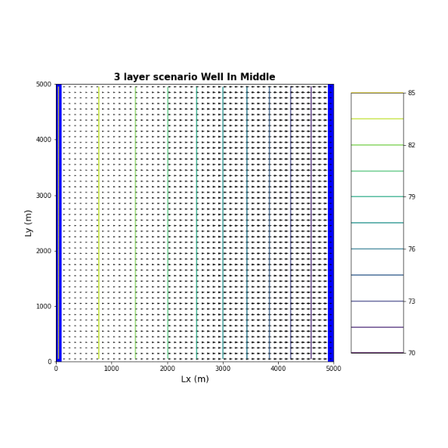

**Top Middle Bottom**

Figure 2. This figure shows side by side flow vectors and head contours for a three layer system with a well established on the bottom layer, with a well established in the middle layer, and with a well established in the top layer.

When we put the well in the top layer only the head contours do not deviate and look uniform and the flow vectors are almost identical, however we do see a subtleness to them near our left boundary. When we put the well in the middle layer we see an even more uniform head gradient, however, there seems to be an even more pronounced flow reduction near our left boundary. When we put the well in the bottom layer, we see the funneling and less flow in the right boundary area as well as a drastic morphing of the head gradient. All three of the plots maintain a left head boundary of 85 and a left head boundary of 70.

**Well in the middle layer breaks our model. It will work with a very small pumping rate. IF we have a really low k we need a very high head gradient. No water wants to go into this layer.**

**3.Change the properties of your three-layer model so that it matches the 1 layer model (but still has 3 layers) put the pump in the bottom layer and compare and contrast with your one layer solution. How does your answer to this challenge compare with your answer to the first?**

Figure 3. Side by side plots of our one-layer system compared to our 3 layer system. Both scenarios have the same layer properties. The plot on the right has a well at (2500,2500) in the one layer, and the plot on the left has a well completed at (2500,2500) in only the bottom layer (it has three).

We have the same layer properties throughout the entire domain for each of the scenarios. When we do this the figures look a lot similar that when the properties were different. I believe this is because we basically have our one-layer scenario layered three times. If all of the properties are the same in each layer it looks like it acts as a one-layer system would. There is just a little more funneling in the three-layer scenario due to the well being located in the bottom layer. If we put it in the top layer, our system would probably be even more similar to the single layer scenario.

**Greater drawdown in the three layer bottom layer than the drawdown in the one layer system.**

**4.Modify the topography of your domain so that it is no longer sloping left to right (you can make it a valley or have it sloping the other way, whatever you want). Re-run your 1 and 3 layer solutions and explain any differences you do or don't see.**

Figure 4. The two plots above show the flow vectors for a one layer and three layer system. The two scenarios have the same layer properties. The three-layer scenario has a well in the bottom layer only.

Figure 5. These plots show the cross-sectional view of our domains for the one-layer system and the three-layer system. The two scenarios have the same layer properties. The three-layer scenario has a well in the bottom layer only.

For this part We have two valleys and both scenarios have the same layer properties. At first glance the two scenarios do not look different than the plots we had with our original topography. However, if we look at the details, we can’t tell that the flow vectors are opposing in our valley to the right and it looks as though there are some spots in our valley to the left which have little flow. We can see all of this in figure 5. The head gradients for both scenarios look similar which could be due to the layer properties being the same.

**The topography has no effect on the water table. It only depends on the head gradients. Water only cares about where down hill is. You can also have water above, this is why there is a water table line in a valley on your model. Valley cuts below the constant head boundary.**

Glossary Questions

**Layers: Why do we want multiple layers in our groundwater models? Compare and contrast the different approaches to vertical discretization (briefly describe different approaches and discuss their strengths and weaknesses).**

The reason we want multiple layers in our groundwater models as this is much more relative to what happens in the subsurface. We use the layers to identify areas that have the same subsurface characteristics, such as material content or conductivity. In vertical discretization we have to account for layer properties in the z direction (vertical). To do this we have to specify our z properties just as we would our x and y. The most used approach is by using the head values along our domain. I am unaware of the other approaches for vertical discretization, I could not find anything of use to this question from my research on the topic.

**Discretization: What are the pros and cons of adding more layers to a model? Are there considerations for vertical discretization that are different from horizontal discretization?**

A pro to adding more layers to a model is that it is more representative of the subsurface and we get a higher resolution in the z direction. A con to adding more layers is that it will take more time to compute or to give you an answer. I believe that both the vertical and horizontal discretization do have limits.

**Stream Aquifer Exchange: How is water exchanged between a stream and an underlying aquifer? Include the following concepts: (dis)connected streams; streambed hydraulic conductivity; boundary condition type; and coupled models.**

A stream can discharge into an aquifer or vice versa. It depends on whether the stream is connected or disconnected to a stream. A connected stream can feed a stream, contributing to the flow of the stream. A disconnected stream does not receive water from an aquifer, rather the stream can contribute to the aquifer through infiltration. Infiltration of stream water depends on the streambed hydraulic conductivity (the ability of water to move through the streambed and into the subsurface). Also, the boundary condition types can contribute to how water is exchanged between a stream and aquifer. The head boundaries can tell us the direction of flow of an aquifer, and from this we can tell if the aquifer is contributing to the stream.