Starlivia Kaska

HWRS 482

Dr. Laura Condon

February 7, 2022

HW3 Figures

Figure 1. This figure shows the flow coming into the left boundary and leaving the right boundary of each cell. This graph is for the initial values of background and inclusion K.

Figure 2: This figure shows the flow going from left to right along a line that passes through the center of the inclusion. This graph is for the initial values of background and inclusion K.

Figure 3. This plot shows the total flow coming in (left boundary plot at the left end of the domain) and out (right boundary plot at the right end of the domain) of the system for a center inclusion having a K value of 0.1. This is for the initial heterogeneous system with the K values as given in the starter code.

Figure 4. This plot shows the total flow coming in (left boundary plot at the left end of the domain) and out (right boundary plot at the right end of the domain) of the system for a center inclusion having a K value of 0.01. This a heterogeneous system.

Figure 5. This plot shows the total flow coming in (left boundary plot at the left end of the domain) and out (right boundary plot at the right end of the domain) of the system for a center inclusion having a K value of 1. This a homogeneous system. We use the left boundary for the inflow and the right boundary for the outflow.

Figure 6. This plot shows the total flow coming in (left boundary plot at the left end of the domain) and out (right boundary plot at the right end of the domain) of the system for a center inclusion having a K value of 10. This a heterogeneous system.

Figure 7. This plot shows the total flow coming in (left boundary plot at the left end of the domain) and out (right boundary plot at the right end of the domain) of the system for a center inclusion having a K value of 100. This a heterogeneous system.

|  |  |  |  |  |  |
| --- | --- | --- | --- | --- | --- |
| **Inclusion K Value** | **Flow In** | **Flow Out** | **Keq Harmonic** | **Keq Arithmetic** | **Keq Flow in-out** |
| 0.01 | 4 | 4 | 0.201612903 | 0.957 | N/A |
| 0.1 | 4.04 | 4.04 | 0.735294118 | 0.964 | N/A |
| 1 | 6 | 7 | 1 | 1 | N/A |
| 10 | 4.31 | 4.31 | 1.037344398 | 1.36 | N/A |
| 100 | 4.34 | 4.34 | 1.04123282 | 4.96 | N/A |

Table 1. This table contains all the values for Flow in and Flow out as well as the Keq using the harmonic mean, flow in, and the arithmetic mean for the different inclusion K values. Keq values for the Flow in-out are missing due to miscommunication, was unable to calculate values without an equation to base of off, and was unaware of what that equation was.

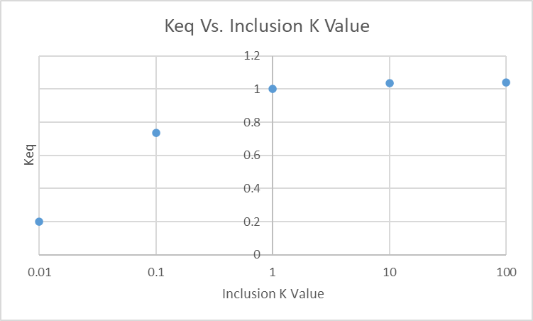

Graph 1. This shows the plot for the data in Table 1. It shows the value of Keq (harmonic mean) for the different inclusion values.