Starlivia Kaska

HWRS 482

Challenge

**1. Change the boundary condition heads to make this an unconfined model. You can pick whatever heads you would like but I recommend keeping both above zero (Hint: these are the variables H_left and H_right in the starter code). Run two simulations with the same head gradient across the model (i.e. H_left minus H_right being the same between your confined and unconfined cases) but where one is confined and the other is unconfined. Plot the equipotentials and flow lines for both simulations and plot the head difference between the two simulations. Describe how the two head profiles differ and explain why this is the case. Would your answer be different if you changed the overall head gradient (H_left-H_right), keeping it the same between confined and unconfined cases though?**

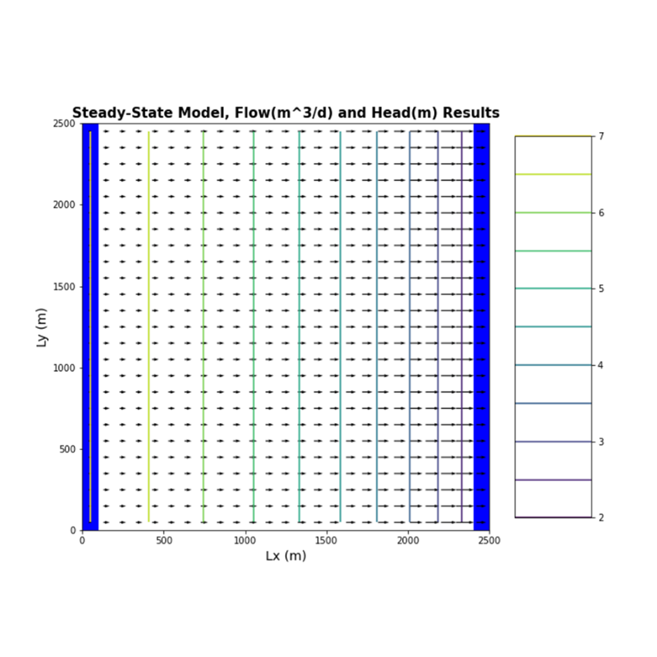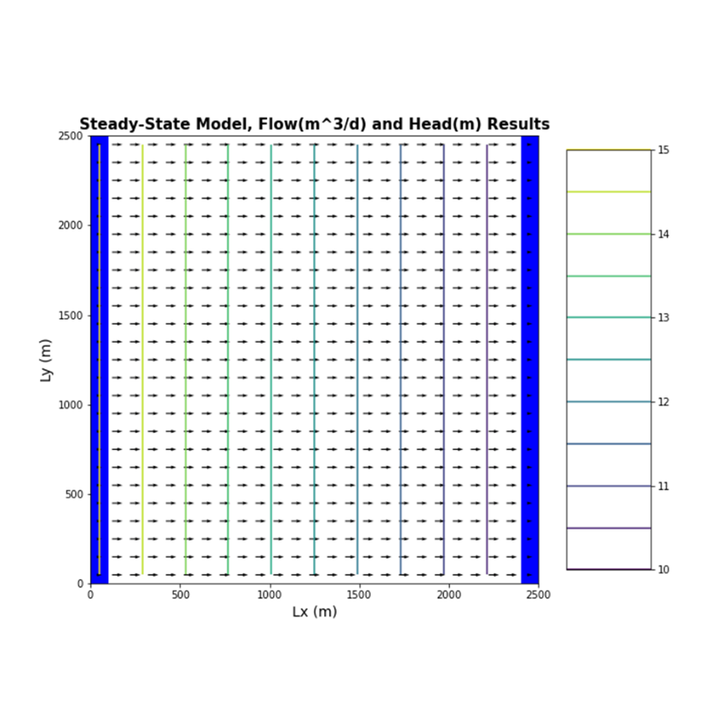

CONFINED UNCONFINED

The two head profiles differ by their equipotential values in the top two plots. One starts at 15 and ends at 10 (confined) and the other starts at 7 and ends at 2 (unconfined). The flow arrows in these same two plots are also different. For a confined system the flow lines are perpendicular and all flow in the same direction. For the unconfined system the arrows aren’t as vivid, and you can’t tell which way they are going. It starts to clear up around Lx =1000 where the arrows start to go in the same direction (to the right). The equipotential plot with the clear flow arrows in one direction is confined (under pressure) and the other one with the blurry flow arrows is unconfined (related to atmospheric pressure). I am unsure of how to interpret the two plan view head difference plots.

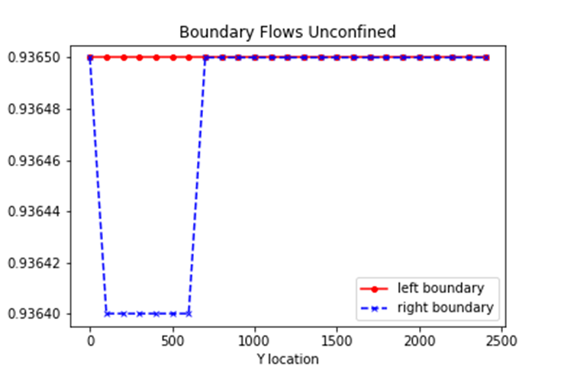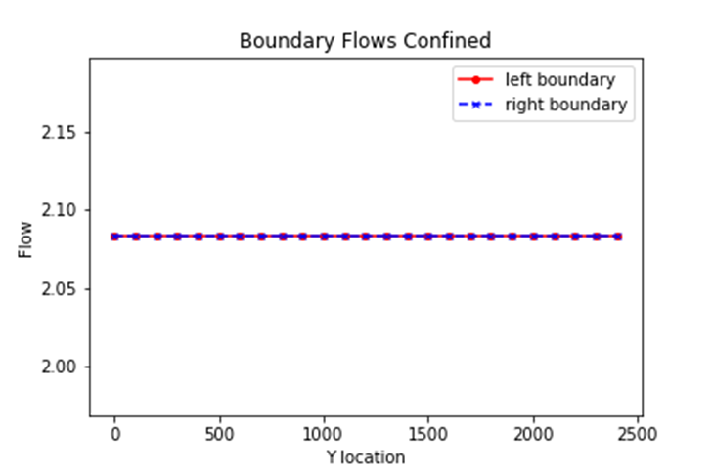**2.For the two runs above (1) plot the flux across the left and right boundaries and (2) calculate the total flux. Compare these calculations and plots and provide an explanation for why you see the behavior you do. The overall gradient is the same, as is the K of the medium. Is the flow the same for both boundary conditions? Why or why not?**

For the confined system the Left flux = 52.08, the Right Flux = 52.08, and the Difference = 0.00. For the unconfined system the Left flux = 23.4125, the Right flux = 23.411, and the Difference = - 0.0059. We see that the boundary flows for a confined system are equal, and the total flux is zero. This is also due to the pressure in a confined system. The boundary flows for my unconfined system look a little different. I am assuming that the thickness of the system is set at 10 m and our left boundary is 7m and this somehow effects the amount of flow exiting the system.

**3. Now add recharge at a constant rate of 1e-4 m/day over the entire land surface to an unconfined case with the left boundary set 7m and the right boundary set to a 2m. Explain the head transect and boundary flows. Is flow in this system 2D or 3D? Is it represented as 2D or 3D? Explain what you mean by your answers.**

The Left flux = -268.4625, the Right flux = 306.5375, and the Difference = 575 for the boundary flows plot. The head transect shows the head along row 10 of our system and it looks like the head is highest near the center of that row all the way up to 14 m and the lowest head is 7m (at each end of the row). The boundary flows show that what comes in is not going out. There was an addition of water to the system. Flow in this system is 2D. The model shows it in 2D. What I mean by this is that flow goes in two directions, “up” flow and “down” flow, flow now goes in an x and y direction. The head is tallest in the center so now the flow should be going left of that head and the others would go right of that head (flow goes down gradient).

**4. Update your model from #3 to model a system with zero recharge except for a farm located in [6:10, 6:10]. Recharge beneath the farm is 1e-4 m/day due to excess irrigation. Calculate the annual excess irrigation, in meters, that has been applied to the farm. Assuming that the crop is cotton, it is located in southern Arizona, and cotton is grown all year (for simplicity),** **calculate the total irrigation rate on the farm that would be associated with this amount of excess irrigation. Finally, use the flux diagram to identify the area within the domain that might be subject to contamination if the recharge water was somehow tainted (you can do this by saving the plot to PowerPoint and annotating it there).**

The recharge due to excess irrigation is .0001 m/day on this farm. To annual excess irrigation is the excess irrigation per day multiplied by 365 days, which is 0.0365 m/year. To calculate the total irrigation rate on the farm that would be associated with this amount of excess irrigation (I am assuming) you would have to identify the normal irrigation for a year (for cotton) and then subtract it by your excess irrigation per year. After that you would have to convert that value to m/day. I was unsure of how to do this. When I did it, I googled the amount of water a cotton plant needs per day. I found a value of 0.007m/day. But I didn’t get past that.

**5. Lastly, start the well located at [10,15] pumping at a rate of 8 m3/day. Using one color, identify the capture zone of the well. Using a second color, show the area that might be contaminated by the irrigated farm fields (see not above you can do your annotations in PowerPoint if that is easier. Comment on the impact of the well on the pattern of potential contamination. How will the steady state capture zone of a model with recharge differ from that in the same model without recharge?**

When looking at this figure it seems to me that some of the potential contamination will be captured by the well. It is not a solution to the contamination pattern as we can see that some of the flow from recharge reaches it to the other side of the domain. If there was not a recharge zone, then the capture zone would extend all the way to the left side of the domain. What I mean is that it would look like a bullet with its end at the left side of the domain. The capture zone would look more like this figure.

Glossary questions

**1. What does it mean for an aquifer to be unconfined? How does this impact how we calculate flow and how do we expect it to impact head gradients and fluxes?**

ON GLOSSARY THIS WEEK

**2. List each layer type available in the LPF and BCF packages. Provide a summary explanation for each. Explain how approaches differ.**

ON GLOSSARY THIS WEEK

**3. How can MODFLOW, which does not model unsaturated flow, represent an unconfined aquifer?**

ON GLOSSARY THIS WEEK

**4. Define recharge. How do we represent recharge in a MODFLOW model? What package do we use and what are the assumptions of this package? Where exactly is the top boundary of the model?**

ON GLOSSARY THIS WEEK