Starlivia Kaska

Dr. Laura Condon

HWRS 482

March 21, 2022

The Challenge

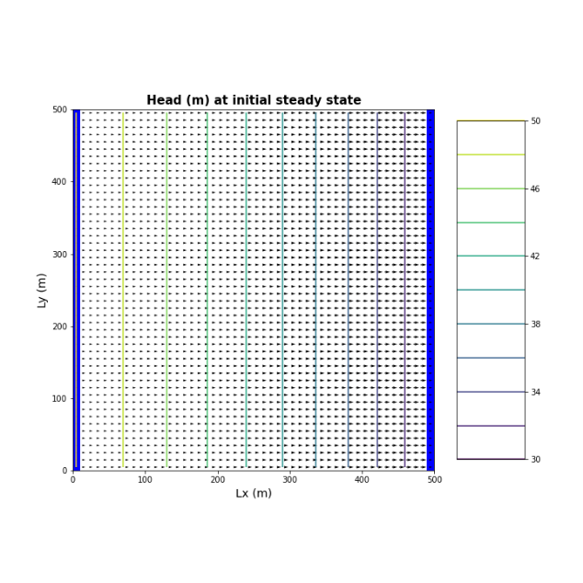**1.Plot the heads (or WTD) of the initial steady state condition. The gradient is not uniform for the initial steady state conditions - discuss the influences of recharge and the unconfined condition on this nonlinearity**

The head is oscillating at the well and at the midpoint. This means that after the head is decreased there is some source dumping water back into the area. This could be an influence of recharge. Also, the non-linearity is due to the unconfined nature of the aquifer. Both head boundaries are equal to or less than the thickness. This results in a cross sectional are that changes over time and is not constant, therefore the fluxes vary.

Answer: The cross-sectional area changes over time. The first graph shows our initial conditions, without anything happening.

**2.Determine if the system has reached steady state after 10 years - consider a point at the well and another at the center of the domain.**

After ten years the system seems to have reached a steady state. I am assuming this is the case as at the end of the simulation the head value returns to the value it was initially, or about the same value. This is the same for both heads a the well and the head at the midpoint. To explain it a little more, the steady state head value can be read at time zero, and after time 10 years the head returns to the steady state head value from time zero.

Answers: you can have a system that is oscillating at a steady state. End is almost the same is called a dynamic equilibrium. The amount of water in the system is always the same at the end of the year (or every year).

**3. Repeat your run this time for 100 years and reconsider question 2 again.**

The system does not reach steady state after 100 years. As we can see, our plot for our midpoint does not reach the same value as the initial head, which is the head in a steady state condition. For the head at the well, it also doesn’t reach the initial steady state head in this area. We can say it almost reaches a steady state but doesn’t make it all the way. You could potentially say that about the 10-year simulation as well, as the values are almost similar but vary by 0.2 meters.

**4. Find the zone of influence of the well, defined in two ways: Based on the drawdown from the initial steady state to the end of simulation time (end of final no-pumping stress period). Based on the drawdown from the end of the last pump-on stress period to the end of simulation time.**

You see the influence of recharge in the first graph, nine months after pump was off (no zone of influence). You see the influence of just the pumping from the well in the second graph (cone of depression).

Glossary questions:

**Explain the concept of stress periods in MODFLOW. How should you determine stress periods when setting up your model? How do they differ from timesteps?**

A stress period is a designated length of time you would like your model to do a specific thing. For example, if we wanted a well to be turned on and off, we would need to tell the model how many times it would have to change the setting. It is important that during a stress period, all parameters are the same. You determine the stress period in your model by identifying how many times you would want a setting changed. They differ from timesteps in that they give you an output.

**What is the period length in MODFLOW? How does the meaning of the period length differ for a steady state vs non steady state solution?**

I am assuming you mean the stress period. In a steady state system, there is only one stress period. To start a transient state system, it is a good idea to first start with the stress period of 1 (steady state) and then you can increase it afterwards. For a steady state system, we would get only one output for the one stress period, however for a transient state system we get an output for every timestep.

<https://water.usgs.gov/nrp/gwsoftware/ModelMuse/Help/modflow_time_dialog_box.htm>

**What does the nstep variable signify in MODFLOW and how does it relate to the stress periods and period lengths? List the pros and cons of taking large timesteps vs. small timesteps. Is there any limit to how large a time step you can take and if so what determines this limit?**

The nstep variable in MODFLOW signifies the number of timesteps in a stress period. If you take large timesteps you model runs faster, however you lose the potential to see what is happening in between those larger timesteps. You don’t get to see the data in between. If you use smaller timesteps, it takes your model a longer time to run. It needs to give more and more outputs. It is beneficial to use smaller timesteps for a better resolution of your system. You get to see the data in between if you use small timesteps.