Starlivia Kaska

Dr. Laura Condon

HWRS 482

March 21, 2022

HW 8 Figures

Figure 1. These two plots show the head (WTD) as a function of time. Right is the head at the well and the left is head at the midpoint of our domain. The plots are for the initial steady state condition.

Figure 2. This plot shows the head along a transect through the well at three times: the initial steady state; the final pump-on period; and the final pump-off period. You can use this plot to determine if the system reached a steady state after running the simulation for 10 years.

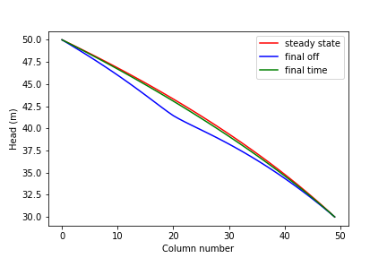

Figure 3. This plot shows the head along a transect through the well at three times: the initial steady state; the final pump-on period; and the final pump-off period. You can use this plot to determine if the system reached a steady state after running the simulation for 100 years

Figure 4. These plots show the drawdown from the beginning of the simulation to the last month of the simulation (left), and the head drawdown of the simulation from when the pump last stopped and the end of the simulation (right).