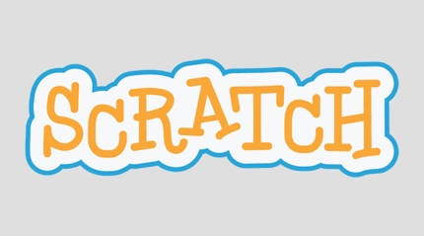

Download today’s scratch code at home: https://github.com/GWC-DCMB/FEMMES

**Definitions**

**Events:** ways to indicate the start of your code



**Operators**: These are “Boolean” expressions. They are logical statements that can be True or False. For example, “Are you 12 years old?” could be written with the operator: Age=12? The answer could take on the values yes (true) or no (false).



**Controls:** perform different computations or actions depending on whether a specified boolean **operator** is true or false

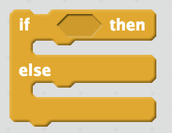 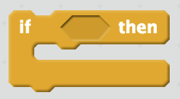

**Sensing:** ways toget receive input, and store in the variable “answer”





**Motions:** actions that your sprite can do





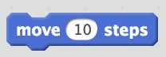

**Looks:** actions that your sprite can do

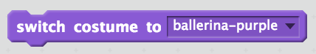



**Choreograph with Code**

**Write a code that WHEN the sprite (i.e. character, ballerina) is clicked,**

(use an item from the **Events** tab)

**the sprite will ASK “Do you like the color of my costume? (yes/no)”**

(use an item from the **Sensing** tab)

**Then, take the user’s ANSWER**

(use an item from the **Sensing** tab)

**And depending on what the response is,**

(use an item from the **Operators** tab)

**Change the color of her costume based on the response**

(use items from the **Controls** tab)

(use an item from the **Looks** tab)

**Make your code ROBUST enough to deal with responses that are not yes, no, or the accepted costume color.**

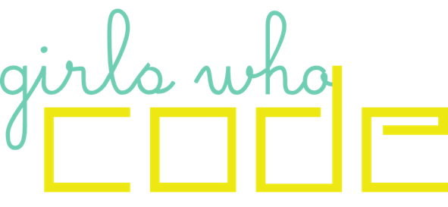

**Find a Girls Who Code (GWC) club for the 2018-2019 School Year**

* GWC across the nation: <https://girlswhocode.com/locations/>
* GWC by University of Michigan Women in Science and Engineering: Email Jamie Saville at jsaville@umich.edu (middle and high school students)
* GWC at University of Michigan Department of Computational Medicine and Bioinformatics: <http://umich.edu/~girlswc/> (high school students only)