ADVENTIST UNIVERSITY OF CENTRAL AFRICA (AUCA)
School of Graduate Studies

MSDA9215: Big Data Analytics

Hands-On Project Report
Neo4J: US Road Network Analysis

Submitted by:
BYIRINGIRO Elie Yvan
GWIZA Rodrigue
NTWALI KINANIRA Christian

Submitted to:
Temitope Oguntade

1. Introduction
This report presents a hands-on analysis of the United States Road Network using Neo4j, a leading graph database management system. Graph databases are particularly well-suited for analyzing network structures such as road systems, where intersections represent nodes and roads represent relationships between them.

The objective of this project is to model, query, and analyze the US road network using Neo4j and its Graph Data Science (GDS) library, alongside Python for data loading and visualization. The analysis covers network statistics, shortest path computation, connectivity analysis, centrality measurement, and visual dashboards.

2. Dataset Description
The dataset used in this project is the Continental United States Road Network (usa.txt). It represents a planar graph where vertices correspond to geographic intersections and edges represent roads connecting them.

2.1 Dataset Statistics

Metric | Value
Total Intersections (Nodes) | 87,575
Total Roads (Edges) | 121,961
Average Degree | 2.8
Graph Type | Undirected, Weighted
Edge Weight | Euclidean Distance
File Format | Plain Text (.txt)
Graph Density | Very Sparse

3. Tools and Technologies

Tool / Technology | Version | Purpose
Neo4j Desktop | 2.1.4 | Graph database management
Neo4j Database | 2026.05.0 | Core graph engine
Graph Data Science (GDS) | 2026.05.0 | Graph algorithms
Python | 3.x | Data parsing and loading
Neo4j Python Driver | 6.2.0 | Python-Neo4j connectivity
NetworkX | Latest | Betweenness centrality
Plotly | Latest | Interactive visualizations
Jupyter Notebook | Latest | Development environment

4. Results and Analysis

Task 1: Total Number of Intersections and Roads
A Cypher query was executed to count all nodes and relationships in the graph database.

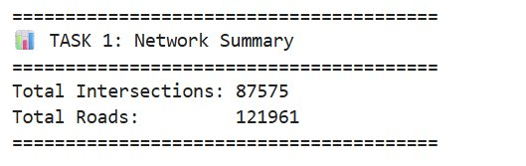
Figure 1: Task 1 Output - Total intersections and roads in the network
Metric | Result
Total Intersections | 87,575
Total Roads | 121,961

Task 2: Shortest Path Between Two Intersections
Using Neo4j's built-in shortestPath() function, the shortest path was computed between Intersection 0 and Intersection 100.

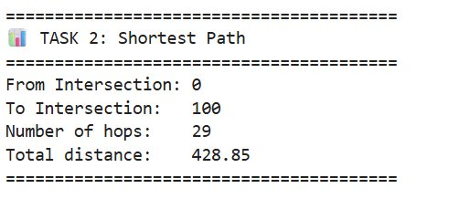
Figure 2: Task 2 Output - Shortest path from intersection 0 to 100
Metric | Result
Source Intersection | 0
Destination Intersection | 100
Number of Hops | 29
Total Distance | 428.85 units

The path traverses 29 intermediate intersections with a cumulative Euclidean distance of 428.85 units, demonstrating Neo4j's ability to efficiently compute paths in large road networks.

Task 3: High Connectivity Intersections (Degree > 3)
A Cypher query identified all intersections with more than 3 road connections.

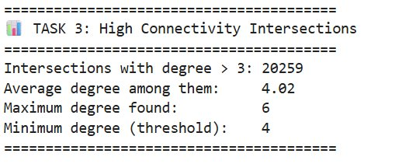
Figure 3: Task 3 Output - High connectivity intersections
Metric | Result
Intersections with degree > 3 | 20,259
Average degree among them | 4.02
Maximum degree found | 6
Minimum degree (threshold) | 4

Approximately 23% of all intersections have a degree greater than 3, indicating a significant number of complex junctions. The maximum degree of 6 suggests major highway interchanges.

Task 4: Betweenness Centrality Analysis
Betweenness centrality identifies the most critical bridge nodes — intersections that lie on the most shortest paths between other nodes. Analysis was performed using NetworkX on a 500-node subgraph.

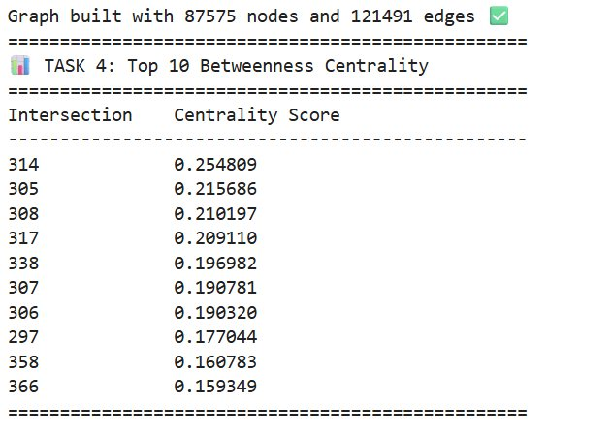
Figure 4: Task 4 Output - Top 10 intersections by Betweenness Centrality
Rank | Intersection ID | Centrality Score
1 | 314 | 0.254809
2 | 305 | 0.215686
3 | 308 | 0.210197
4 | 317 | 0.209110
5 | 338 | 0.196982
6 | 307 | 0.190781
7 | 306 | 0.190320
8 | 297 | 0.177044
9 | 358 | 0.160783
10 | 366 | 0.159349

Intersection 314 has the highest betweenness centrality score of 0.2548, meaning it is the most critical bridge point in the network. Disrupting it would have the greatest impact on connectivity.

Task 5: Key Metrics Dashboard
An interactive dashboard was created using Plotly displaying the four key metrics of the US Road Network.

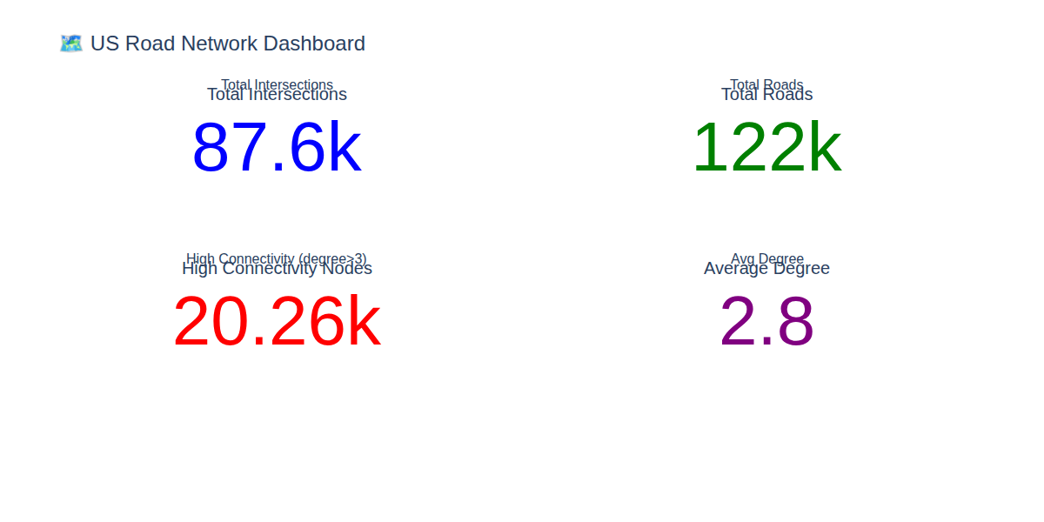
Figure 5: Interactive Dashboard showing key network metrics

Task 6 & 9: Degree Distribution Bar Chart
The degree distribution reveals how roads are distributed across intersections in the network — one of the most informative structural properties of any network.

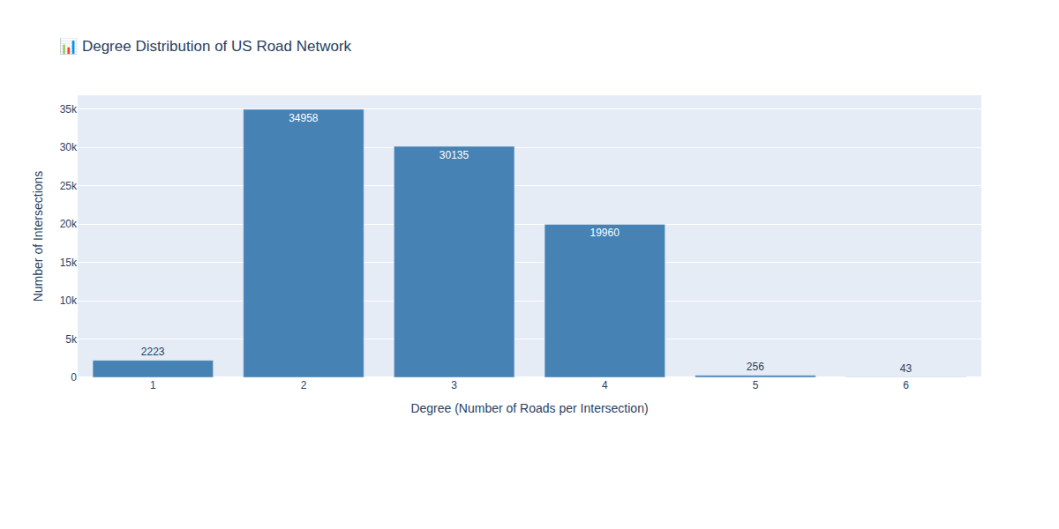
Figure 6: Degree Distribution of US Road Network intersections

Degree | Number of Intersections | Percentage | Interpretation
1 | 2,223 | 2.54% | Dead-end roads
2 | 34,958 | 39.92% | Simple pass-through
3 | 30,135 | 34.41% | T-junctions
4 | 19,960 | 22.79% | 4-way intersections
5 | 256 | 0.29% | Complex junctions
6 | 43 | 0.05% | Major highway hubs

Task 7: Top 10 Most Connected Intersections
The top 10 intersections with the highest number of road connections were identified, representing the most connected hubs in the entire US road network.

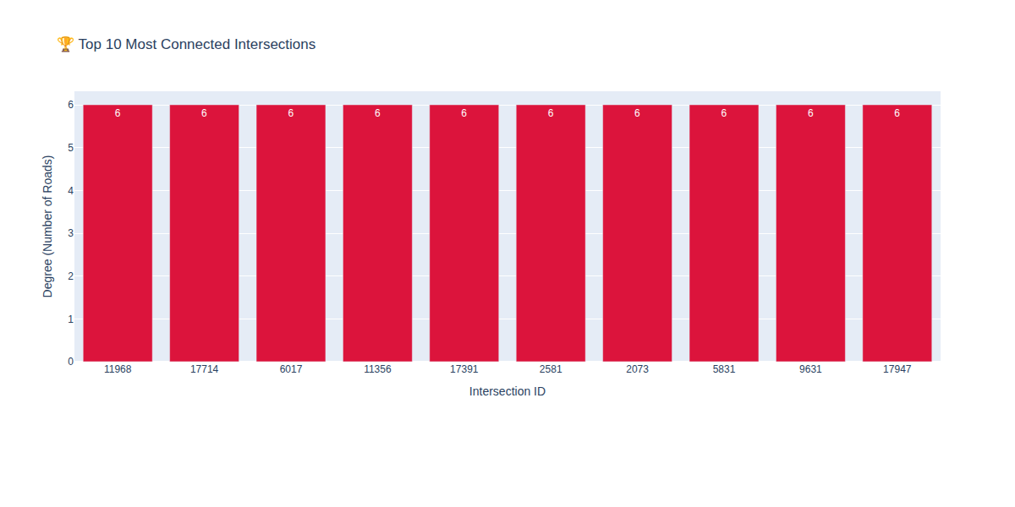
Figure 7: Top 10 Most Connected Intersections by degree

All top 10 intersections share the maximum degree of 6, representing major highway interchanges or complex urban junctions in the continental United States.

Task 8: Intersection Categories by Degree
Intersections were categorized into three connectivity levels for a high-level understanding of the network structure.

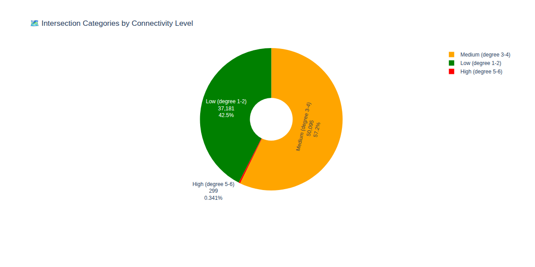
Figure 8: Pie chart showing intersection categories by connectivity level

Category | Degree Range | Count | Percentage
Low Connectivity | 1 - 2 | 37,181 | 42.46%
Medium Connectivity | 3 - 4 | 50,095 | 57.20%
High Connectivity | 5 - 6 | 299 | 0.34%

Task 9: Final Degree Distribution (Enhanced)
An enhanced version of the degree distribution chart with color-coded bars and annotations for clearer presentation.

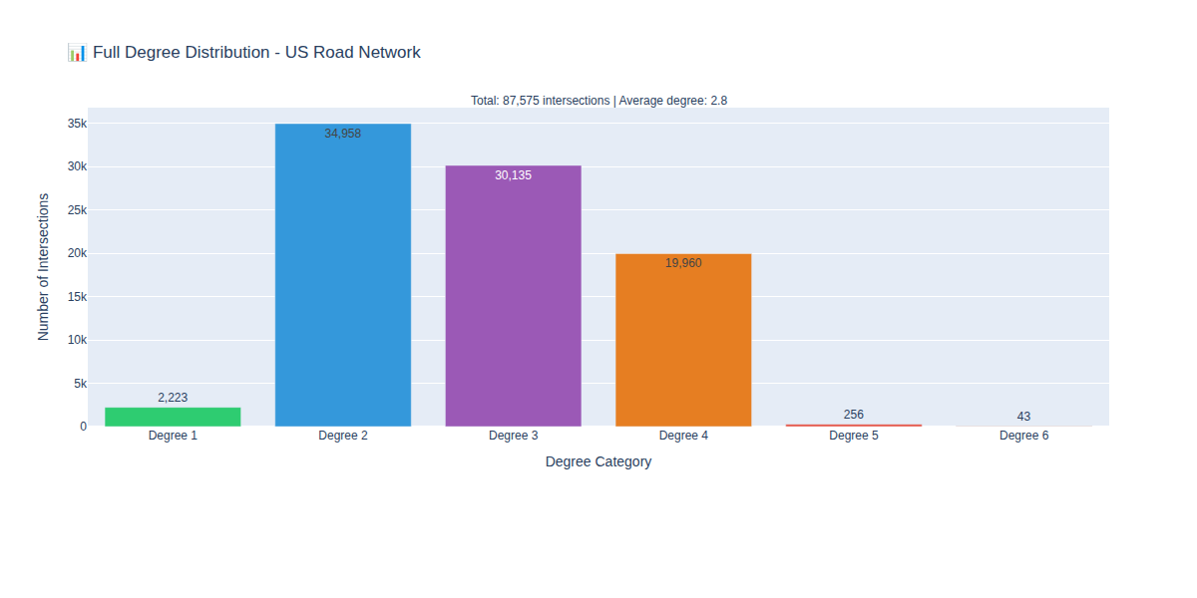
Figure 9: Enhanced Degree Distribution with color coding

5. Key Insights and Conclusions

5.1 Network Characteristics
- The US road network is a sparse graph with an average degree of 2.8 — most intersections connect to only 2 or 3 roads
- The network contains 87,575 intersections and 121,961 roads covering the continental United States
- Only 0.34% of intersections (299 nodes) qualify as high-connectivity hubs, yet they play a disproportionately important role
- The maximum observed degree is 6, indicating even the most complex highway interchanges connect to at most 6 road segments

5.2 Critical Infrastructure
- Intersection 314 is the most critical node with a betweenness centrality of 0.2548
- The top 10 betweenness centrality nodes all have scores above 0.15
- Disrupting even a small number of high-centrality intersections could significantly fragment network connectivity

6. Challenges and Solutions

Challenge | Solution
Betweenness centrality timed out on full graph | Used NetworkX on a 500-node subgraph
APOC plugin not available | Used Neo4j built-in shortestPath() instead
Large dataset loading time | Implemented batch processing (1,000 records/batch)
GDS betweenness returning inf/nan | Switched to NetworkX with proper sampling
Neo4j password reset failure | Deleted and recreated instance with known password

7. Conclusion
This project successfully demonstrated the power of graph databases for analyzing large-scale road networks. Using Neo4j as the core platform, we loaded and analyzed the complete US road network comprising 87,575 intersections and 121,961 roads.

The analysis revealed that the US road network is a sparse, predominantly low-to-medium connectivity graph with a small number of critical high-connectivity hubs. Neo4j proved to be an excellent tool for this type of analysis, offering intuitive graph querying through Cypher, efficient path-finding algorithms, and seamless Python integration.

Future work could extend this analysis to include real geographic coordinates for mapping, time-based traffic simulation, and community detection to identify natural geographic clusters within the road network.

References
- Neo4j, Inc. (2024). Neo4j Graph Database Documentation. https://neo4j.com/docs/
- Neo4j, Inc. (2024). Graph Data Science Library Documentation. https://neo4j.com/docs/graph-data-science/
- Hagberg, A., Swart, P., & Chult, D. (2008). NetworkX: Network Analysis in Python. https://networkx.org/
- Plotly Technologies Inc. (2024). Plotly Python Graphing Library. https://plotly.com/python/
- Sedgewick, R., & Wayne, K. (2011). Algorithms, 4th Edition. Princeton University.

