**Good day HyperionDev Mentor,**

I hope this message finds you well.

I am writing to express my excitement about the recent assignment from a backend perspective, a field I am passionate about and intend to pursue upon graduation. For my capstone task, I decided to create a webpage featuring multiple bands. While the assignment specified a fictional band, I chose to focus on real bands to enhance my learning experience, particularly in embedding music or playlists into a webpage. I have attached the references for the sources of information for your review.

I hope that despite this slight deviation from the fictional requirement, I have successfully met the objectives of my capstone project. I understand that in a professional setting, clients often have specific and stringent requirements, and I am committed to adhering to such standards in my future endeavours.

Additionally, please note that I have commented out a function (or element) in my base.html file, specifically the drop-down menu. I plan to link my other Django web applications to it once I refine their designs, as I intend to include them in my portfolio. Kindly refer to the code comments for further details.

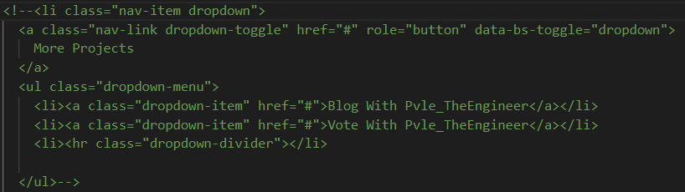

Thank you very much for your assistance. It is highly appreciated, and I eagerly anticipate completing my bootcamp, hopefully among the top five in the class.

Wishing you well,

Kind regards,

**Gaopalelwe Molekoa, GW24010012802**

**References:**

**The Temptations:**

* AllMusic, 2024. The Temptations | Biography & History. [online] Available at: https://www.allmusic.com/artist/the-temptations-mn0000569685/biography [Accessed 8 July 2024].
* Rock & Roll Hall of Fame, 2024. The Temptations. [online] Available at: https://www.rockhall.com/inductees/temptations [Accessed 8 July 2024].

**The Beatles:**

* Rolling Stone, 2024. The Beatles Biography. [online] Available at: https://www.rollingstone.com/music/artists/the-beatles/biography [Accessed 8 July 2024].
* Britannica, 2024. The Beatles | Members, Songs, Albums, & Facts. [online] Available at: https://www.britannica.com/topic/the-Beatles [Accessed 8 July 2024].

**Wu-Tang Clan:**

* AllMusic, 2024. Wu-Tang Clan | Biography & History. [online] Available at: https://www.allmusic.com/artist/wu-tang-clan-mn0000959878/biography [Accessed 8 July 2024].
* Rolling Stone, 2024. Wu-Tang Clan Biography. [online] Available at: https://www.rollingstone.com/music/artists/wu-tang-clan/biography [Accessed 8 July 2024].