1, Mean, Median and Mode

(<https://en.wikipedia.org/wiki/Mode_(statistics)#Example_for_a_skewed_distribution)>

Estimator a, b and c are calculated for the following two empirical probability distribution functions (PDF)

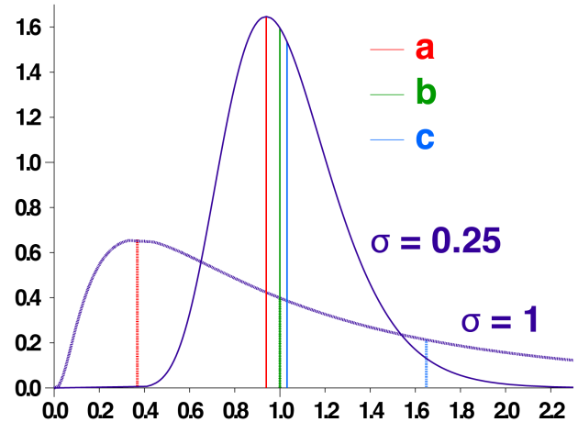From a frequentist point of view (i.e., in a long series of repeated experiment), estimator c is a good approximation of the expect value of random value draw from PDFs in a long run, while random value *x* draw from these PDFs has 50% being x>b and 50% being x<b.

a \* \* Mode

b \* \* Mean

c \* \* Median

2, Variance and Covariance

(<http://stats.stackexchange.com/questions/18058/how-would-you-explain-covariance-to-someone-who-understands-only-the-mean>)

We can represent variance as the mean of the pair-wise distance (Euclidean distance) between all the points of a sample.

Similarly, covariance could be represented as the “common 2D space” cover by all the pairs of points, the average of all the space is the covariance.

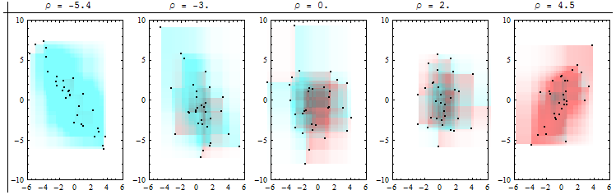Covariance could be positive or negative: given the following 4 pairs of points in 2D, draw all the positive and negative rectangle of all the possible combinations.

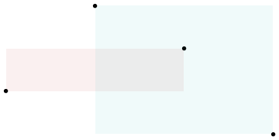Positive : Negative: