**Project Name: UMB Campus 3D**

**Team Members:**

☺ Ankur Upadhyay

☺ Fangyu Lin

☻ Haikun Huang (Chair)

☺ Srinivas Iyer

☺ Vijeth

☺ Zheng Zheng

**Project Agreement**

**Introduction:**

Our goal is to build a first-view 3D UMass Boston Campus Map by using the tool Unity_3D and the Oculus Rift Virtual Reality Headset. The development tool is Unity_3D which is a free programming source online. The Oculus Rift Virtual Reality Headset is used to view and walk in the virtual UMB Campus and all the buildings. Users can use keyboard or other electrical input devices to walk around in the virtual campus, or if it is possible to use “Virtuix Omni Virtual Reality platform” which would be awesome. There are 8 buildings in the UMB campus and they have different architectures and structures, including Campus Center, Wheatley Hall, McCormack Hall, Science Center, Healey Library, Quinn Building, Clark Athletic Center, and Massachusettls Archives. Users are able to view them from outside, as well as walking inside the buildings. There are many rooms in all the buildings so visitors can enter to take a close look. Our team may implement some abilities for the users to move instantly from one building to another one which they prefer to visit first. Our team may also add some virtual characters and services around the campus which provide more information about different buildings. We hope that it is enough time to build as many campus buildings as we can to give visitors a good view of UMass Boston.

**Components:**

1. Map: Top view of UMass Boston Campus.
2. Street: Surround the campus.
3. Buildings: 8 different buildings.
4. Campus Center
5. Wheatly Hall
6. Science Center
7. McCormack Hall
8. Healey Library
9. Quinn Building
10. Clark Athletic Center
11. Massachusettls Archives
12. Furniture and equipments:
13. Chairs;
14. Tables;
15. Personal Computer;
16. Doors;
17. Floors;
18. Stairs;
19. Elevators;
20. Bridges;
21. Trees and glasses;
22. Characters or services:
23. Front desk character design;
24. Information input;
25. Audios Speaking and language;
26. Main menu design:
27. Sidebar selection for light source or colors;
28. Language selection (English default);
29. Height selection (optional);
30. Walking speed selection (optional);
31. May have music interface available;
32. Exit virtual UMB campus;

**User Input:**

The basic version:

The Oculus Rift Virtual Reality Headset: control the rotation of the camera.

Keyboard: control the move and the special action/interact.

The advance version:

The Oculus Rift Virtual Reality Headset: control the rotation of the camera.

Leap Motion Hand Tracking device: control action/interact.

Virtuix Omni Virtual Reality platform: control the move.

**Simulation**:

User/Player will start at the start point which is located the front door in the CC Building, and he/she/it can feel free to go around. In the advance version, there are will be some NPCs (students or others) walking in the same level.

User/Player can use the doors, stairs, or elevators to move to the next level.

User/Player can interact with the NPCs, in order to get the informations about the campus. In advance version, we can fetch the news from the database, in order to keep the informations up to date.

The computer counters can provide some small games to our User/Player for fun, the idea come from the game Watch Dogs. Such as a shooting flies or something like that, we also can create a leaderboard for each games.

ect.

===========================IMPORTANT============================

**Tasks List:**

Our basic goal is complete the basic version on time, if we have extra time for the project, we can try to take the advance version down.

**Main Framework** (coding | basic): this task is responsibility to handle and organize all the levels in the project.

**Model Collector** (modeling | basic): this task required to collect the model online or somewhere, both buildings and NPC characters (include animations) (Haikun can provide some ugly characters with animations for test).

**Level Design** (modeling | basic & advance): this task is responsibility to build up or layout the models similar to the campus. For the basic version, this task is required to build an outside level (which is the map with all the 8 building in campus), and an indoor level (e.g SB or CC).

**Lights Setting** (modeling & coding | basic & advance): this task is responsibility to setup the light in each levels. For the advance version, also, this task is required to build up a relationship between light(s) and switch, this feature will be applied to the advance version.

**NPC System 1** (modeling & coding | basic): this task is responsibility to setup the NPC system, for the basic, NPC could just keep walking around in the currently level. We can setup some waypoint, which can guide the NPC to walk to. So, here we need to make the NPC walking looks more nature, the setting of the waypoint and the algorithm of finding a waypoint must be logically.

**NPC System 2** (coding | advance) this task is responsibility to make the NPC more humanity. In this task, we allow the user/player interact with NPCs, such as provide information about our school, or something else. Fetch the information from online database or local text files, or both. Different NPC should provide different kinds of the information, in other words, the information which be provided from the NPC must be match the NPCs’ identity.

**Levels Change** (coding | basic) this task responsibility to organize all the levels in the project, in other words, this task is required to build up the relationship between the levels, (e.g, level 1 of the CC only can go to the level 2 or upper level of the CC via stairs, or can go which level you want of the CC building via elevators, or go to the SB via the catwalk, but no way to directly go to the MB, WB or other buildings), also, need to mark out or setup the transfer point to levels change.

**Games** (coding | advance | big task) this task is responsibility to build up some funny game into the project, such as shooting something or finding something in the campus.

Here is a good example, Light Up the Building, once User/Player activate a mission, there is a time limit, such as 1, or 2 mins, and some or all of the lights in the currently building will turn off, and the goal of this mission is turn all lights before the time countdown to 0.

Or Bomb Setting, once User/Player activate a mission/setup the bomb, he need to escape from the currently building, and avoid to be caught/seen by anyone(NPC). Once he/she/it escaped, win the game, and of cause we do not need to bomb the building up, because it is to evil.

More funny game.

All the scores will record and signed into the leaderboard.

**Responsibility**:

☺ Ankur Upadhyay

☺ Fangyu Lin

☻ Haikun Huang, Main Framework, Games, and supporting to the all the tasks,

☺ Srinivas Iyer

☺ Vijeth

☺ Zheng Zheng

**Folders Organization:**

Once you setup down the file from the SVN, please just create a new project in local, and just copy these two folder [**ProjectSettings**, **Assets**] to your local project. And you will see the folders organization as below: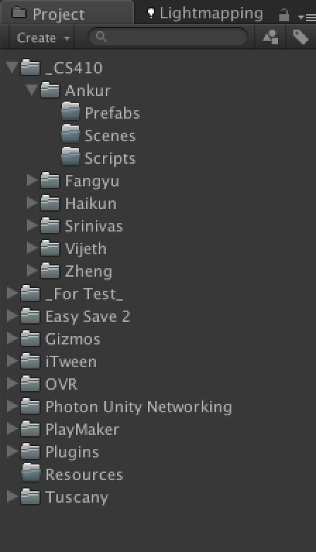

Here is some main folders we need to pay attention on it.

[**Resources**], this folder is reserved by Unity3D, this is use to store the resource which will be loaded by Unity3d runtime. We will use it later.

[**_CS410**], this folder is use to store all the files of the final project, we are going to put our jobs under our folders,

and the folder [**Prefabs**] will use to store the prefabs, which is a kind of resource of Unity3d recognized. [**Scenes**] will use to store the *.unity files which your created. [**Scripts**] will use to store all the *.cs files which your created. So, all the final works will be store here.

[**_For Test_**], this folder has the same organization to the [**_CS410**]. This folder can use to do some test or some demoes for study the Unity3D, it is not for the final project. So, feel free to test your code here and shared to the team, for fun or study.

Other folders are the add-ons or demoes or other recourse, so just leave them there.

**NOTE: Please create a folder [Model] under your folder to store the models your find online.**

[**ProjectSettings] is the basic setting of the Unity3D, we will discuss later. And Haikun will maintain this folder.**

**How to name your files?**

Use your name as a prefix of the *.cs file, e.g, HHK_XXXX.cs, and store it under your folder/Scripts.

**How to upload your files?**

Please Just upload the works which you did, you do **not** want to upload the whole project include the other people’s work, if you do so, it would be covered all the files when the other people download the project from the SVN, they will lose their works.

**Where are the docs located?**

All the docs should be located under the Docs/your folder of SVN, do **not** leave any docs under any Unity3D project, Unity3D may not recognize the docs files and may cause the errors.

The docs are used to describe what did you do and how to use the *.cs files which you create.