1. 可不可以举个例子说明什么时候会调用super()函数去访问父类的方法？（其实想问一下为什么要设计super函数？子类都重写父类的方法了为什么还要去调用父类的方法？）

Could you give an example of when to use the super() function to access a method from the parent class? (Actually, I want to ask why the super function is designed. If subclasses override methods from the parent class, why bother calling methods from the parent class?)

2，Why does our example implement the queue with such complex code? Can't it be simpler as the following?

为什么我们的示例当中实现队列要采用那么复杂的代码，这样不可以吗？

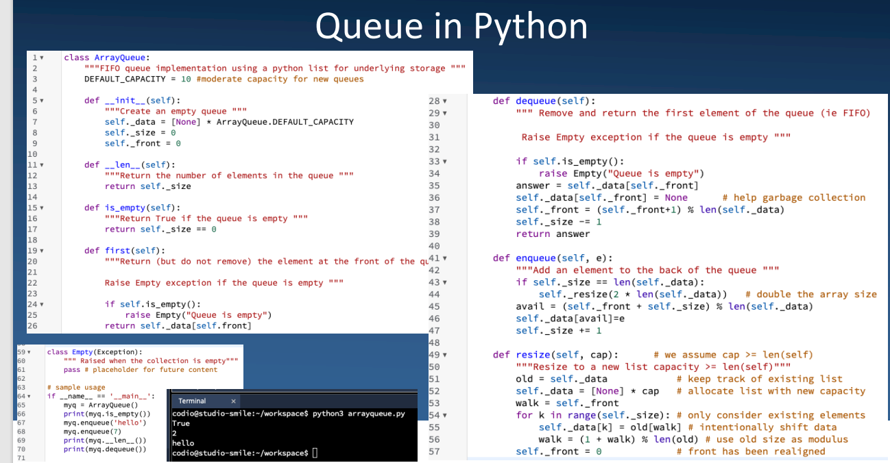

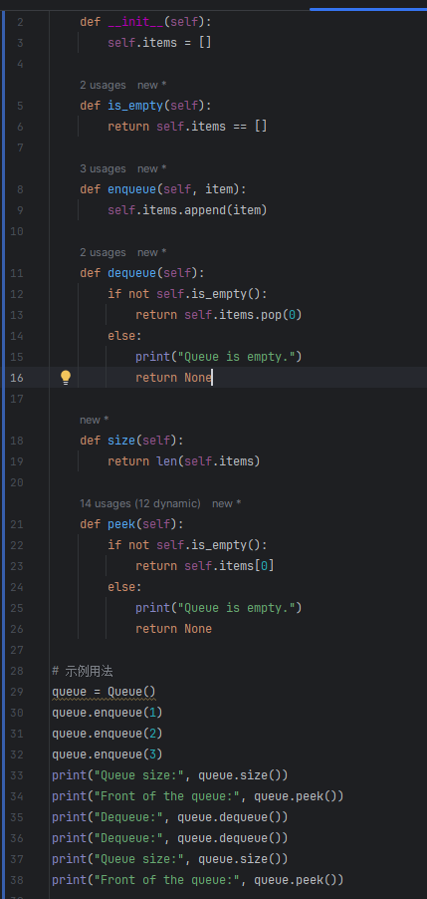

3

Why are there two different ways to implement the queue?

为啥队列的实现要分成这两种方式？

