UNIVERSITI TUNKU ABDUL RAHMAN

JUNE 2024 TRIMESTER

PRACTICAL ASSESSMENT
(30 marks)
This Practical Assessment is worth 15% of the overall assessment of the course.

UCCD3243 SERVER-SIDE WEB APPLICATIONS DEVELOPMENT

THURSDAY, 5 SEPTEMBER 2024 TIME: 6.15 PM to 7.45 PM (1 Hour 30 Minutes)

BACHELOR OF COMPUTER SCIENCE (HONOURS)
BACHELOR OF INFORMATION TECHNOLOGY (HONOURS)
COMMUNICATIONS AND NETWORKING
BACHELOR OF INFORMATION SYSTEMS (HONOURS)
BUSINESS INFORMATION SYSTEMS
BACHELOR OF INFORMATION SYSTEMS (HONOURS)
INFORMATION SYSTEMS ENGINEERING

Instructions to Candidates:

General

- This Practical Assessment (PA) is an Individual, time restricted assessment which consists of ONE (1) question.

- You are required to answer the question, and submit the ANSWER SCRIPT by 5th SEPTEMBER 2024, 7.45 PM.

Answer Script File

- The answer script and project solution MUST be saved and compressed in a ZIP file and the formatting of your solution is as follows:

- You MUST name your zip file using the following file name for submission:
[Course Code]_PA_[Programme Abbreviation]_[Student ID Number]_[Student Name]

For example, if you are from the degree programme IB, and your student id is A01234CBIBF, then your zip file should be named as
UCCD3243_ PA_ IB_ 17ACB07451_SamDavid.zip

- Your Project File MUST be named as follows: *no space between names

[Your Name][Your ID Number] (Example: SAMDAVID17ACB07451)

SAM DAVID17ACB07451 

SAMDAVID17ACB07451 

- After that, zip again the project solution file and practical test question file (ensure that you have filled up your necessary information on page 3). For this zip file, you can follow the same file format name in Step 4.

- The zip file should consist of the following files:
- The answer script with your details
- The source code files

- You are required to use PHP, XAMPP, and phpMyAdmin to complete the practical test.

- COMMENTS MUST BE INCLUDED IN THE SOURCE CODES WHERE NECESSARY.

Answer Script and Project Solution Submission

- Your answer script and project solution files must be submitted to the following platform before the due time/date.
- Upload your zip file at the following Google Form:

https://shorturl.at/pHyT9

Note: Use your “1UTAR” email account to access the Google Form.

UNIVERSITI TUNKU ABDUL RAHMAN

JUNE 2024 TRIMESTER

PRACTICAL ASSESSMENT

ANSWER SCRIPT

Candidate is required to fill in ALL the information below:
Name : (as stated in Student Identity Card) | Chwa Guang Yao
Faculty /Institute/ Centre: | FICT | Programme : | CN
Student ID (in numbers) : | 2106423 | Student ID (in words) :
Course Code : | UCCD3243 | Course Name :
Submission Date : |  | Time :

GRADING CRITERIAS | FOR EXAMINER’S USE ONLY
GRADING CRITERIAS | MARKS
Database Setup (2 marks)
Live Search Functionality (9 marks)
AJAX Implementation (9 marks)
User Experience (2 marks)
Error Handling (5 marks)
Code Organisation and Quality (3 marks)
TOTAL MARKS

Answer the following question:

Task: Implement a live search feature for the book search functionality on ABC School’s website.
Current Setup: The school’s database currently holds information on 20 books, including details such as titles, authors, genres, publishers, and ISBN numbers.
Provided Resources:
- SQL File: You have been given a “library_db.sql” file that contains the structure for a book_details table. You need to import this file into your MySQL database using phpMyAdmin.
- PHP File: A file named search_book.php has been provided for you to implement the live search functionality.
Instructions:
- Use the search_book.php file to implement a live search feature that displays book records from the “library_db” database.
- Live Search Feature:
  - Users should be able to search for books by entering keywords into a search input field.
  - The search functionality should match the user’s input against book titles, authors, genres, publishers, or ISBN numbers.
  - The results should update in real-time as the user types.
- Implementation:
  - Use AJAX in conjunction with PHP to implement the live search.
  - The PHP script should query the database based on the user's search input and return the relevant results.
  - If no records match the search term, display a status message to notify the user.
- AJAX Functionality:
  - You may implement the AJAX functions either within the same page (search_book.php) or in a separate page, depending on your preference.
  - Ensure that the page functions properly and provides a seamless user experience.
- Error Handling:
  - Implement appropriate error-handling techniques to manage potential issues that may arise during the live search process.
Sample Output (for your reference)
Live Search

Search by title:

Search by author:
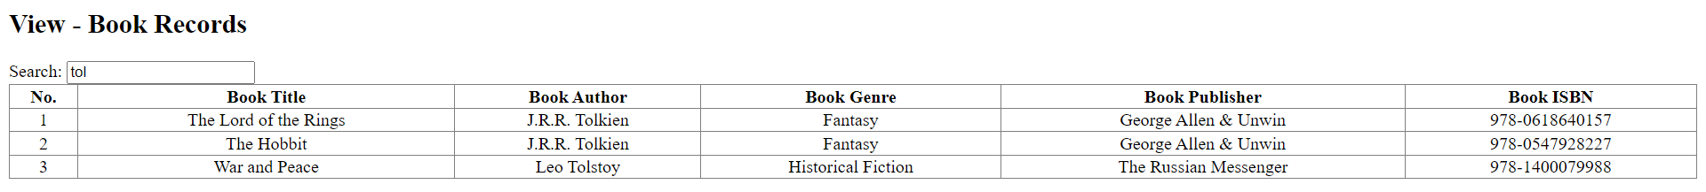

Search by genre:
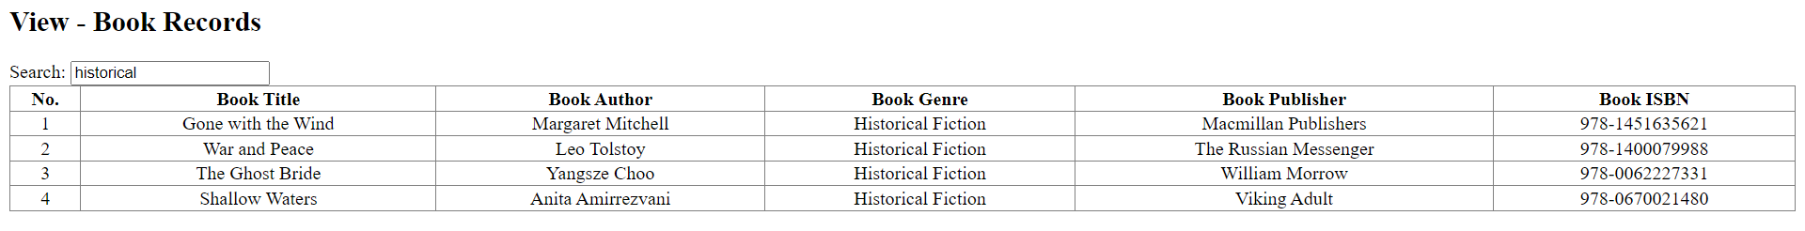

Search by publisher:

Search by ISBN:


View all records - display without search:
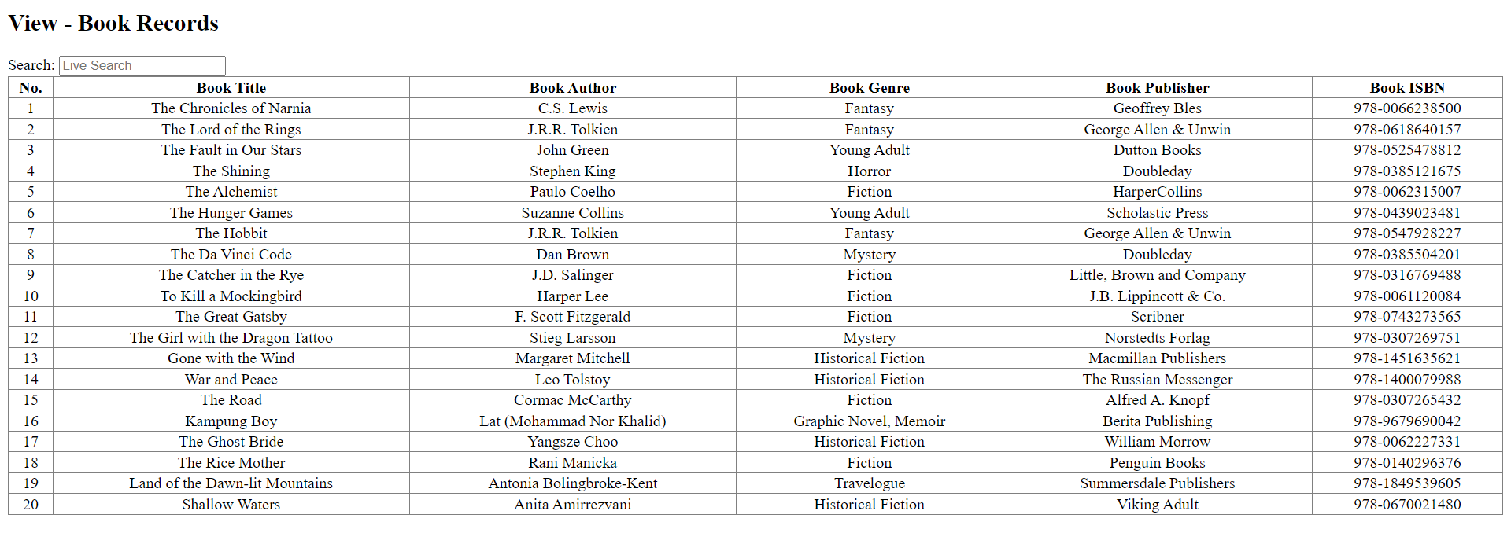

If the search term entered by the user does not match any records in the database:
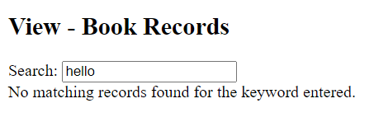

If the search term is empty:


