1. **根据日期区间查日历图的数据** 
   1. 接口地址：

<http://localhost:50401/apis/inspectorder/GetSubInspectOrderDateByTime?start=2019-11-04&stop=2019-11-08>

* 1. 参数列表：

start string 开始时间

stop string 结束时间

* 1. 返回值示例：(返回值为集合)

{

"Flag": true,--查询成功并且有数据为True。没有数据或者报错为false

"Message": "查询成功",

"Data": [ {

"Device_id": "0", --设备编号,用来区分颜色。（0:平台，1:主臂，2:辅臂）

"Platform_id": "6d5f8d87-a0af-4ac0-a008-6ed38946d6c5",--平台号对应页面中的resourceId

"PartName": "Q3_右侧围*1",--零件名称和数量对应页面中title

"Plan_Start_Time": "2019-11-05 00:00:00",--开始时间，对应页面中的start

"Plan_End_Time": "2019-11-05 23:59:59"—结束时间，对应页面中end

},

{

"Device_id": "0",

"Platform_id": "6d5f8d87-a0af-4ac0-a008-6ed38946d6c5",

"PartName": "Q3_右侧围*1",

"Plan_Start_Time": "2019-11-06 00:00:00",

"Plan_End_Time": "2019-11-06 23:59:59"

},

{

"Device_id": "1",

"Platform_id": "f4d335f7-5fa9-41a8-8c09-1cf90ee8229e",

"PartName": "Q3_右侧围*1",

"Plan_Start_Time": "2019-11-06 00:00:00",

"Plan_End_Time": "2019-11-06 23:59:59"

},

{

"Device_id": "1",

"Platform_id": "f4d335f7-5fa9-41a8-8c09-1cf90ee8229e",

"PartName": "Q3_右侧围*1",

"Plan_Start_Time": "2019-11-07 00:00:00",

"Plan_End_Time": "2019-11-07 23:59:59"

}]

}

注：页面代码截图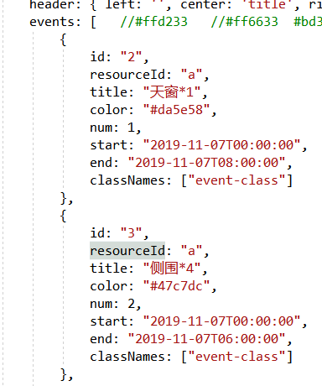

1. **根据日期区间和平台号查子任务列表**
   1. 接口地址：  
      http://localhost:50401/apis/inspectorder/GetSubInspectOrderListByTime?oneday=2019-11-07&platformid=f4d335f7-5fa9-41a8-8c09-1cf90ee8229e
   2. 参数列表：  
      oneday string 鼠标点击的日期  
      platformed string 平台号
   3. 返回值示例：

{

"Flag": true,--查询成功并且有数据为True。没有数据或者报错为false

"Message": "查询成功",

"Data": [

{

"OrderNo": "P-Q3_YCW-20191105-3",--主任务编号

"PartCode": "Q3_YCW", --零件编号

"PartName": "Q3_右侧围",--零件名称

"LevelId": "L3",--检测等级

"RequireDate": "2019-11-05T00:00:00",--需要结束时间

"SubOrderNo": "P-Q3_YCW-20191105-3-1",--子任务编号

"Status": "完成",--子任务状态

"PlanStartTime": "2019-11-06 00:00:00",--计划开始时间

"PlanEndTime": "2019-11-08 00:00:00",--计划结束时间

"StartTime": "2019-11-06 15:05:40",--实际开始时间

"EndTime": "2019-11-06 15:05:46",--实际结束时间

"InspectorId": "76b7869f-255d-4ab2-b8ef-20ce48c09b27",--检测人编号

"Inspector": "姚文泊",--检测人姓名

"InspectedDesc": null—备注

},

{

"OrderNo": "P-T-Roc_DG-20191107-3",

"PartCode": "T-Roc_DG",

"PartName": "T-Roc_顶盖",

"LevelId": "L3",

"RequireDate": "2019-11-08T00:00:00",

"SubOrderNo": "P-T-Roc_DG-20191107-3-3",

"Status": "接受任务",

"PlanStartTime": "2019-11-07 00:00:00",

"PlanEndTime": "2019-11-08 00:00:00",

"StartTime": null,

"EndTime": "0001-01-01 00:00:00",

"InspectorId": "76b7869f-255d-4ab2-b8ef-20ce48c09b27",

"Inspector": "姚文泊",

"InspectedDesc": null

}]

}

1. **查询平台列表：**

接口地址：<http://localhost:50401/apis/resource/GetAllPlatform>

参数：无

返回值信息：最下面有代码图片 （当前只有id和name 有数据，其他的都是null）

{

"Flag": true,--查询成功并且有数据为True。没有数据或者报错为false

"Message": "查询成功",

"Data": [

{

"Code": null,

"OrgId": null,

"SerialNo": null,

"ID": "6d5f8d87-a0af-4ac0-a008-6ed38946d6c5",--平台ID ，代码中的Id对应

"Name": "平台一", --平台名称，代码中的title对应

"Description": null,

"ParentId": null,

"TypeId": null,

"TypeDetailId": null,

"TypeDetailName": null,

"TypeDetailModelId": null,

"TypeDetailModelName": null,

"Manufacturer": null,

"BuyDate": "2019-11-12T21:39:43.7832861+08:00",

"StdHours": null,

"MinTemperature": null,

"MaxTemperature": null,

"WorkingState": null,

"Disabled": null,

"DisabledDate": "2019-11-12T21:39:43.7832861+08:00",

"LastMaintainDate": null,

"NextMaintainDate": null,

"MaintainCycleDays": null,

"MaintainWarnDays": null,

"Picture": null,

"Remark": null,

"Org": null,

"EquipmentType": null,

"PLATFORMTYPE": 0,

"Range": null,

"Precision": null,

"ModelFormat": null,

"ValidatedDate": null,

"CreationUser": null,

"CreationTime": "2019-11-12T21:39:43.7832861+08:00",

"LastUpdated": "2019-11-12T21:39:43.7832861+08:00",

"ObjectState": 0 },

{

"Code": "Test003",

"OrgId": "3712a5c8-e69b-4225-b5f4-d96ff076a488",

"SerialNo": null,

"Name": "平台三",

"Description": null,

"ParentId": null,

"TypeId": null,

"TypeDetailId": "14b95a55-edf1-44f7-aad7-c84c487803e6",

"TypeDetailName": null,

"TypeDetailModelId": null,

"TypeDetailModelName": null,

"Manufacturer": null,

"BuyDate": "2019-11-12T00:00:00",

"StdHours": null,

"MinTemperature": null,

"MaxTemperature": null,

"WorkingState": "on",

"Disabled": null,

"DisabledDate": "2019-11-12T19:22:35.3541092",

"LastMaintainDate": "2019-11-12T00:00:00",

"NextMaintainDate": "2020-04-11T00:00:00",

"MaintainCycleDays": 180,

"MaintainWarnDays": 30,

"Picture": null,

"Remark": null,

"Org": null,

"EquipmentType": null,

"PLATFORMTYPE": 0,

"Range": null,

"Precision": null,

"ModelFormat": null,

"ValidatedDate": null,

"ID": "c0481acc-3fad-4364-82c5-bb8b17c515bc",

"CreationUser": null,

"CreationTime": "2019-11-12T19:22:35.3541092",

"LastUpdated": "2019-11-12T19:22:35.3541092",

"ObjectState": 0

}]

}

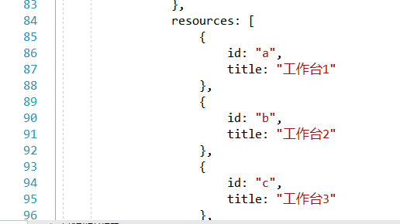

0:蓝色

1:绿色

2:红色