**Data integration (Airbyte cloud) data source**

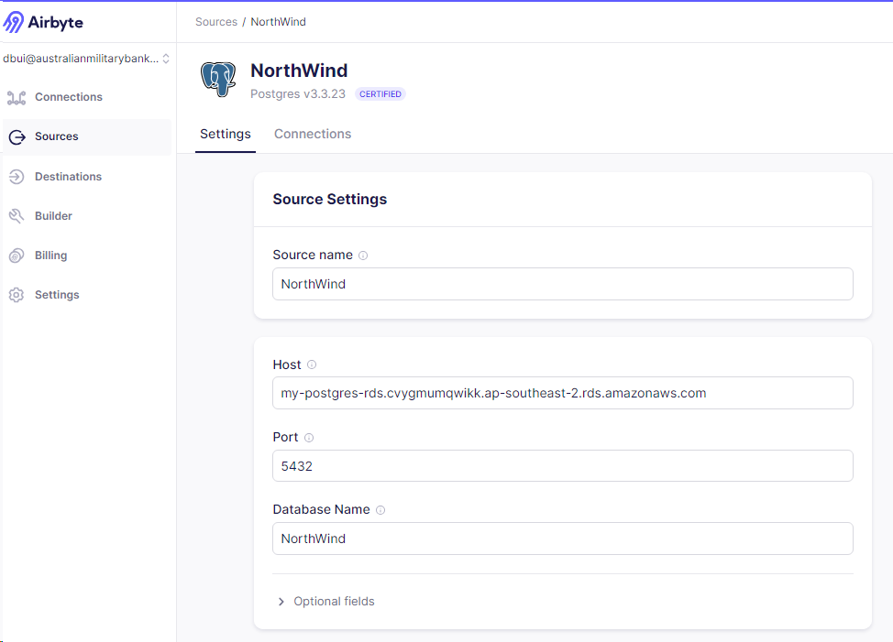

**Data integration (Airbyte cloud) data destination (Snowflake cloud DWH)**

**Airbyte cloud incremental extract**

**Data Transformation (DBT cloud and Snowflake)**

**Data modelling**

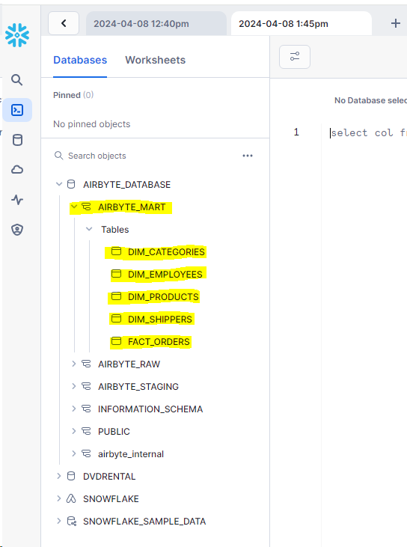

**Testing**

(generic tests)

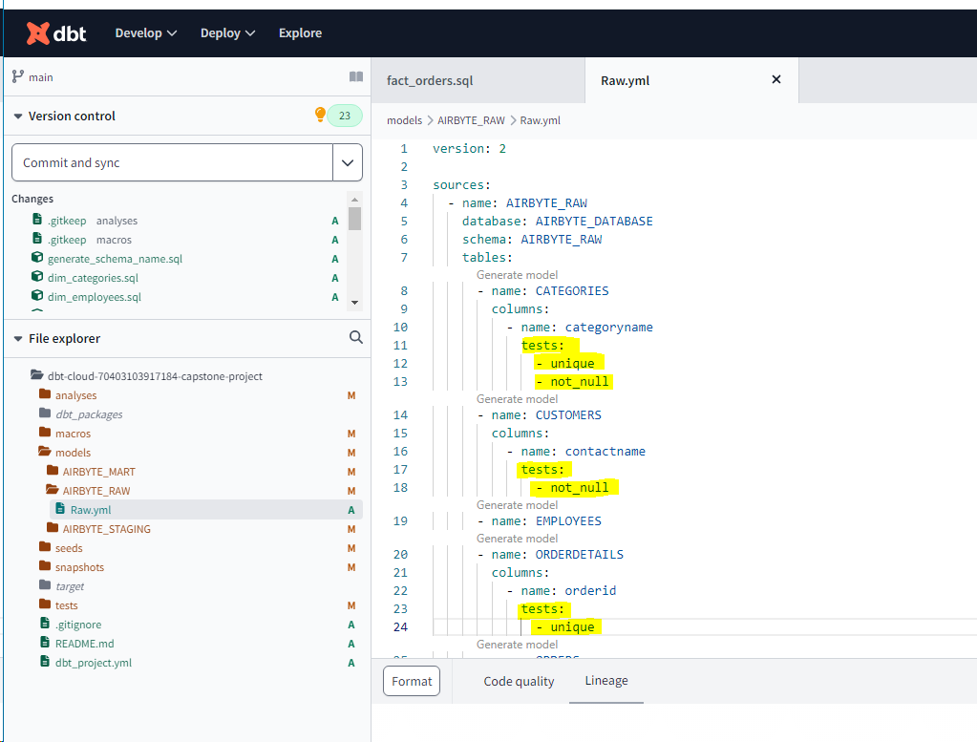

(singular test)

**Creating dependencies**

(source)

(ref)

