CIS355A Lab Report

**Your Name:** Roman Kovtun

**Date:** 09/09/2018

**Lab Week 1**

**Objective/Purpose of the program**

* Create a class in java with appropriate methods.
* Process user input with the class using the scanner for keyboard input and console output.

**Analysis/Design**

To approach the objectives of the program, we had to create a class HealthProfile which contain the attributes (name, age, weight, and height) which is private instance variables. In addition, class required additional SET and GET methods to call the object from it and pass the new object to the console of the actual program

**Testing/Results**

|  |  |  |  |  |
| --- | --- | --- | --- | --- |
| **Case** | **Description** | **Test Data** | **Expected Result** | **Actual Result** |
| 1 | Tacking a simple test from the user that was shown on Sample Output | Name: John Smith  Age: 35  Weight: 200  Height in Feet: 6  Height in inches: 0 | Expecting the name of the user, BMI result of 27.1, BMI Category: Overweight, and Max heart rate of 185 | Actual results – reference an image that you include below. |
| 2 | Check if the user press X to exit the program | Enter letter X | The console should return the code with 0 to exit the program | Actual results – reference an image that you include below. |

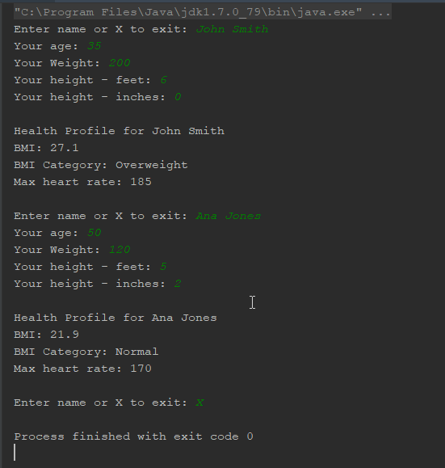

The document the known issue, is that heart rate should 220 minus the age. The max heart rate calculation on the instruction were wrong. So, when I start developing the program I was getting wrong numbers for HR.

**Conclusions / Lessons Learned**

The difficulty that I faced was in building the actual console with a loop. I did had issues of losing the full strings declaration and wrong spacing in the code, but in overall its was fixed on the next day when I came back to the code to check it again and test it as much possible to be sure that everything working fine for the final build.

The only thing I would do for this lab is that I would give some advice how to format the Decimals, I spent a lot of time how to figure out it to get it right one. 😊