CIS355A Lab Report

**Your Name:**

**Date:**

**Lab Week 3**

**Objective/Purpose of the program**

Burger Barn needs a point of sale application.

* Create a GUI that uses JCheckBox, JRadioButton, JTextArea, and menus.
* Process multiple events.

**Analysis/Design**

The GUI should use JRadioButton to choose single or double burger.

* Single burger
* Double burger

It should use JCheckBox for add ons.

* Add cheese
* Add bacon
* Make it a meal

JTextField for item price, order quantity, order total

JTextArea to display the receipt

Create a menu with the following options.

File Order

Exit Add to Order

Clear for next item

New Order

**Testing/Results**

|  |  |  |  |  |
| --- | --- | --- | --- | --- |
| **Case** | **Description** | **Test Data** | **Expected Result** | **Actual Result** |
| 1 | Adding a single burger to the order | - Selected Single burger  - Quantity set to one | Order added to order list and Order total has been updated  Quantity is 1  3.50 for each burger | Image 1 |
| 2 | Adding Double burger with cheese and meal and qty of | - Selected Double burger  - Selected Add Cheese  - Selected Make it a Meal  -Quantity set to two | Order added to the order list and Order total has been updated  Quantity is 2  Has cheese and meal included in the order  9.25 for each burger | Image 1 |
| 3 | Clear the order for next item.  On click of the Order menu item “Clear for next item” should clean the entire order variable except “Order Total” |  | - All Radio and Checkboxes should be unchecked  - Item price set to 0  - Item Quantity set to 1  - Order Total should Stay 22.00  - Order list stays same | Image 2 |
| 4 | New order Button in the Order Menu |  | All fields should set to 0, qty set to 1  Radio buttons and checkbox’s unchecked  Order List set to empty | Image 3 |
| 5 | File -> Exit |  | Window should close the program | It closed the program and stopped running on background |

**Image 1**

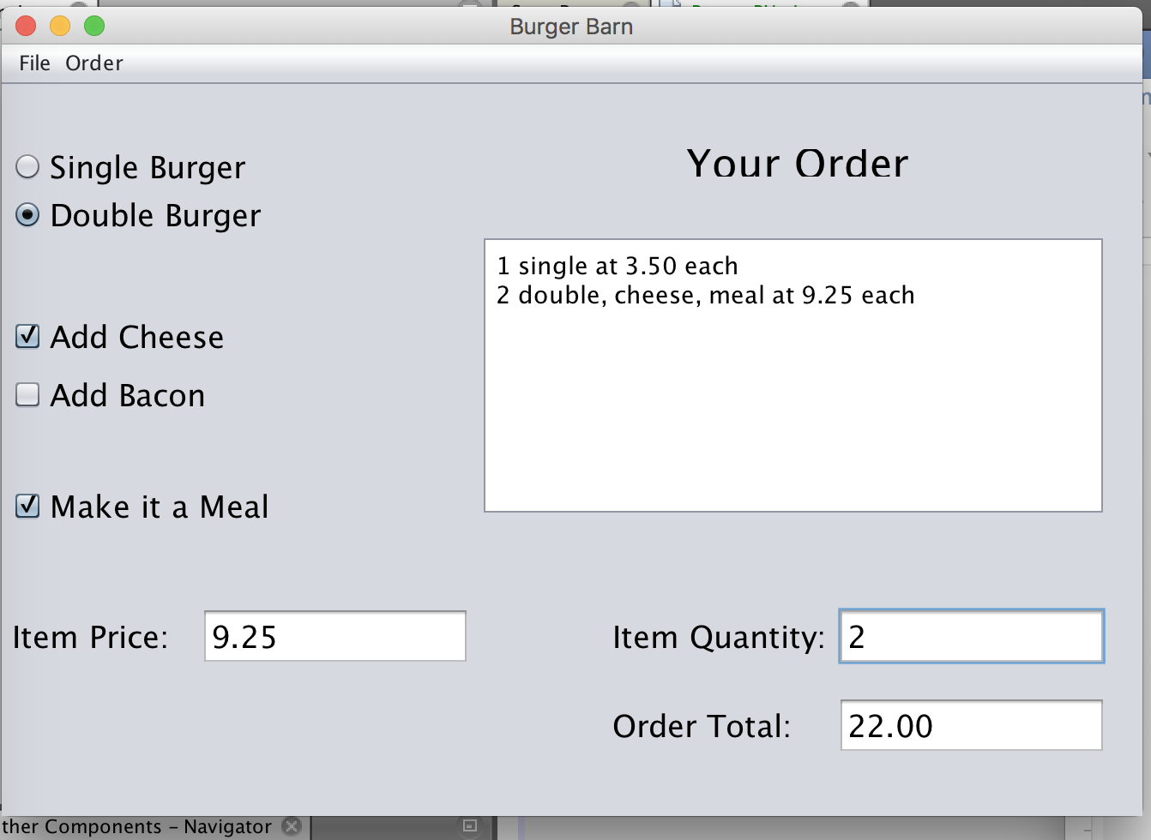

**Image 2**

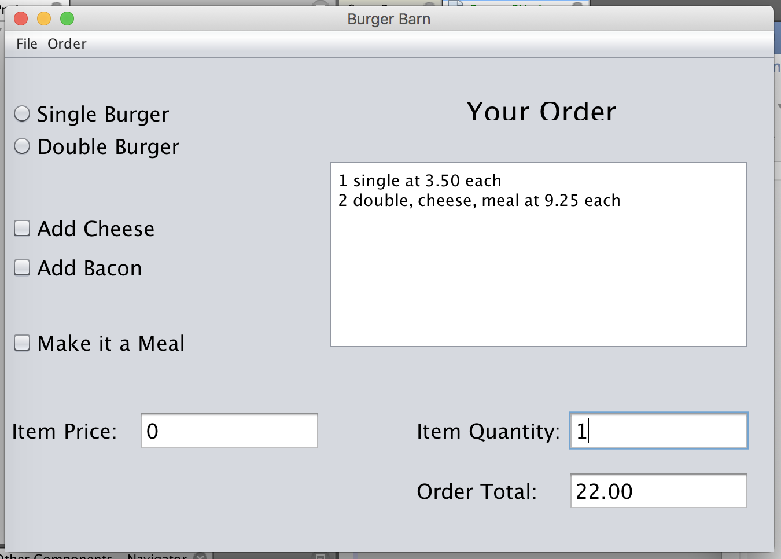

**Image 3**

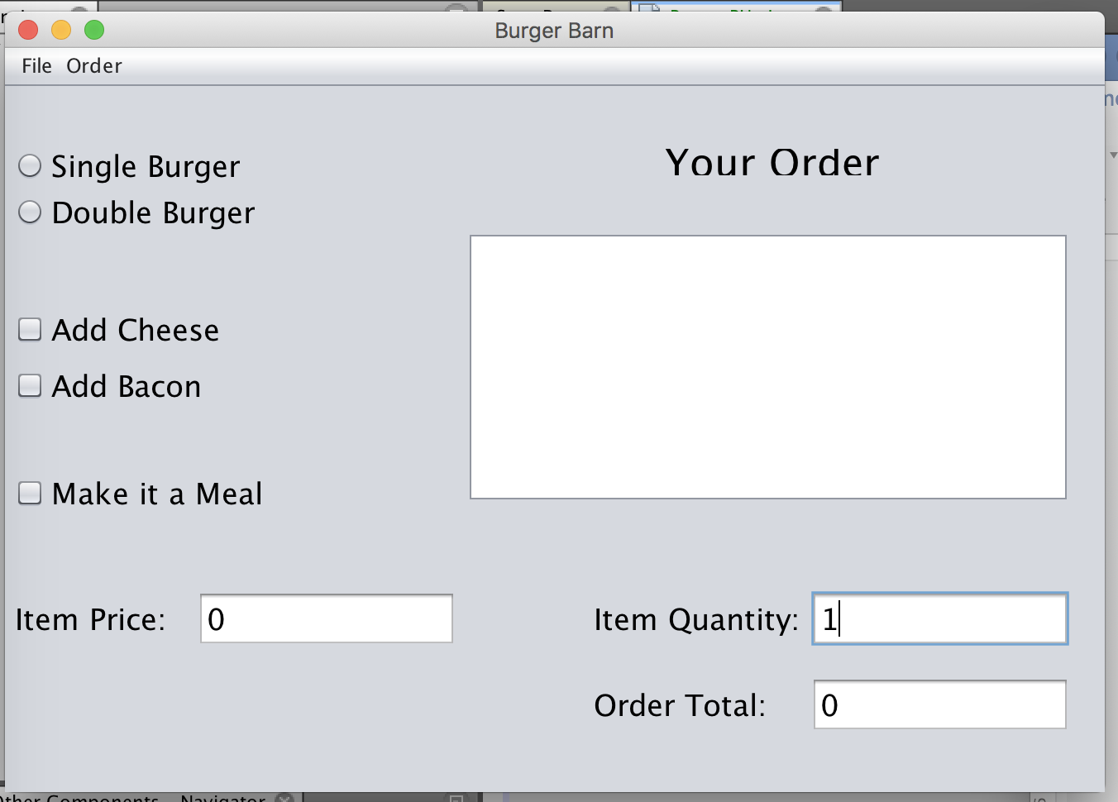

**Conclusions / Lessons Learned**

It was not really hard to work with this program, but I am happy that a program gave me opportunity to learn a new way to group radio buttons to one group and set some of the checkboxes to update the program price.