CIS355A Lab Report

**Your Name: Roman Kovtun**

**Date: 09/29/2018**

**Lab Week 4**

**Objective/Purpose of the program**

* Create a GUI that uses JList and JTabbedPanes.
* Process multiple objects in an ArrayList.
* Code event handlers for multiple events.

**Analysis/Design**

* One tab (“Show stocks”) should have
  + a JList to display all the stock purchases;
  + a text field or label to display information about a particular stock; and
  + a JButton to remove a stock.
* One tab (“Add stock”) should have textboxes, labels, and a button to input a stock.

**Testing/Results**

|  |  |  |  |  |
| --- | --- | --- | --- | --- |
| **Case** | **Description** | **Test Data** | **Expected Result** | **Actual Result** |
| 1 | Create new Stock with name “Apple” | Stock Name: Apple  Quantity: 100  Purchase Price: 200  Current Price: 210 | The stock was added to the List tab and can be selected from the list. Profit / Loss should show $1,000.00 | All results are in the Images below |
| 2 | Removing the “Apple” Stock from the list | N/A | Stock should be removed, and Profit / Loss will become empty field | All results are in the Images below |
| 3 | On selected list should show Profit / Loss | n/a | Should show the result of Profit/Loss value | All results are in the Images below |

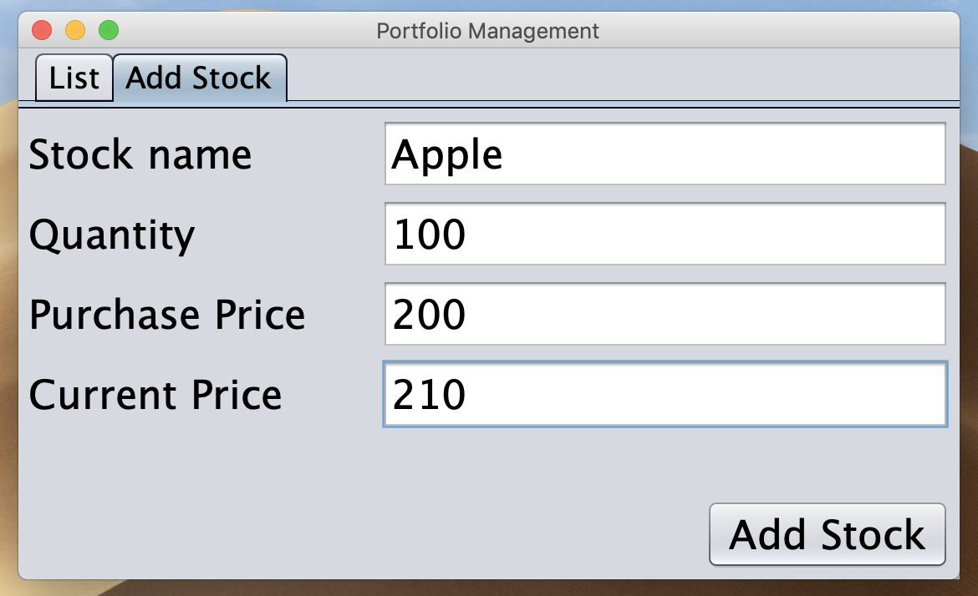

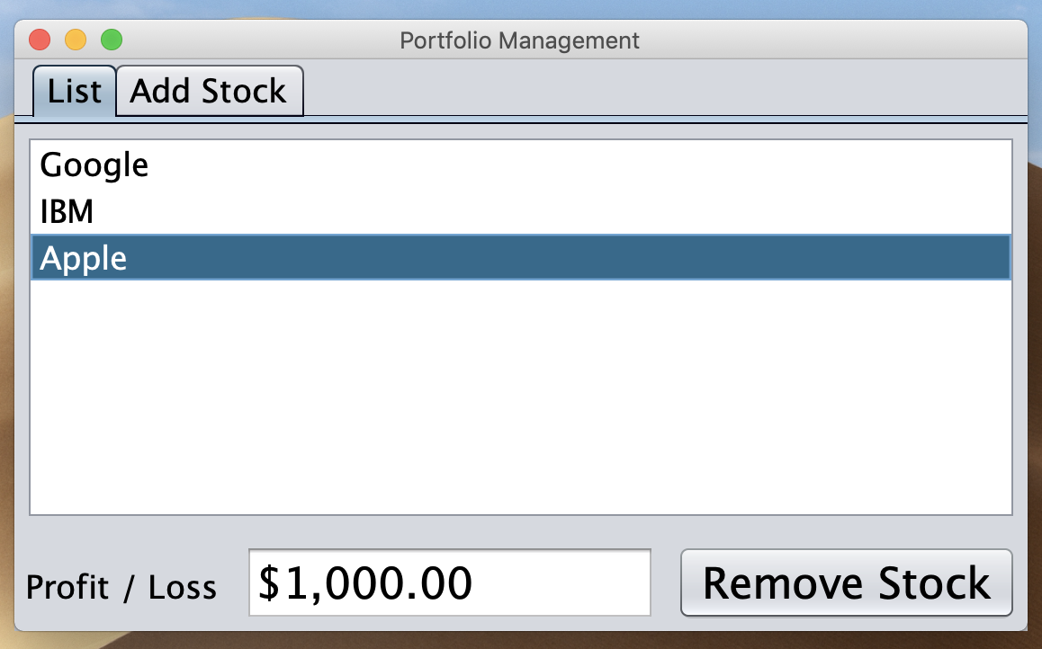

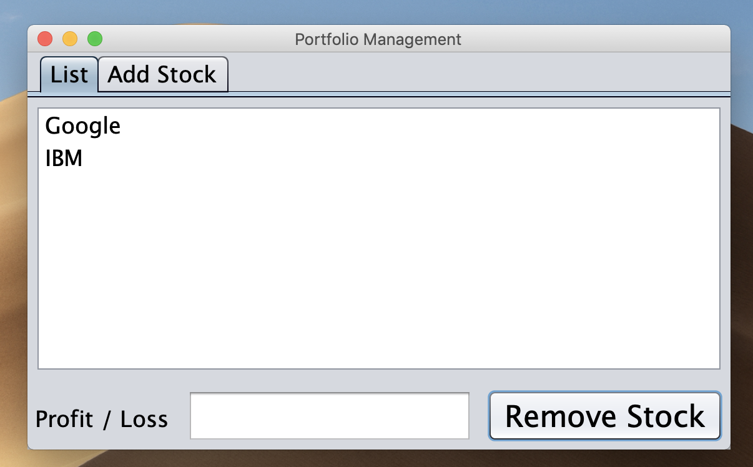

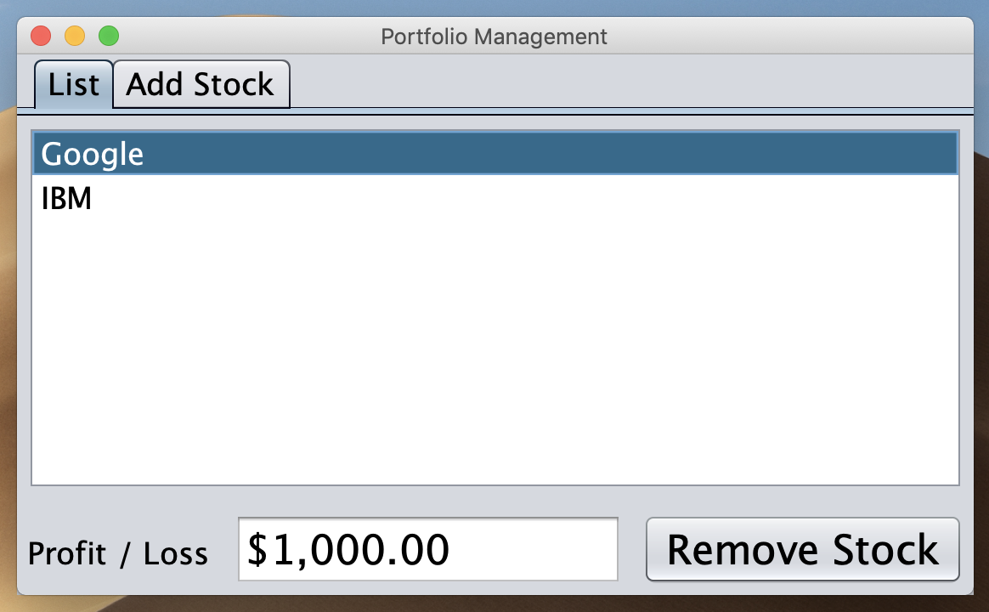

**Conclusions / Lessons Learned**

I have learned how to create a list object that can be selected from the Field List. Also, I learn how to manage a tab when we have multiple values like List and Add Stock. Everything else, was self-explanatory for me and I did not run to any issues.