CIS355A Lab Report

**Your Name: Roman Kovtun**

**Date: 10/07/2018**

**Lab Week 5**

**Objective/Purpose of the program**

* Create a GUI that uses JList and JTabbedPanes.
* Process multiple objects in an ArrayList.
* Code event handlers for multiple events.
* Add persistent data storage to your

**Analysis/Design**

* One tab (“Show stocks”) should have
  + a JList to display all the stock purchases;
  + a text field or label to display information about a particular stock; and
  + a JButton to remove a stock.
* One tab (“Add stock”) should have textboxes, labels, and a button to input a stock.
* GUI class
  + File—open should prompt for file name using JOptionPane, read the file and populate the JList.
  + File—save should prompt for file name to save data from JList to.
  + File—exit should exit the program.
* getData—reads data from file, returns data in array list of stock objects
* saveData—writes data from an array list to the file in proper format
* Create a StockIO class that is used to read from and write to a text file using an ArrayList. Example format of the file is:

Apple#100#55.0#80.0

Intel#50#75.0#70.0

**Testing/Results**

|  |  |  |  |  |
| --- | --- | --- | --- | --- |
| **Case** | **Description** | **Test Data** | **Expected Result** | **Actual Result** |
| 1 | Create new Stock with name “Apple” | Stock Name: Apple  Quantity: 100  Purchase Price: 200  Current Price: 210 | The stock was added to the List tab and can be selected from the list. Profit / Loss should show $1,000.00 | All results are in the Images below |
| 2 | Removing the “Apple” Stock from the list | N/A | Stock should be removed, and Profit / Loss will become empty field | All results are in the Images below |
| 3 | On selected list should show Profit / Loss | n/a | Should show the result of Profit/Loss value | All results are in the Images below |
| 4 | Create a text.txt and stock.txt files | Create 1 stock that will have Apple stock with criteria and then click to save the data, and name the file as stock.txt  After that, create additional file that contain another stock like google and save it as text.txt | text.txt file  apple#100.0#100.0#100.0  google#100.0#200.0#300.0  stock.txt  apple#100.0#100.0#100.0 | Files were created in the folder  All results are in the Images below |
| 5 | Open file to read data | Currently we have text.txt open and saved to our machine. We want to switch the file back to stock.txt | The file should open only stock with Apple | Files were created in the folder |
| 6 | We want to check if the Total value is updated | When we open the stock text.txt file again we want to see that Total Value input has updated value and when we click on the removing one of the stocks we will get one stock. | File should be deleted and only one stock should be left | Files were created in the folder |
| 7 | Clicking on exit | When we select File > Exit the app should turn of itself | GUI turn of itself and its not running anymore | GUI is closed |

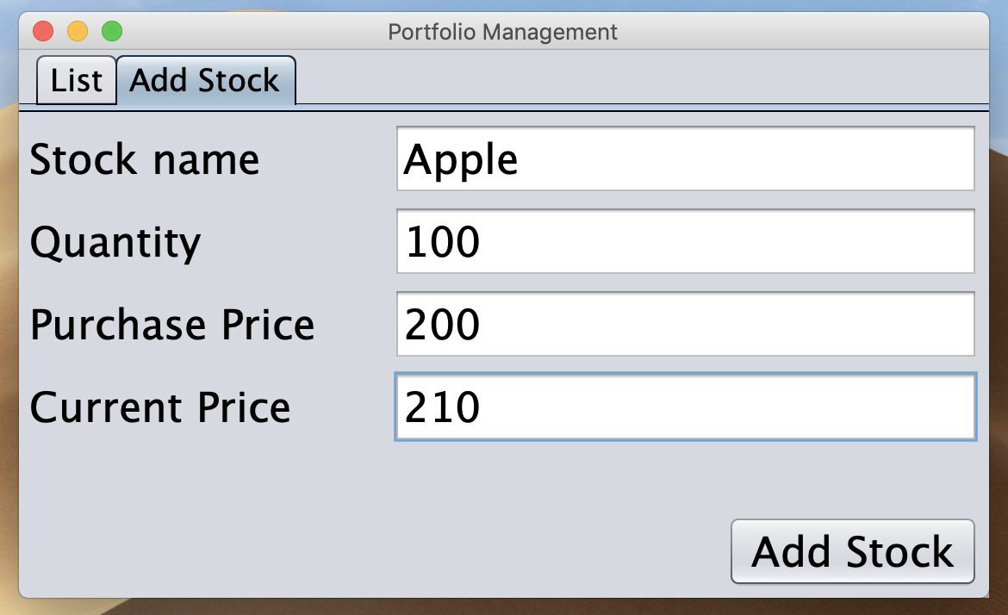

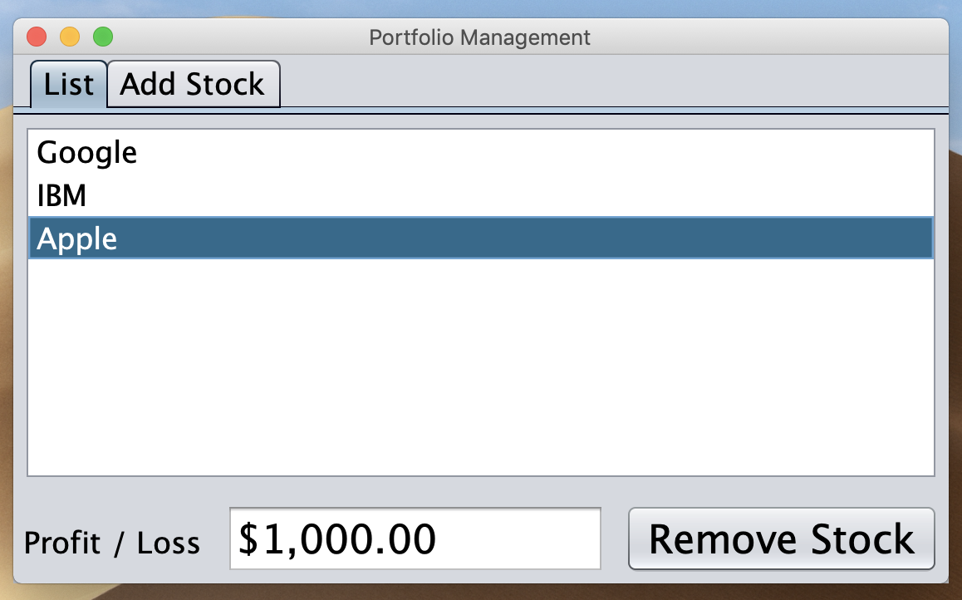

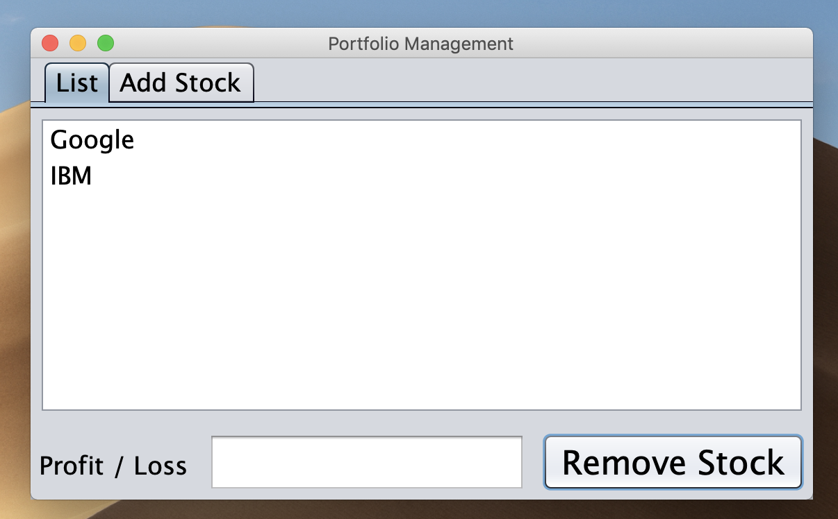

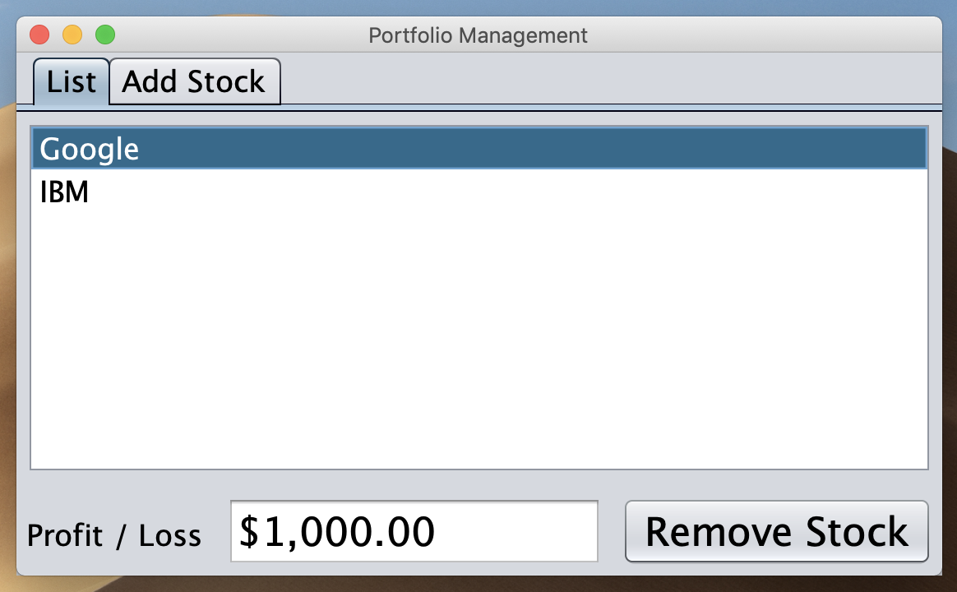

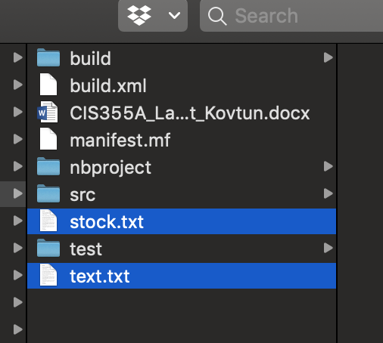

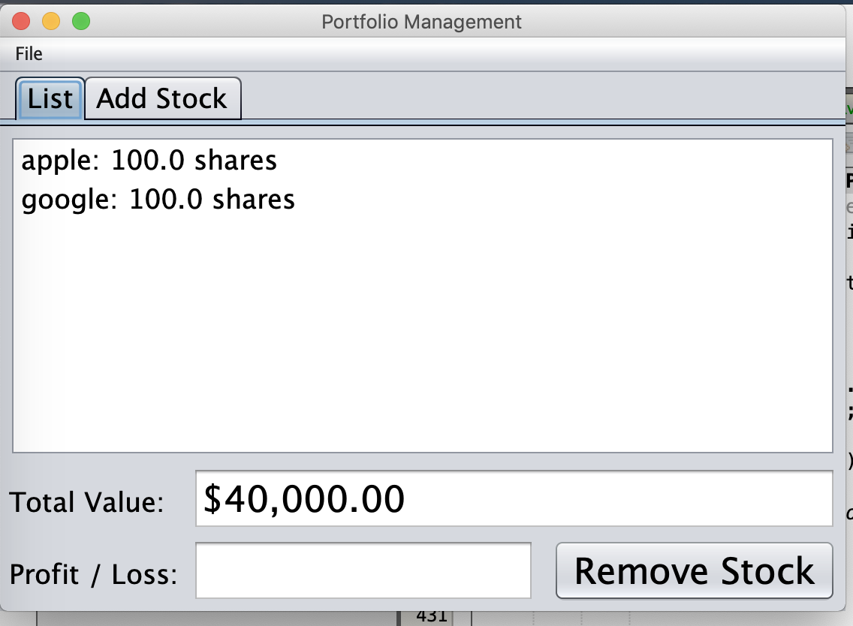

**Conclusions / Lessons Learned**

I have learned how to create a list object that can be selected from the Field List. Also, I learn how to manage a tab when we have multiple values like List and Add Stock. Everything else, was self-explanatory for me and I did not run to any issues.