CIS355A Lab Report

**Your Name: Roman Kovtun**

**Date: 14/10/2018**

**Lab Week 6**

**Objective/Purpose of the program**

Programmatic access to a MySQL database to add and display records. Create a database and table to store student name and three test scores.

**Analysis/Design**

Student class to manage the student data. StudentDB class that is used to create a connection and interface with the database. GUI class with insert buttons will take the info from the GUI (student name and three test scores) and insert a record into the table. Input should be cleared from the textboxes.

**Testing/Results**

|  |  |  |  |  |
| --- | --- | --- | --- | --- |
| **Case** | **Description** | **Test Data** | **Expected Result** | **Actual Result** |
| 1 | Insert the test data | For the fields Name: Barry Allen, Test1 – 99 Test2 – 88, Test3 – 77 | Record should be added to database and user should receive the note that it was added | Actual results – reference an image that you include below. |
| 2 | Display all people that took the Test | When we click on the Display All to see all Student that took the Tests | Expect to see a textArea with data, average score and the Grade that they receive | Actual results – reference an image that you include below. |

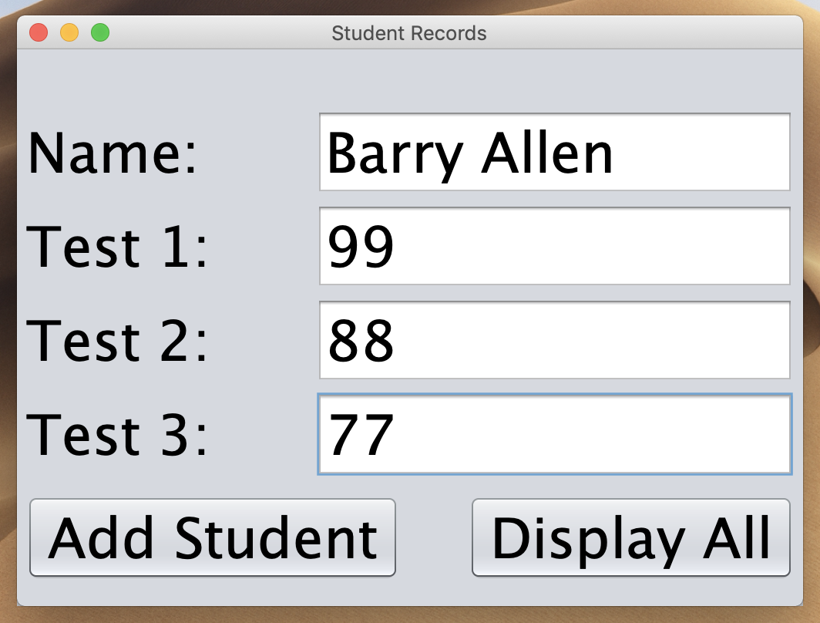

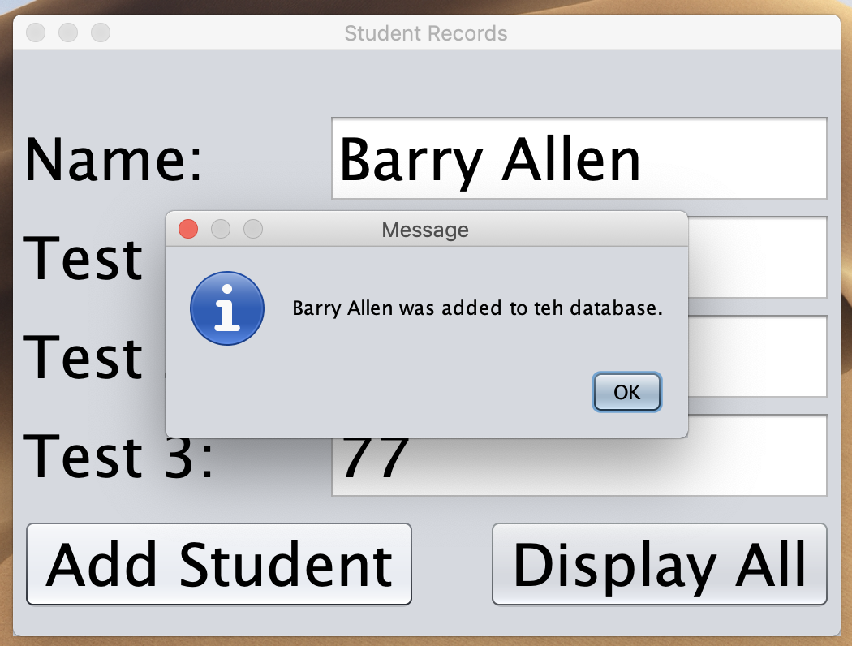

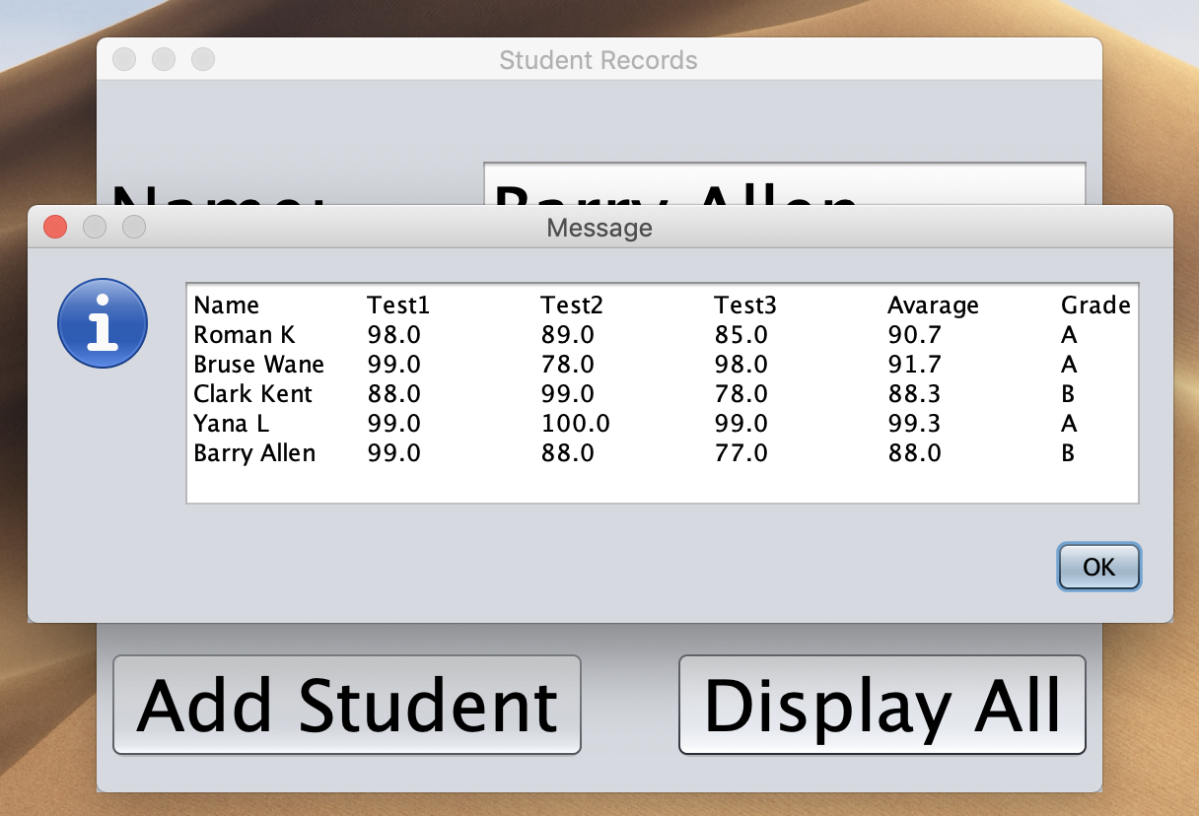

**Conclusions / Lessons Learned**

The only problem that I got is that my database access was limited to me and I couldn’t connect to the db. Eventually, the problem was easy to fix, and I had to get new password to get back to the database system.