|  |  |  |  |  |  |
| --- | --- | --- | --- | --- | --- |
| Name: | Roman Kovtun | DSI#: | D40685801 | Date: | March 9, 2019 |

**WEB375 Week 1 Lab Report: Basic Linux Review**

**Lab Grading Rubric**

|  |  |
| --- | --- |
| **Category** | **Points** |
| Task D: Step 5—Display edited file | 10 |
| Task E:  Step 1—Clear the screen.  Step 2—Type the command *whoami.* Step 3—Create a new directory named *lab1.* Step 4—Change directories into *lab1.* Step 5—List all files, even hidden files.  Step 6—Create a new file containing this month’s calendar. Step 7—List all files again, even hidden files.  Step 8—Display the entire contents of new file. Step 9—Delete the file,and verify. Step 10—Display today's date. | 5  5  5  5  5  5  5  5  5  5 |
| Total | 60 |

**Task D: Step 5**

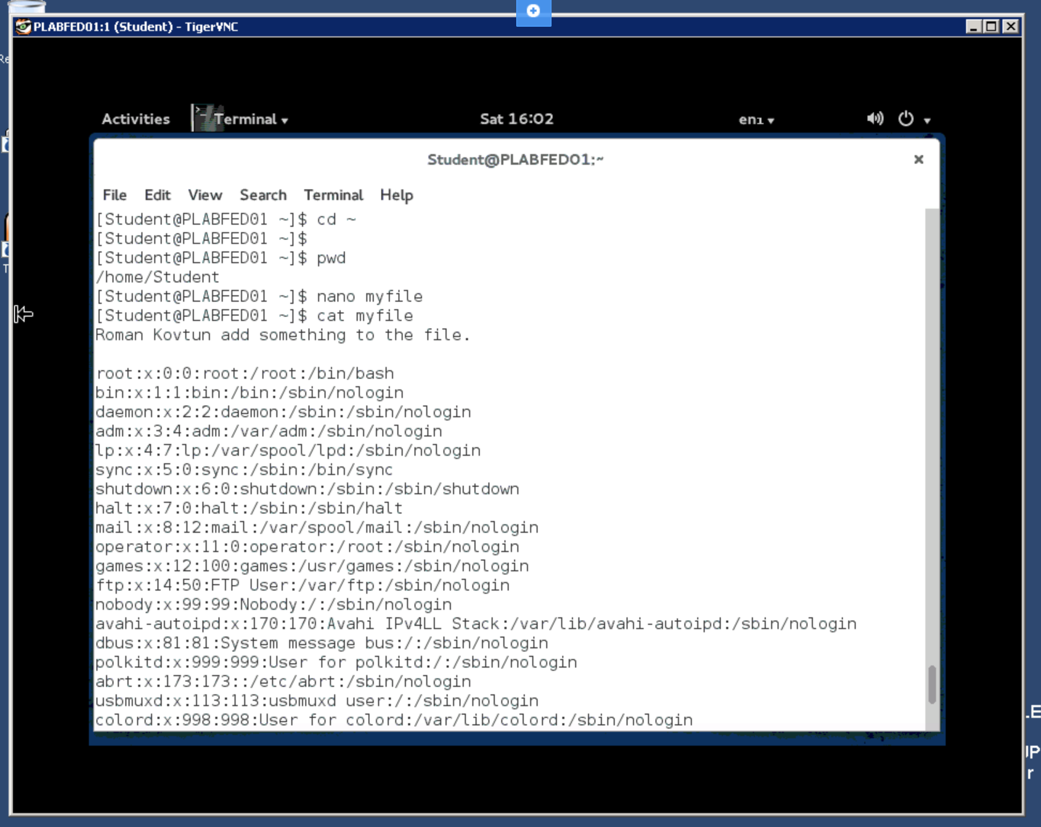

**Task E:**

**Step 1:**

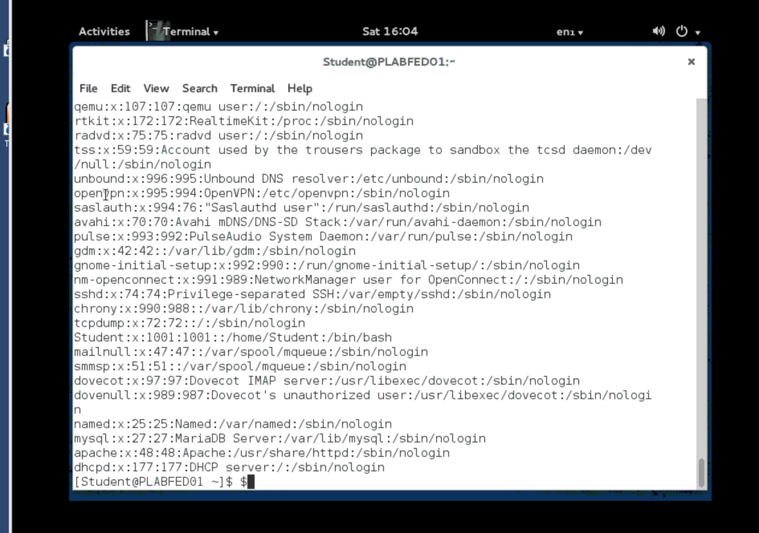

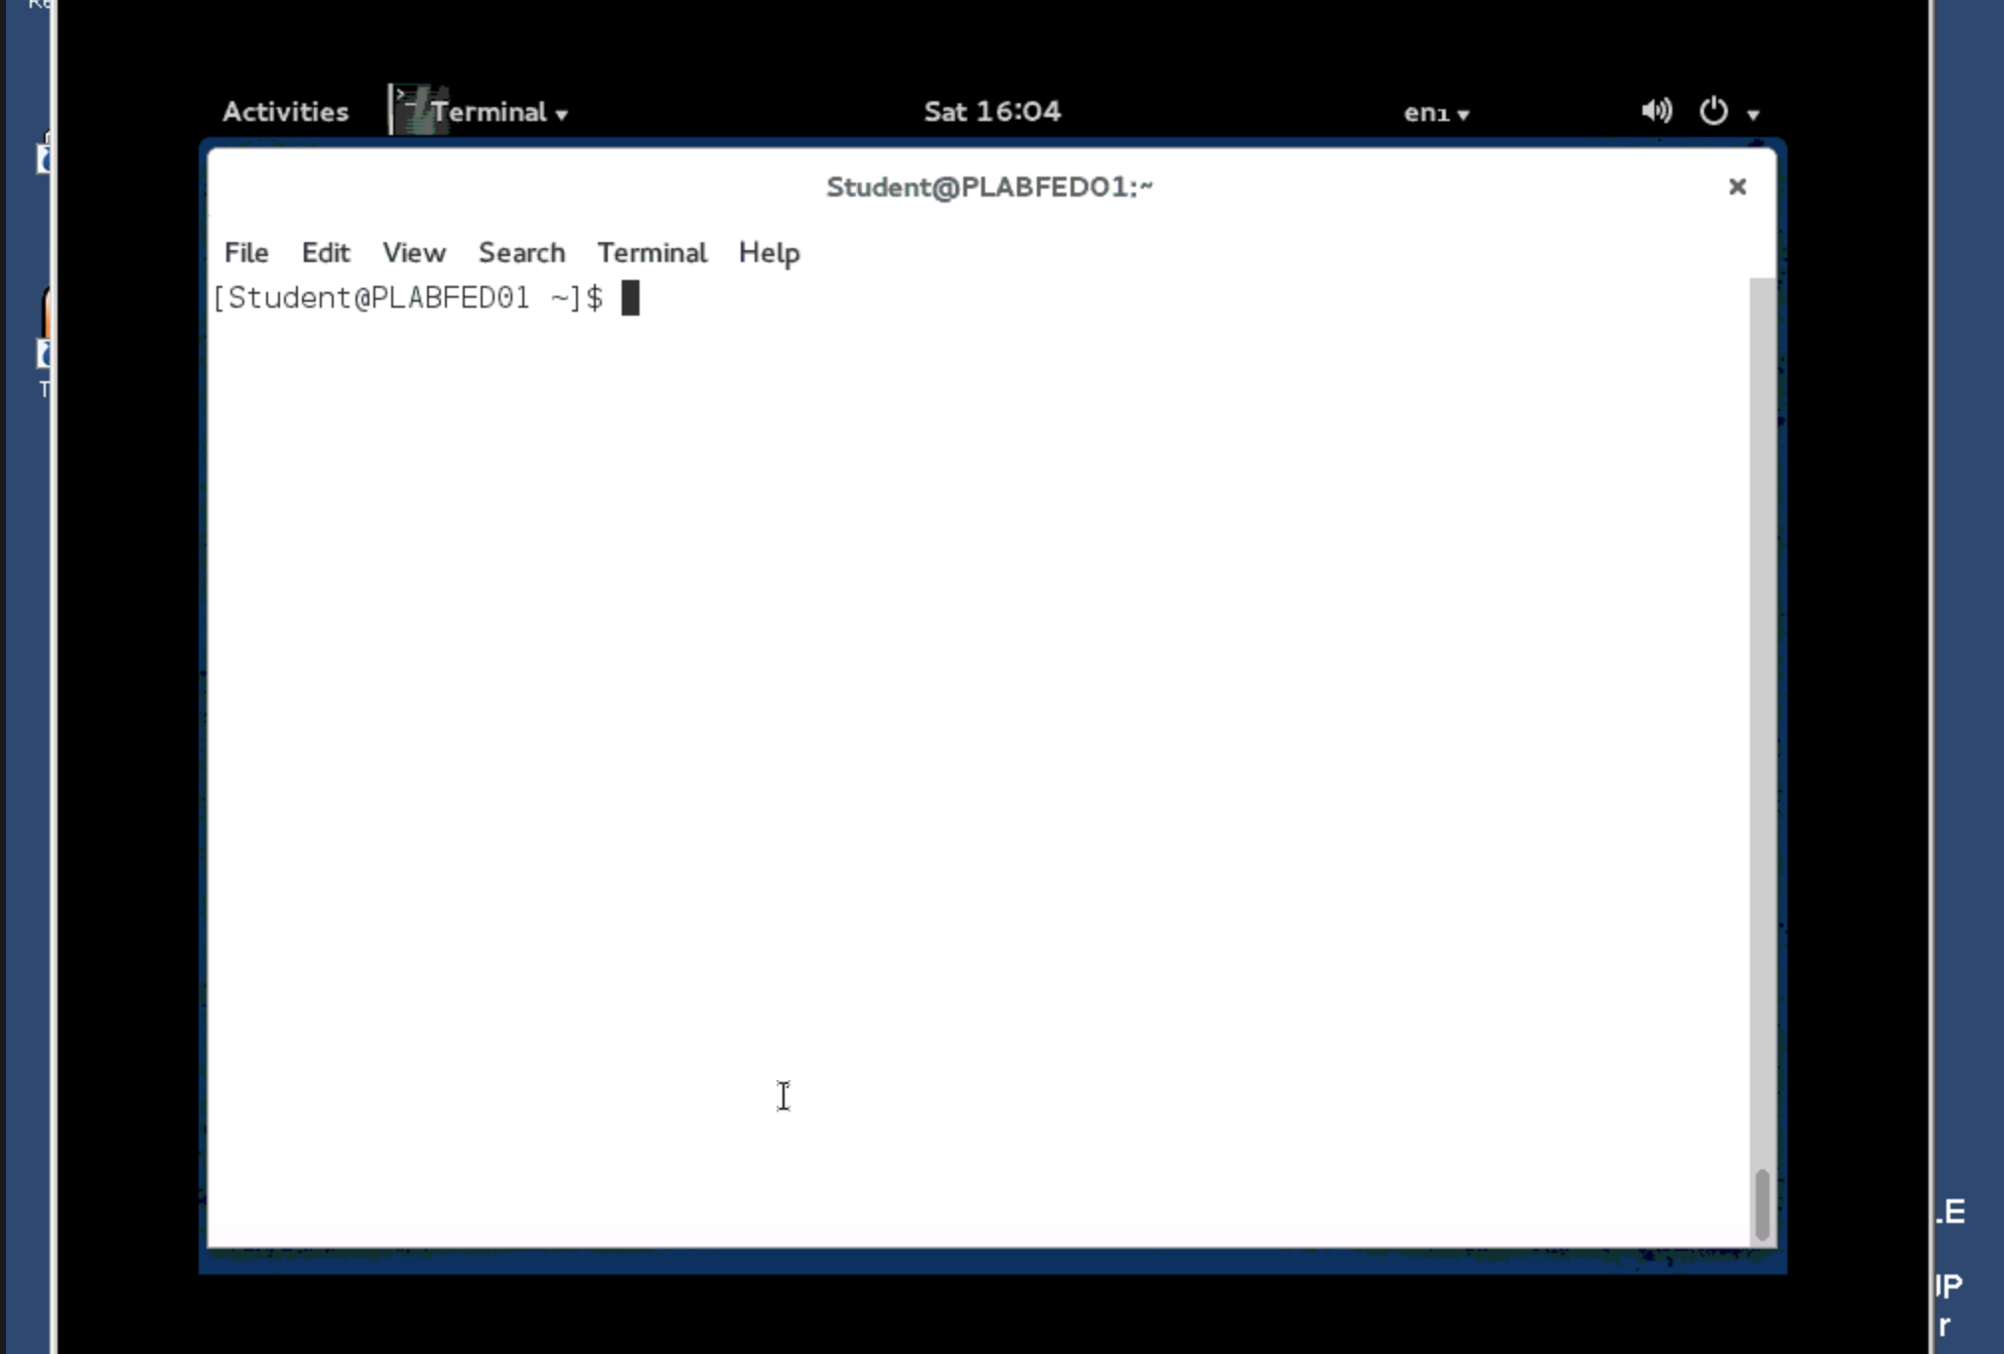

**Step 2:**

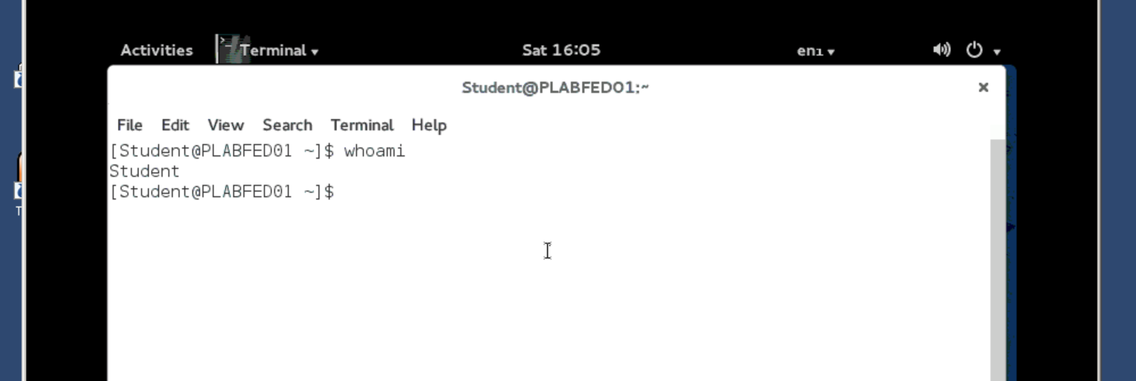

**Step 3:**

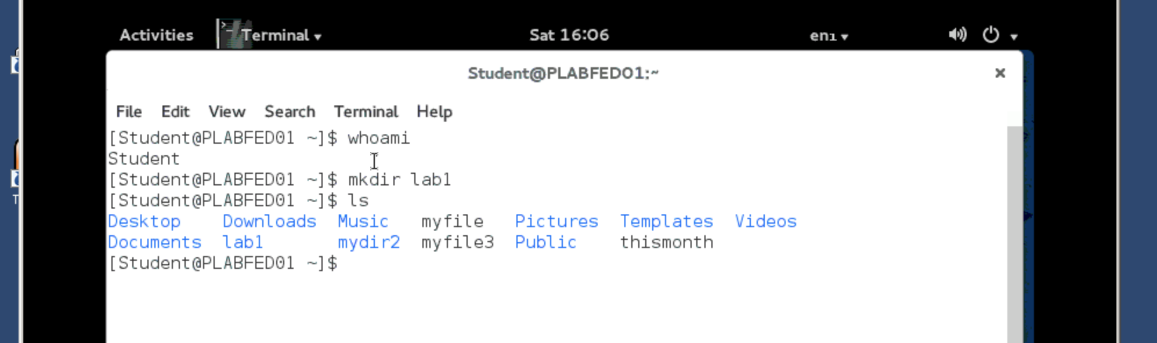

**Step 4:**

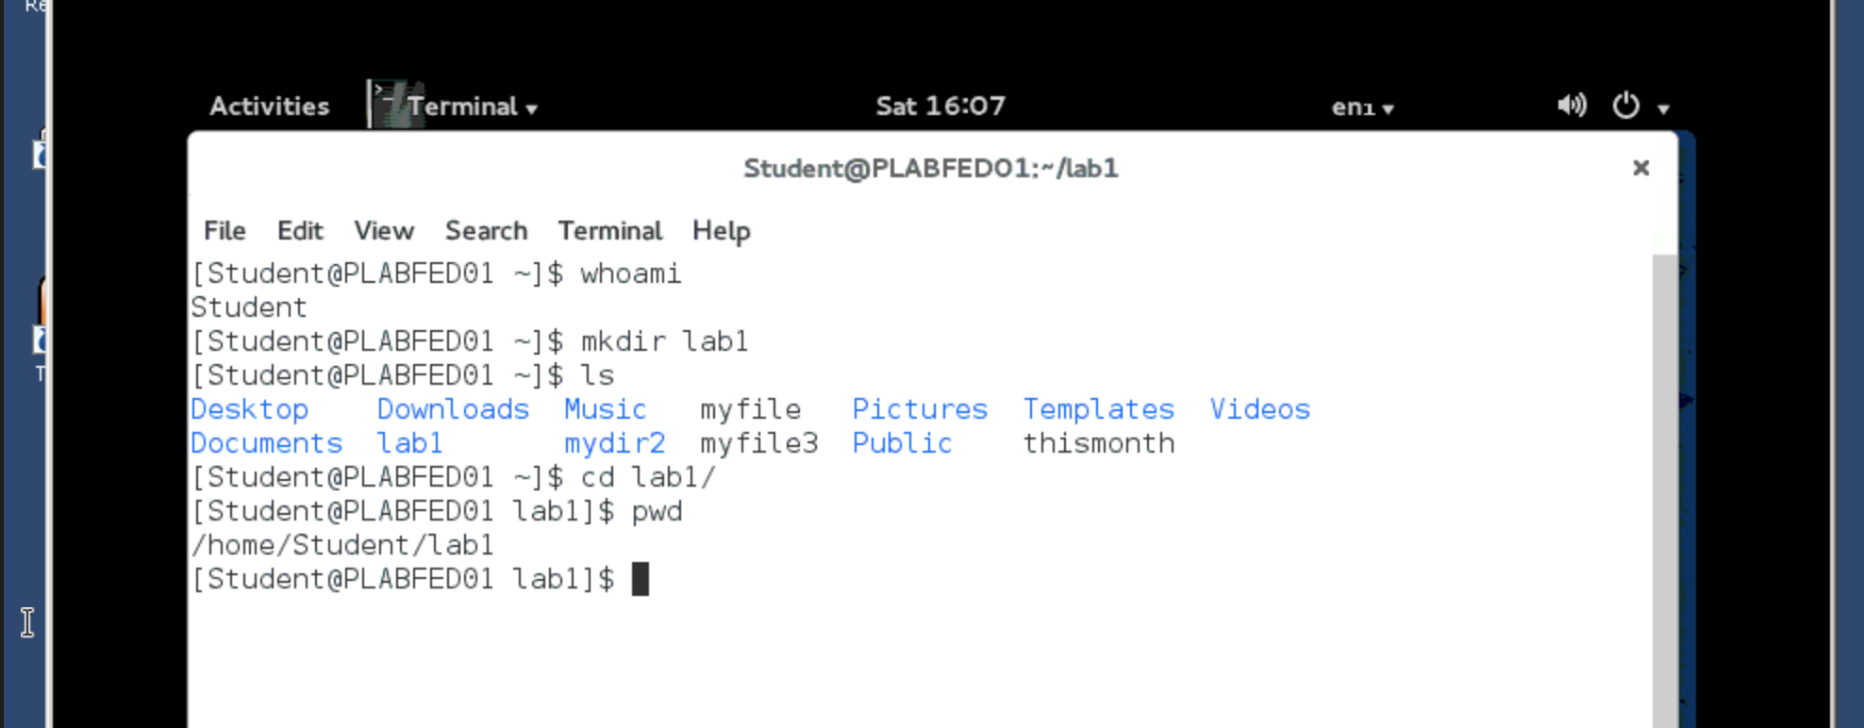

**Step 5:**

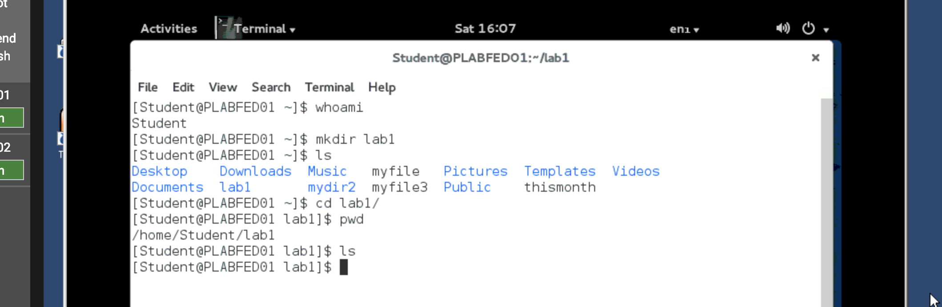

**Step 6:**

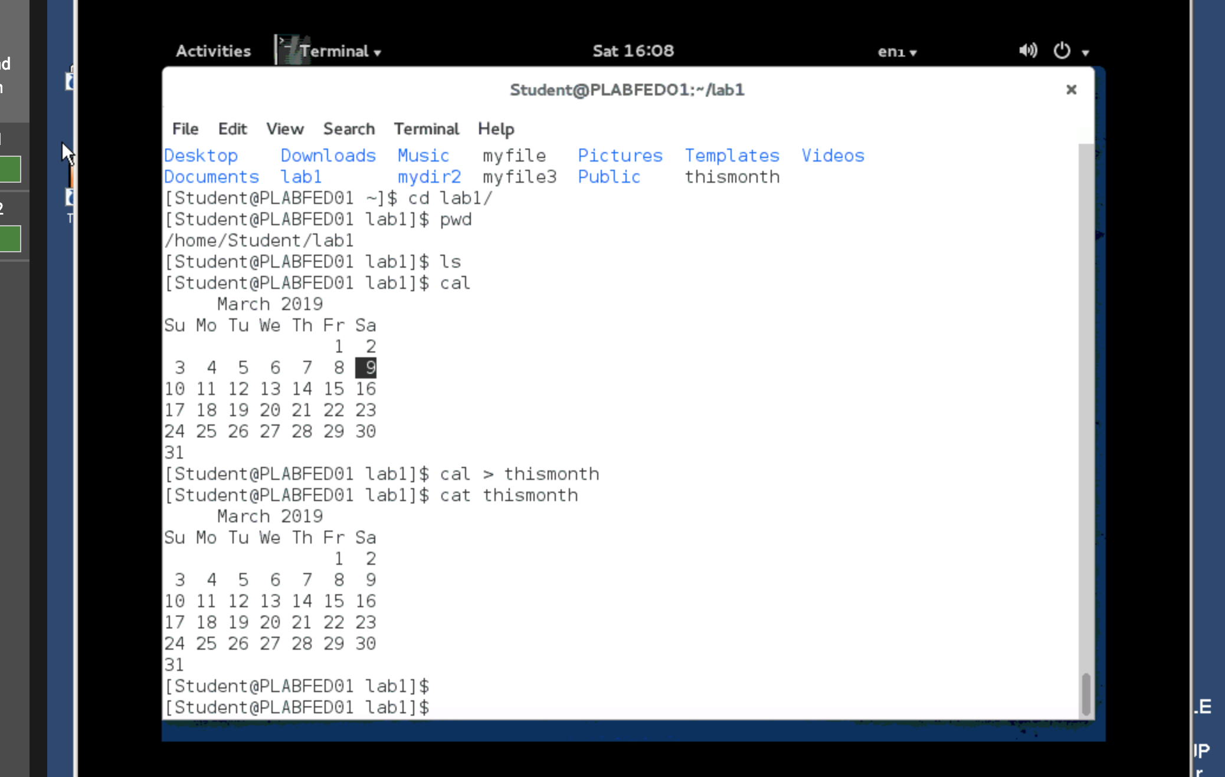

**Step 7:**

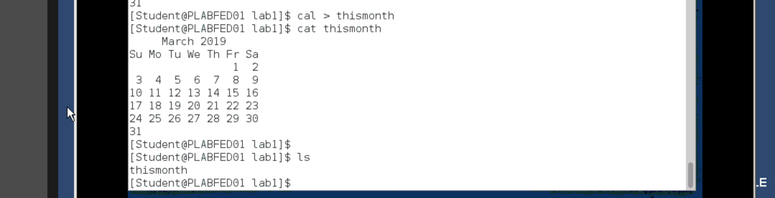

**Step 8:**

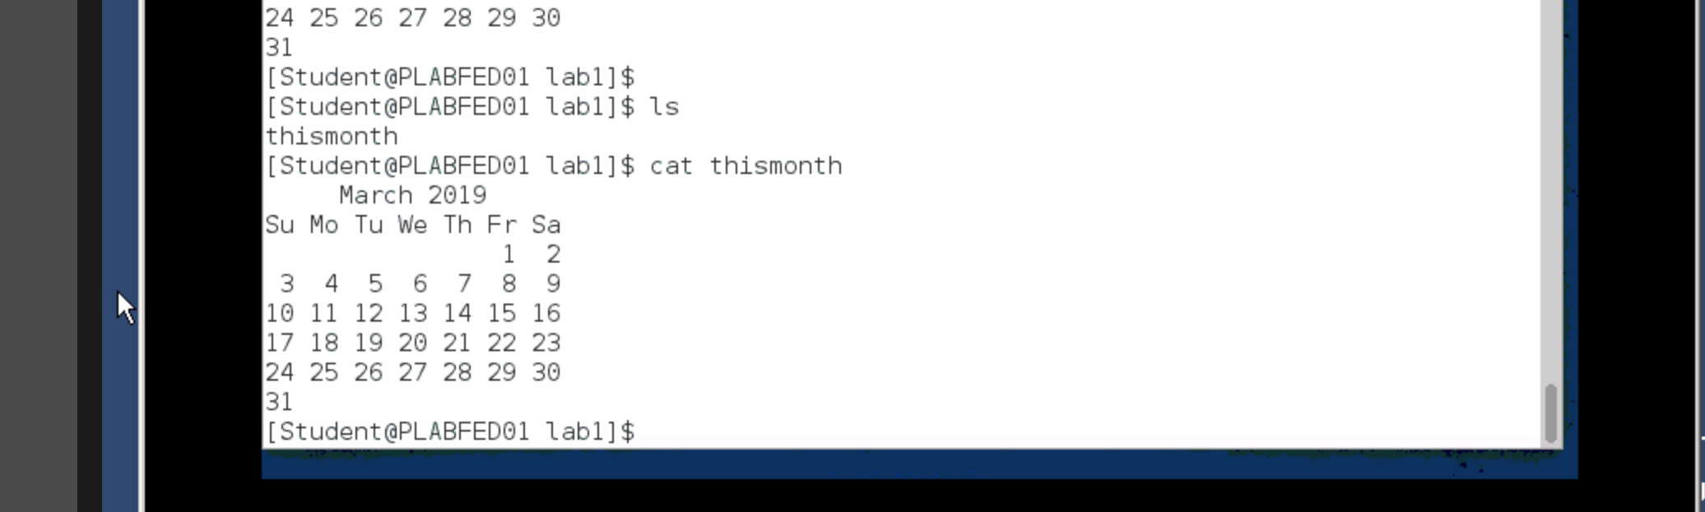

**Step 9:**

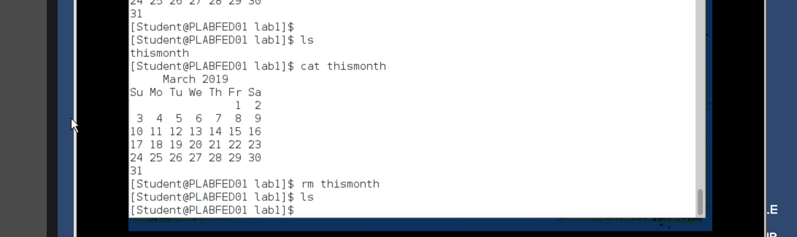

**Step 10:**

