|  |  |  |  |  |  |
| --- | --- | --- | --- | --- | --- |
| Name: | Roman Kovtun | DSI#: | D40685801 | Date: | March 15, 2019 |

**Web375 Week 2 Lab Report—Configuring a Linux Firewall**

**Lab 2 Grading Rubric**

|  |  |
| --- | --- |
| **Category** | **Points** |
| Task C: Step 2: rule delete and iptables rule listing without rule 6 | 15 |
| Task C: Step 3: first telnet connection attempt | 15 |
| Task C: Step 4: rule insert and iptables listing with new rule | 15 |
| Task C: Step 5: second telnet connection attempt | 15 |
| Total | 60 |

**Task C: Step 2**

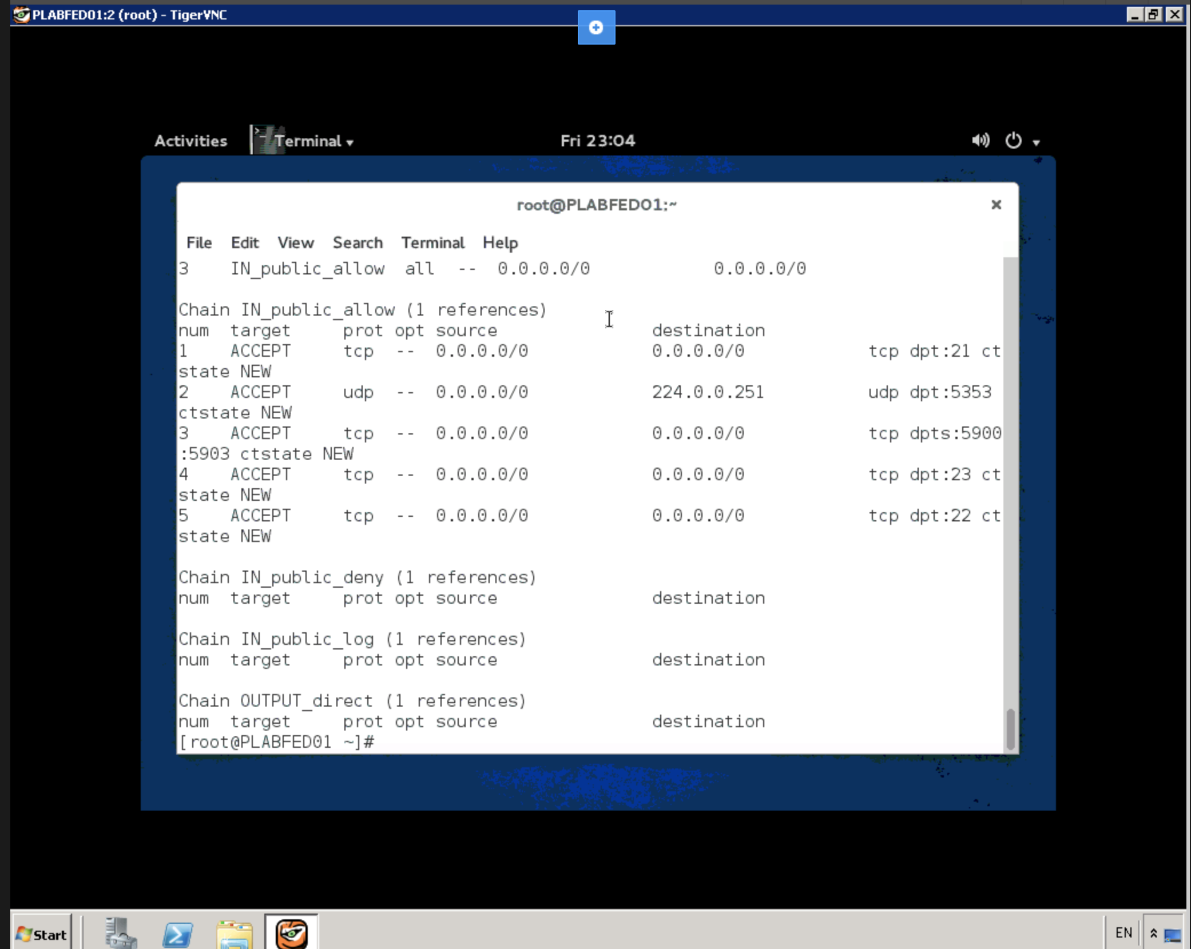

**Task C: Step 3**

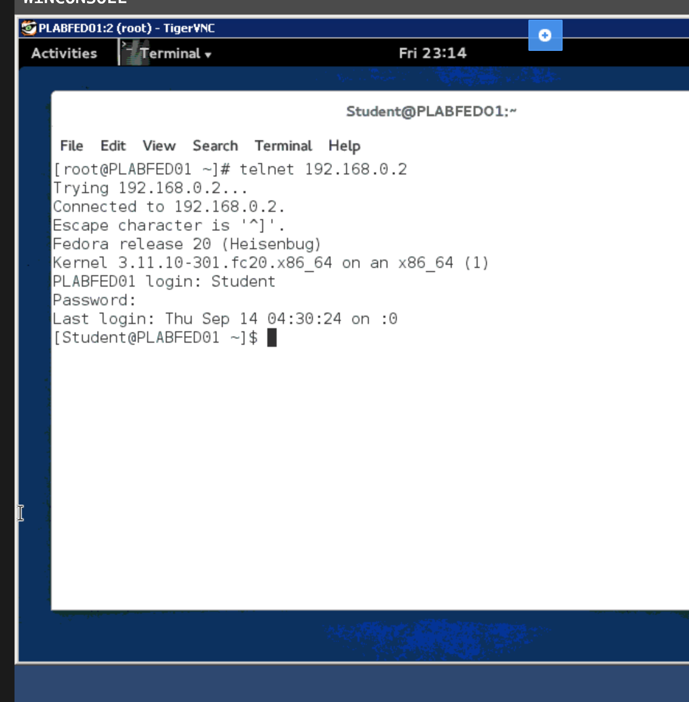

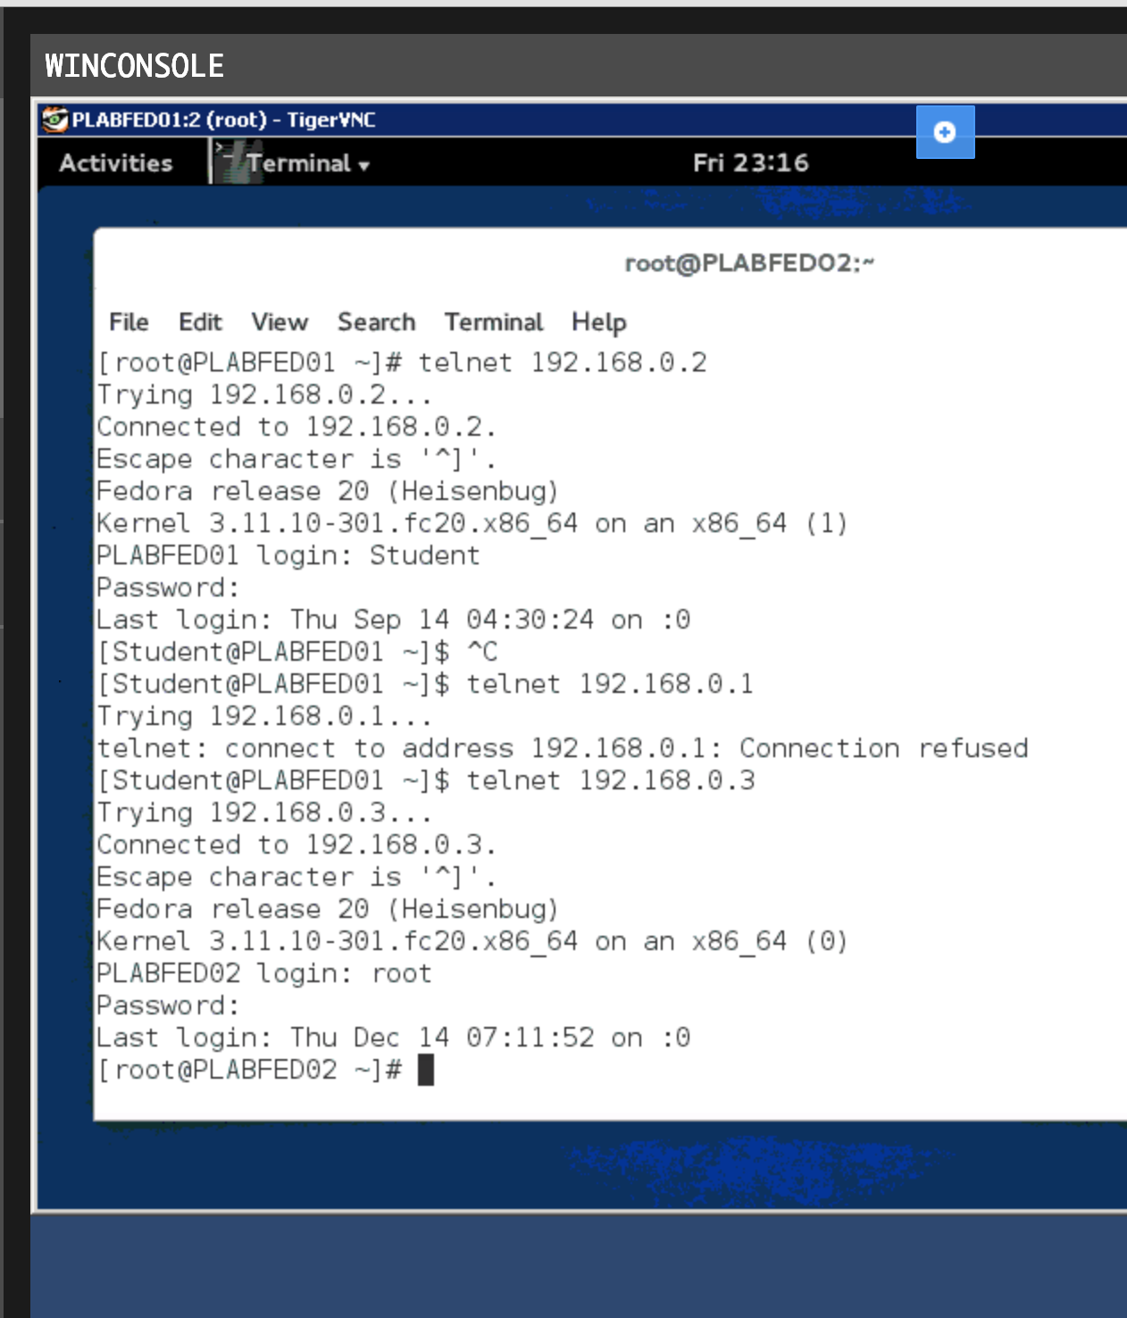

**Task C: Step 4**

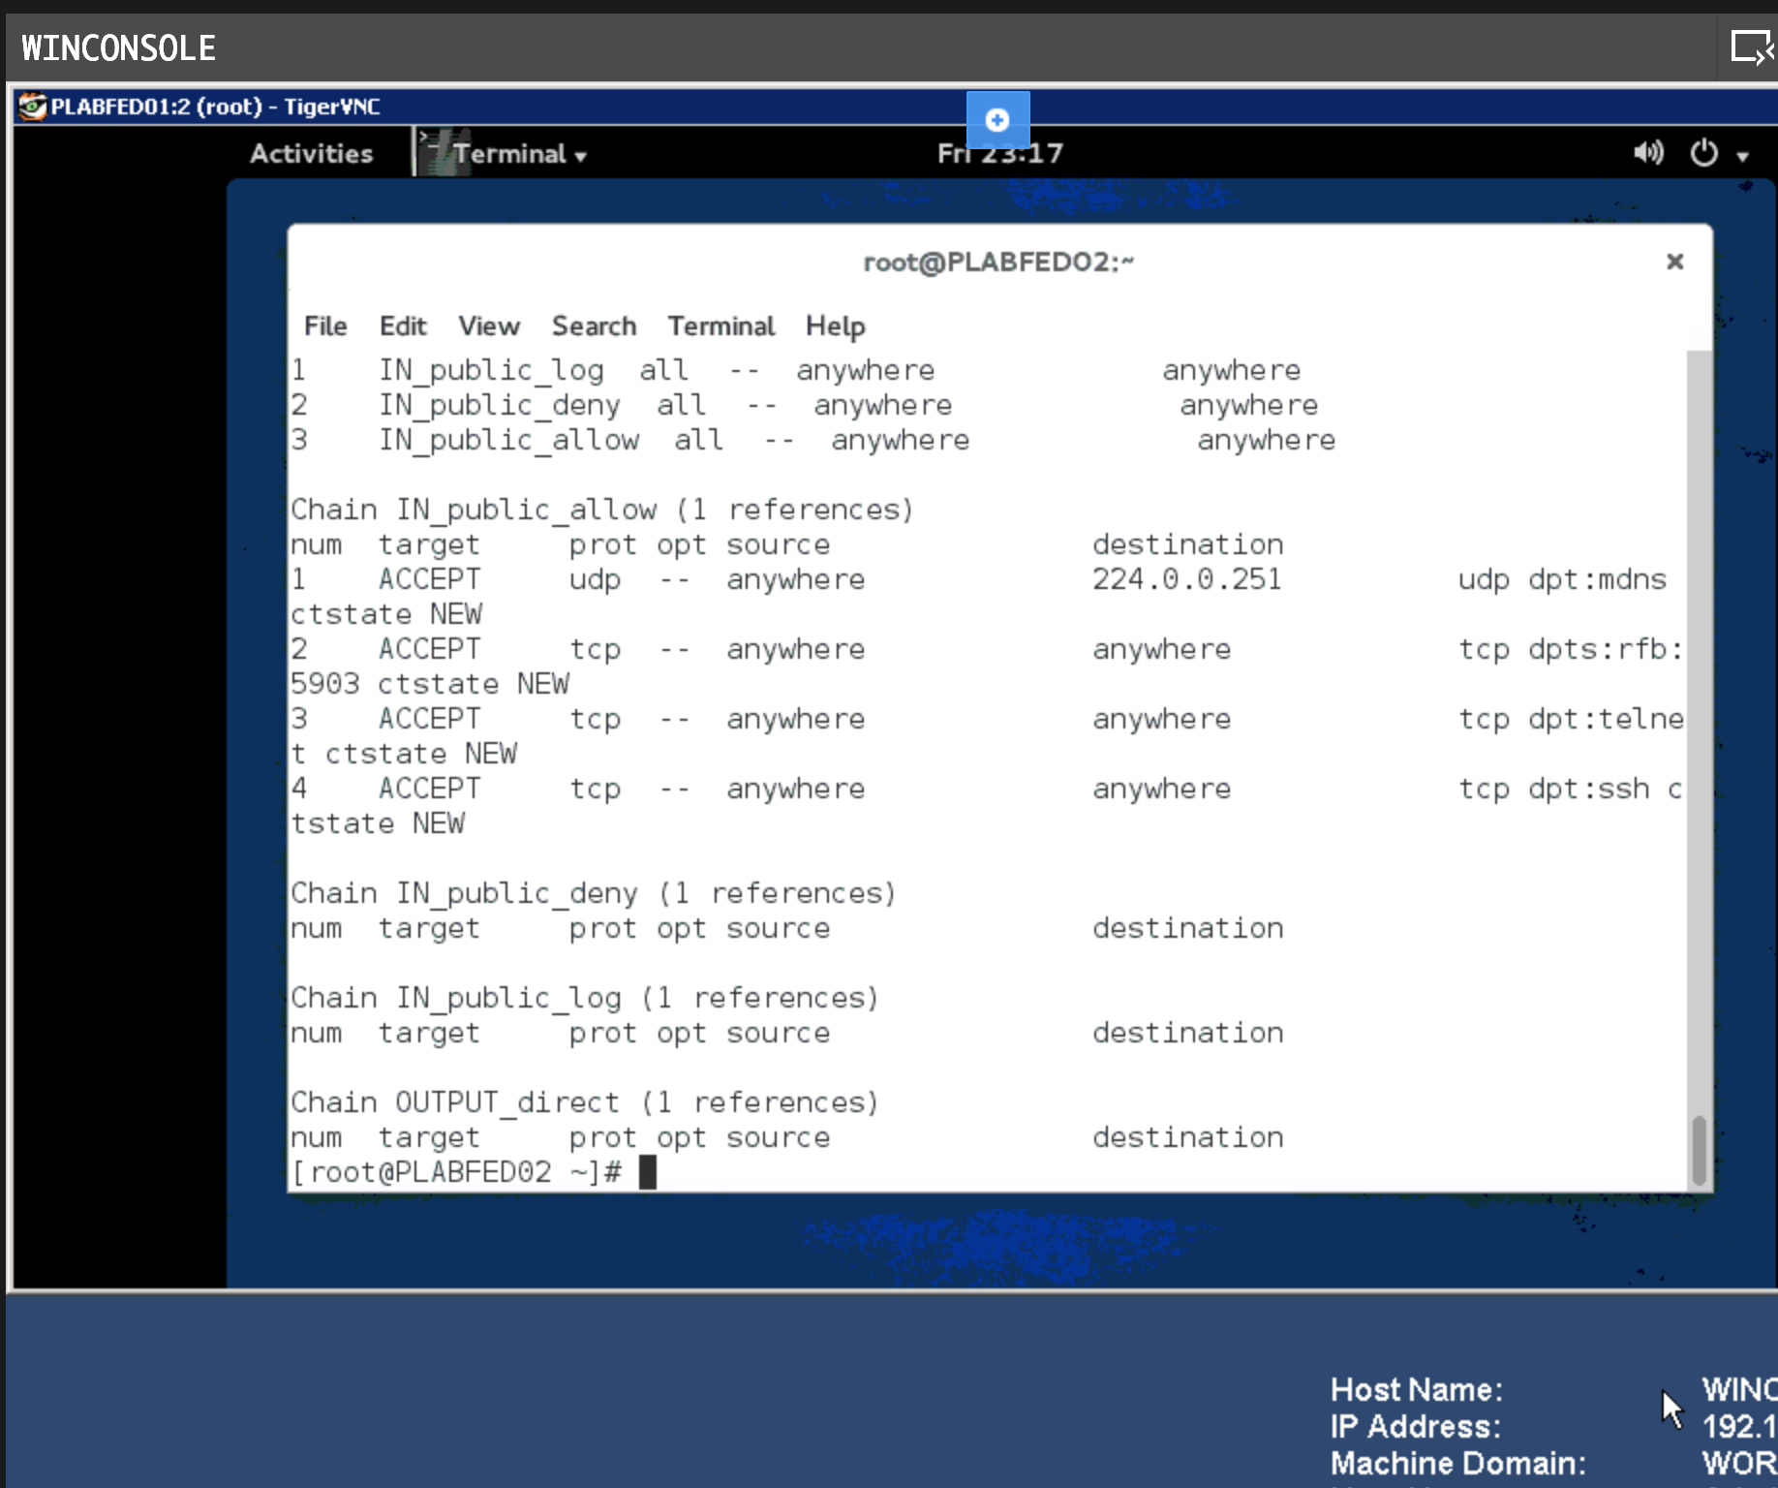

**Task C: Step 5**

