|  |  |  |  |  |  |
| --- | --- | --- | --- | --- | --- |
| Name: | Roman Kovtun | DSI#: | D40685801 | Date: | March 23, 2019 |

**Web375 Week 3 Lab Report—Configuring a Mail Server**

**Lab 3 Grading Rubric**

|  |  |
| --- | --- |
| **Category** | **Points** |
| Task C: Step 3: /etc/hosts | 10 |
| Task C: Step 4: /etc/sysconfig/network | 10 |
| Task C: Step 5: /etc/mail/local-host-names | 10 |
| Task C: Step 6: sendmail status | 5 |
| Task C: Step 7: /etc/passwd | 5 |
| Task C: Step 8: Sending mail | 10 |
| Task C: Step 9: Receiving mail | 10 |
| Total | 60 |

**Task C: Steps 3–5**

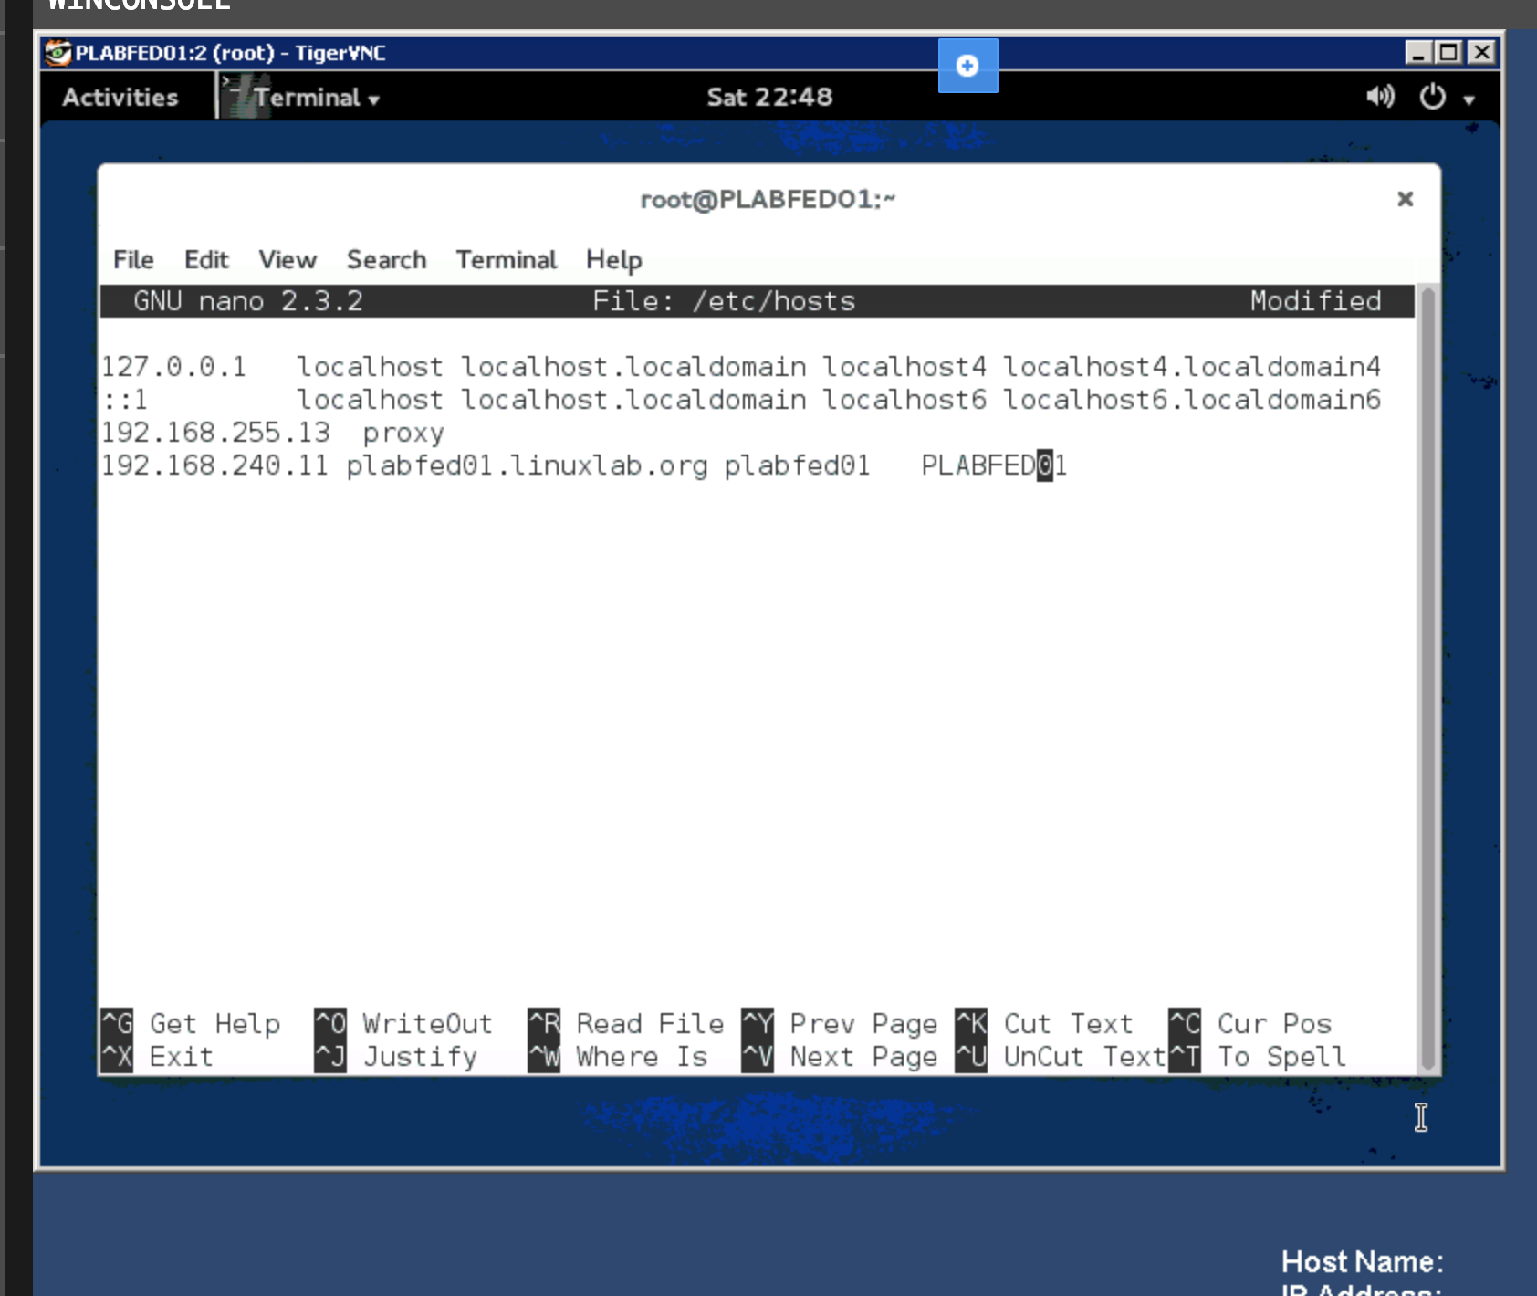

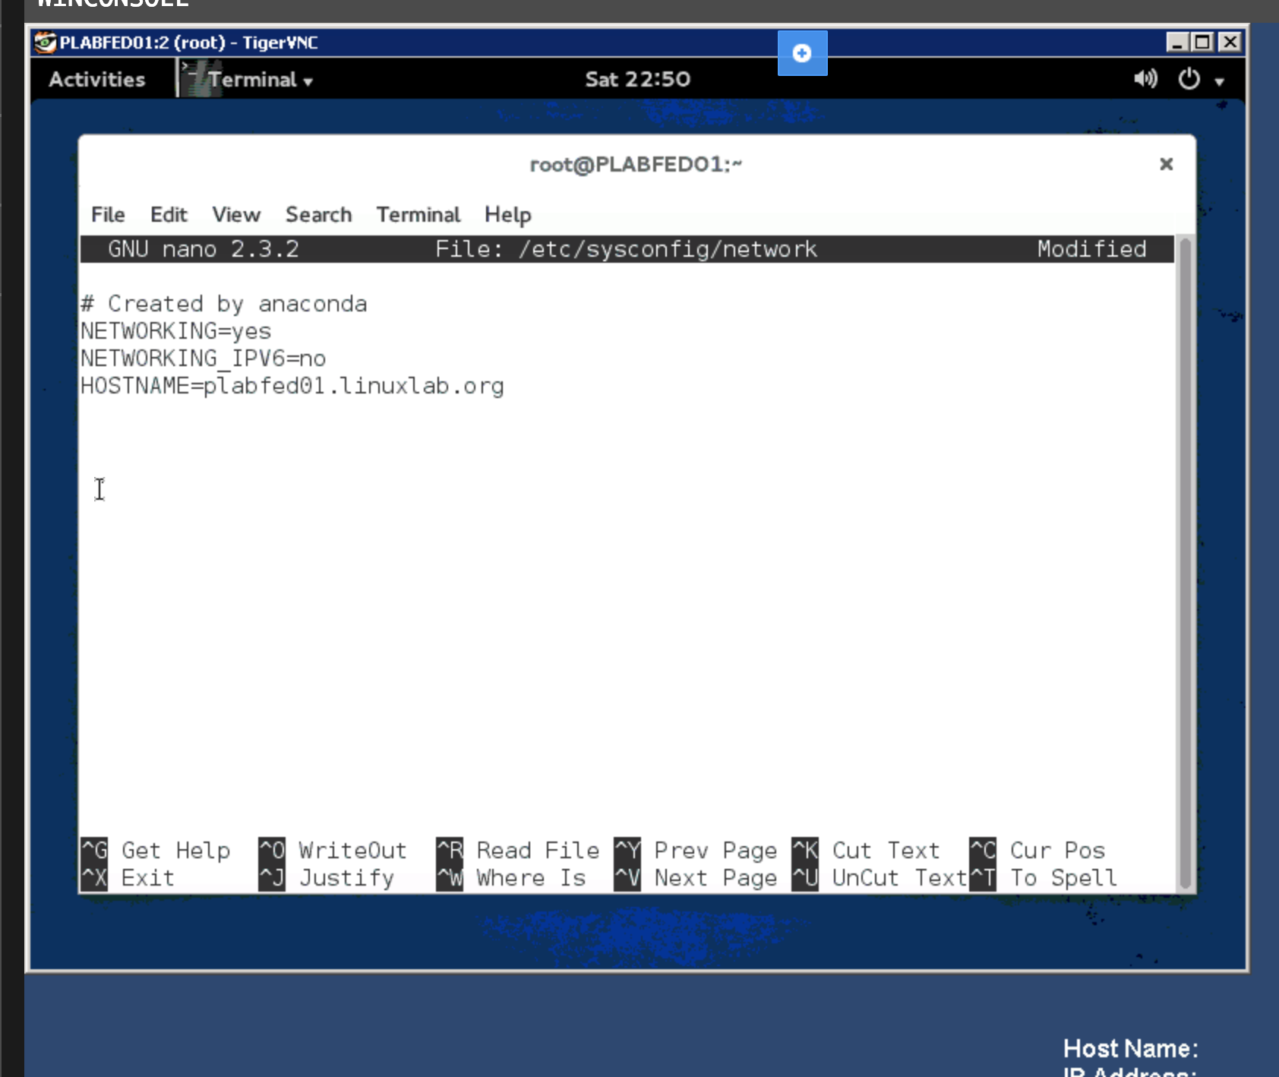

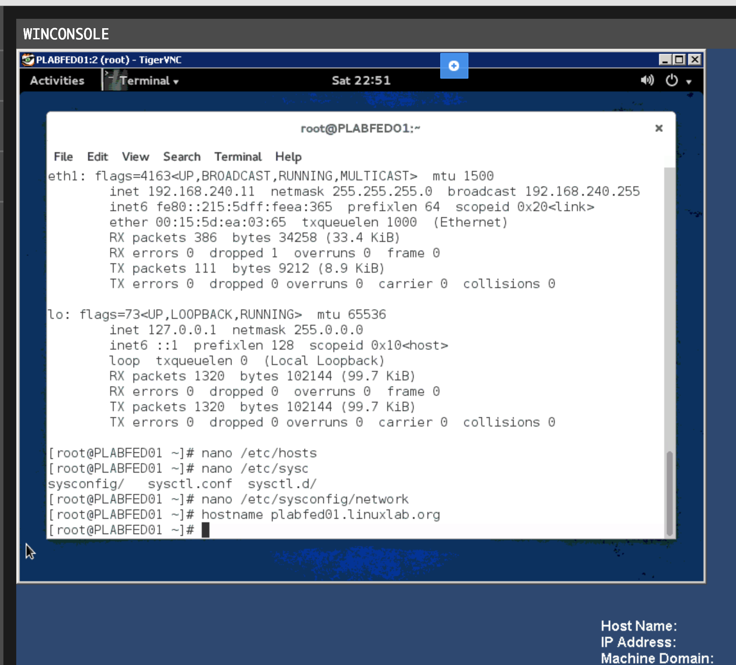

**Task C: Step 6**

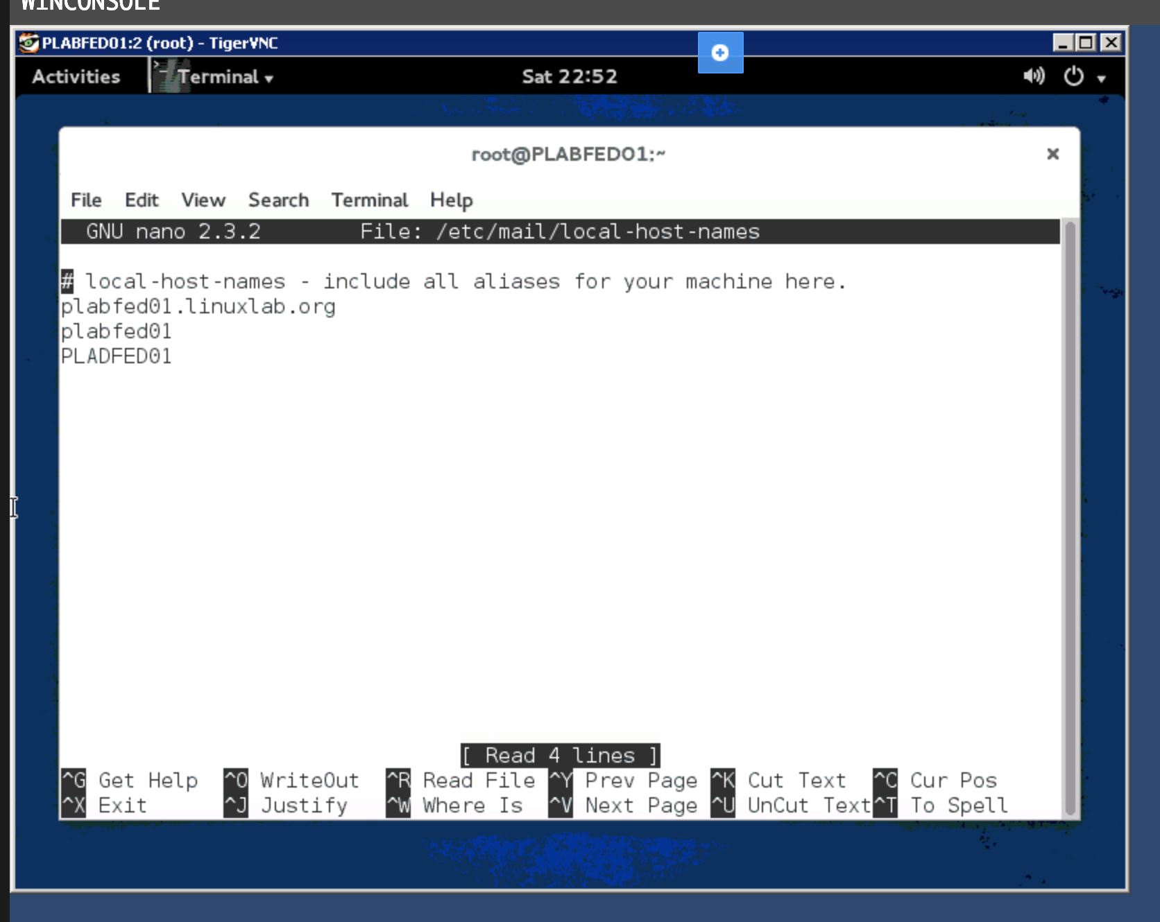

**Task C: Step 7**

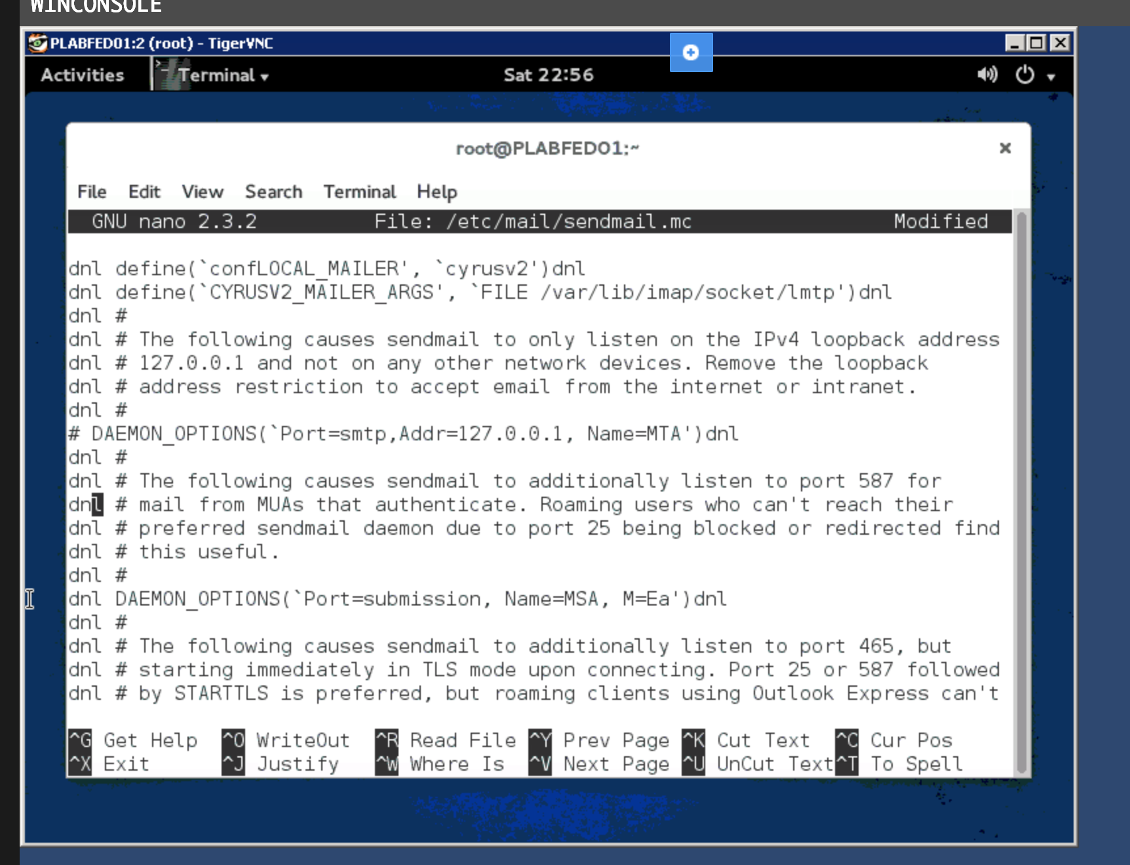

**Task C: Step 8**

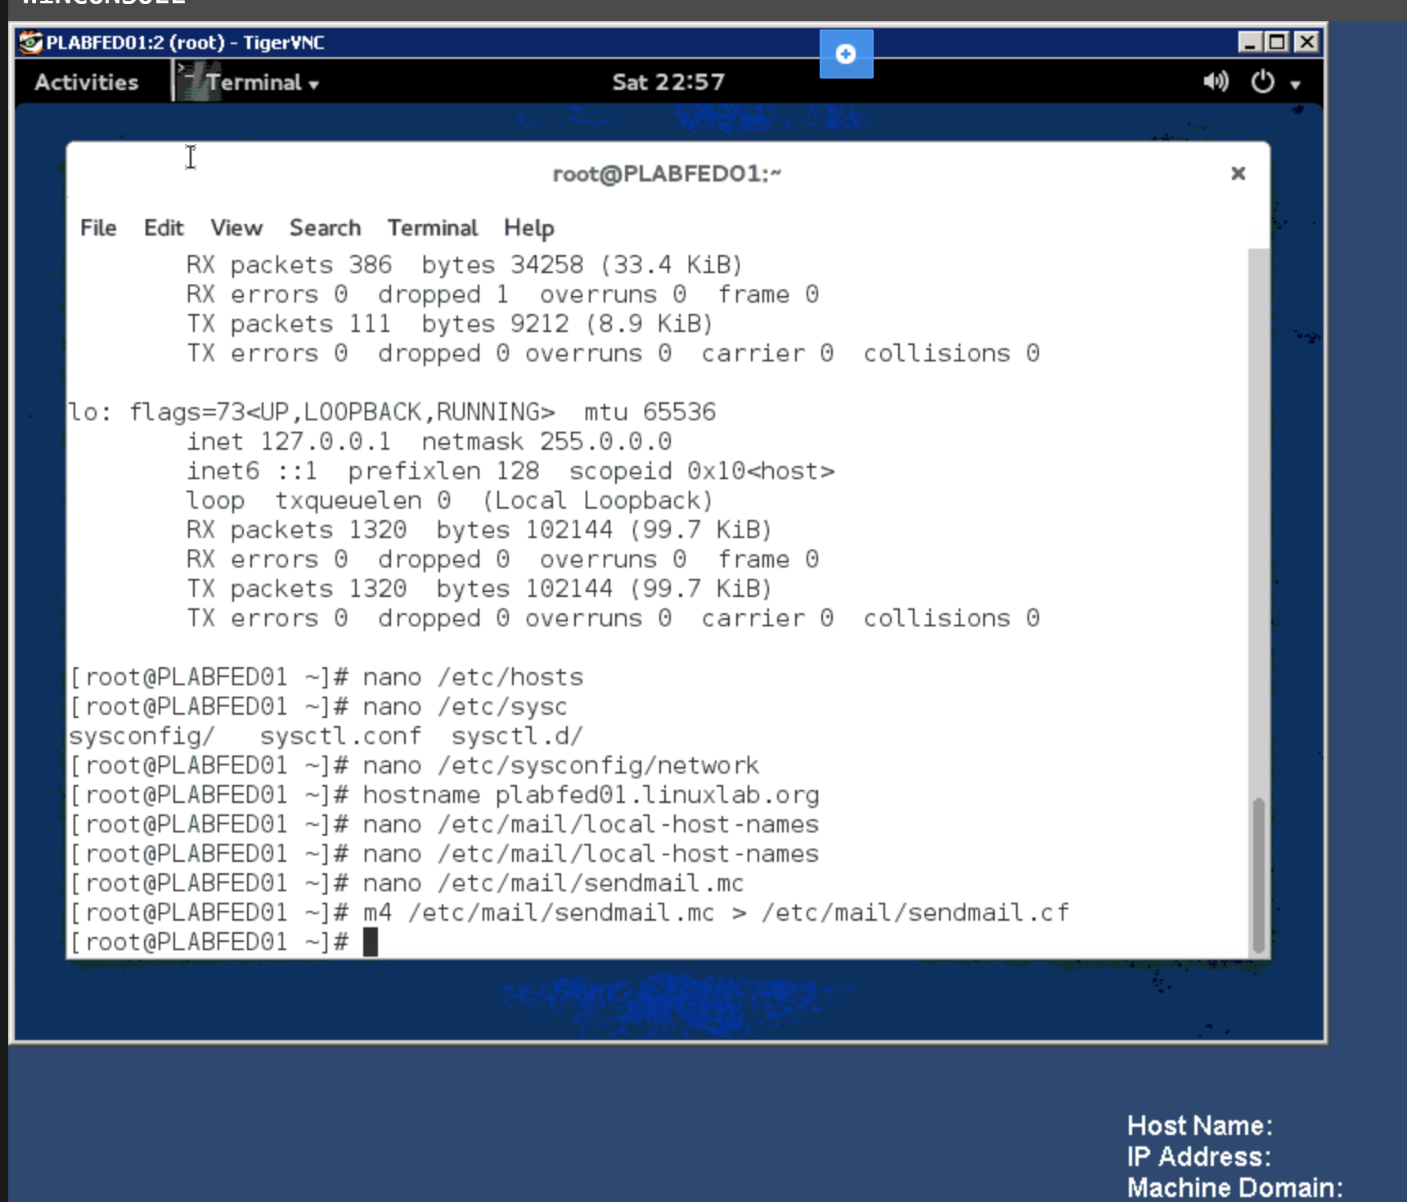

**Task C: Step 9**



